

本科毕业设计说明书

（本科毕业论文）

|  |
| --- |
| 课题名称：基于AR的吉他学习系统的设计与开发  ——用户中心与成长体系 |
| 学院（部）： 国际教育学院 |
| 专 业： 软件工程 |
| 班 级： 软件G213 |
| 学 号： 202100408085 |
| 姓 名： 李韵林 |
| 指导教师： Viettrung Luong(梁越忠) |

2025年5月18日

**独 创 性 声 明**

本人郑重声明：所呈交的毕业设计（论文）是本人在指导教师指导下取得的研究成果。除了文中特别加以注释和致谢的地方外，毕业设计（论文）中不包含其他人已经发表或撰写的研究成果。与本研究成果相关的所有人所做出的任何贡献均已在毕业设计（论文）中作了明确的说明并表示了谢意。

签名：

　　　　　　　　　　　　　　　2025　　年　5　月　18　日

**授权声明**

本人完全理解广西科技大学有关保留、使用本科生毕业设计（论文）的规定，即：学院有权保留并向国家有关部门或机构送交毕业设计（论文）的复印件和电子文档，允许毕业设计（论文）被查阅和借阅。本人授权广西科技大学可以将毕业设计（论文）的全部或部分内容编入有关数据库进行检索，可以采用影印、缩印或扫描等复制手段保存、汇编毕业设计（论文）。

本人毕业设计（论文）中有原创性数据需要保密的部分为：无。



签 名：

　2025　　年　5　月　18　日



指导教师签名：

2025 年　5　月　18　日

# ABSTRACT

**Abstract:** Traditional guitar learning methods often suffer from high costs, lack of engagement, and an absence of real-time feedback, leading to high dropout rates among beginners. To address these issues, this study designs and develops an AR-based mobile application that provides real-time hand placement visualization and fosters a collaborative learning environment. The system integrates augmented reality (AR) technology, image tracking, and database management to overlay fretboard positions, enable practice session recording, and facilitate sheet music sharing. Through iterative testing, the system demonstrates high accuracy in hand tracking and user-friendly interaction, significantly improving engagement and learning efficiency. Results indicate that the AR-based approach enhances real-time feedback and reduces common learning frustrations. Future development will focus on multi-language support, expanded community features, and improved AR tracking in various lighting conditions, ensuring scalability and accessibility for a global user base.

**Keywords** **:** Augmented Reality; Guitar Learning; Hand Tracking; Interactive Education

目 录

ABSTRACT I

1 Project Proposal 1

1.1 Project Overview 1

1.1.1 Problem to Be Solved: 1

1.1.2 Aim & Objectives: 1

1.1.3 Scope & Specialty Areas: 1

1.1.4 Deliverables: 1

1.2 Client Introduction 2

1.3 End Users 2

1.4 Technological Solution 3

1.4.1 Proposed Technological Solution 3

1.4.2 Development & Production Requirements 3

1.4.3 Client Communication & Demonstration 4

1.4.4 Deployment & Market Strategy 4

1.4.5 Cost & Compliance 5

1.5 Client Meetings 5

1.5.1 Date 5

1.5.2 Goals 5

1.5.4 Action items 6

1.5.5 Decisions 6

1.6 Team Contract 6

1.7 Client Agreement 7

1.8 Project Approval 8

2 Iteration 1 9

2.1 Iteration Overview 9

2.2 Design Documentation 11

2.2.1 Iteration Design Goals 11

2.2.2 System Architecture Diagram 11

2.2.3 AR Interaction Design (Storyboard) 12

2.2.4 Future Iteration Roadmap 12

2.2.5Business Rules: 12

2.2.6 Class Diagram 14

2.2.7 The diagram showing the database design 17

2.2.8 API Request 17

2.2.9 storeboard 18

2.3 Development Documentation 25

2.3.1 Summary of Work Done in This Iteration 25

2.3.2 Frontend Development 25

2.3.3 Register and Login Subsystem 25

2.3.4 AR Guitar Tracking 25

2.3.5 Local AI Integration 26

2.3.6 Shop Feature Development 26

2.3.7 Version Control with GitHub 26

2.3.8 Code Development and References 27

2.3.9 Source Code Availability 28

2.4 Testing Documentation 28

2.4.1 Overall 28

2.4.2 Frontend prototype test 28

2.4.2 AR Tracking function test 30

2.4.3 Backend prototype test 30

2.4.4 Login System 32

2.4.5 AI function 32

2.4.6 Shopping Function 33

2.5 Client Documentation 33

2.5.1 Client Training Materials 33

2.5.2 Reference Manuals 34

2.5.3 Client-Specific Customization 35

2.5.4 Support & Escalation 36

2.6 Client Meetings 36

2.6.1 Date 36

2.6.2 Goals 36

2.6.3 Discussion topics 36

2.6.4 Action items 37

2.6.5 Decisions 37

3 Iteration 2 38

3.1 Iteration Overview 38

3.2 Design Documentation 40

3.2.1 Iteration Design Goals 40

3.2.2 System Architecture Diagram 40

3.2.3. AR Interaction Design (Storyboard) 41

3.2.4. Attribution of Non-Original Content 42

3.2.5 Future Iteration Roadmap 42

3.2.6 Class Diagram 44

3.2.7 Database 45

3.2.8 API Request States 45

3.2.8 Storyboard 47

3.2.8.9 comment page 50

3.3 Development Documentation 53

3.3.1 Summary of Work Done in This Iteration 53

3.3.2 Frontend Development 54

3.3.3 AR Guitar Tracking 54

3.3.4 Development Side Development 54

3.3.5 Backend Development 54

3.3.6 Version Control with GitHub 55

3.3.7 Code Development and References 55

3.3.8 Source Code Availability 56

3.4 Testing Documentation 56

3.4.1Overview： 56

3.4.2 New Backend API test 57

3.4.3 Frontend prototype test 2 62

3.4.4 Admin Frontend prototype test 71

3.4.5 AR Function Test and Project integration 77

3.5 Client Documentation 79

3.5.1 Training Materials (New & Updated) 79

3.5.2 Reference Manual (Technical & Maintenance) 80

3.5.3 Confidential Information Management 82

3.5.4 Deliverables 82

3.6 Client Meetings 82

3.6.1 Date 82

3.6.2 Goals 82

3.6.3 Discussion topics 83

3.6.4 Action items 83

3.6.5 Decisions 83

Iteration 3 85

2. Iteration 3 Summary 88

Testing Documentation 3 90

4.Project Closure 104

5 Client Handover Documentation 113

6. Team Project Contribution 118

References 119

致 谢 121

Appendix: Presentation Slides 122

Appendix: Documents on JIRA 123

# 1 Project Proposal

## 1.1 Project Overview

### 1.1.1 Problem to Be Solved:

Traditional guitar learning methods (books, videos, tutors) are either costly, tedious or lack real-time feedback, leading to low engagement and high dropout rates. Existing apps only display sheet music without interactive guidance.

### 1.1.2 Aim & Objectives:

Aim: Develop an AR-based mobile app to guide guitar beginners through real-time hand placement visualization and foster a collaborative learning community.

Objectives:

Use AR technology to overlay hand/fretboard positions via smartphone cameras.

Enable video recording and sharing of practice sessions.

Create a platform for users to upload and share custom sheet music.

### 1.1.3 Scope & Specialty Areas:

Software Development: AR integration, real-time image tracking, database design.

Digital Interaction & User Experience: Intuitive UI/UX design for beginners.

### 1.1.4 Deliverables:

A functional AR guitar learning app with real-time guidance.

Multi-language support and sheet music sharing platform.

Maintenance plan for future updates and scalability.

### 1.2 Client Introduction

Client Name & Business Type: Zibo Yuan (Individual Instruments Reseller)

Role: Primary client and stakeholder; provides project requirements and feedback.

Project Experience: First-time software project involvement: No prior experience in software development or AR technology.

IT Experience:

Basic computer and software usage (e.g., YouTube, Bilibili).

No expertise in software development, cybersecurity, or data analytics.

## 1.3 End Users

|  |  |
| --- | --- |
| **Categories** | **Details** |
| Who Will Use the Product? | Business staff & personel users(mainly Guitar enthusiasts)  Business staff will only use maintain page for development work and maintainence. |
| User Roles | Admin & Regular user |
| User Experience | No need for any other product usage experience |
| Target Audience | The vast majority are beginners in guitar.  We still welcome guitar enthusiasts of different levels to join the community and share their experiences |
| Purpose | Both Business use & Personal use  We mainly benefit from the ads support and other sponsors to maintain the project. |
| Demographic Features | Users only need to have certain Internet awareness and basic mobile phone operation. Easy to operate, no technical barriers |
| User Needs | The user needs to solve the problem of whether the mobile phone camera supports AR function.  Due to our current version only using AR Core as the deployment platform, it only supports the Android system |
| Usage Scenarios | Any scenarios if users have phone |
| Estimated User Number | The project has a broad prospect, and all guitar enthusiasts can use the software. In the initial stage of the project, it was only open to some users for testing, with a scale of about a thousand people |
| User Motivation | Learning tool for free and equipped with AR guidance function |
| Technical Ability | There are significant differences in customers' age, guitar learning level, and proficiency in using mobile phones. We strive to simplify the functional design and involve as many people as possible |
| Potential Barriers | At present, no possible obstacles have been found  At present, no possible obstacles have been found. Some obstacles may be related to device support capabilities, and users' devices may not have corresponding AR functions or even devices. These require users to prepare in advance |
| Connection to Deliverables | Users can quickly get started with this software |
| Cultural/Regional Factors | English and international,no localization need |

## 1.4 Technological Solution

### 1.4.1 Proposed Technological Solution

**Core Solution:**

Develop a mobile AR application using Unity 3D and ARCore SDK to provide real-time guitar hand placement guidance via smartphone cameras.

**Key Deliverable:**

Deliverable Description AR Learning App Functional app with AR fret board overlay, video recording, and sheet music sharing.Multi-language Support UI localization for English, Chinese, and Spanish.Maintenance Plan Documentation for future updates (e.g., new AR features, song libraries).

### 1.4.2 Development & Production Requirements

**Development Environment:**

Category Specifications Hardware: AMD Ryzen 7 5800H, NVIDIA RTX3070, 32GB RAM, 512GB SSD.

Software: Unity 2021.3.1, ARCore XR Plugin 4.2.10, Visual Studio 2022, MySQL 8.0, Git 2.40.

Tools: Jira (task tracking), Confluence (documentation), Tencent Cloud (testing server).

Production Environment:

Component Details Cloud Server: Tencent Cloud (Elastic Compute Service, 8GB RAM, 128GB SSD, Intel Core i5-9400).

Hosting: App distributed via APK files (Android) and Testflight (iOS beta testing).

Database: MySQL hosted on Tencent Cloud for user data and sheet music storage.

### 1.4.3 Client Communication & Demonstration

**Communication Methods:**

Primary: Tencent Meeting (biweekly updates and milestone reviews).

Secondary: QQ/WeChat for daily feedback and urgent issues.

**End of Each Iteration:**

Share a testable APK via Tencent Cloud storage for client installation.

Conduct live demos via Tencent Meeting (screen sharing + AR camera feed).

**Feedback Integration:**

Client submits feedback via Jira tickets; team prioritizes fixes in the next sprint.

### 1.4.4 Deployment & Market Strategy

**Deployment Plan:**

Server: Tencent Cloud ECS for backend API and database hosting.

Security: SSL encryption for data transmission; regular backups.

Scalability: Auto-scaling enabled to handle user growth.

Market Channels:

Target Users: Guitar dealers (B2B partnerships for app bundling with instrument sales).

Distribution: APK downloads via official website and partner platforms.

Monetization: Freemium model (basic features free; premium song packs/subscriptions).

### 1.4.5 Cost & Compliance

Development Costs: Covered by the team (no client budget required).

Cloud Hosting: Tencent Cloud estimated at $50/month (post-launch scaling).

Payment Gateway: Not required initially (focus on B2B partnerships).

## 1.5 Client Meetings

### 1.5.1 Date

2025.4.9

### 1.5.2 Goals

Utilize AR technology to overlay hand/fretboard positions via smartphone cameras.

Enable video recording and sharing of practice sessions.

Create a platform for users to upload and share custom sheet music.

**1.5.3 Discussion topics**

|  |  |  |  |
| --- | --- | --- | --- |
| Time | Item | Presenter | Notes |
| 9:30 | Project Goals & Technical Feasibility | Yunlin Li | Define technical approach, evaluate AR tracking solutions. |
| 10:10 | Market Analysis & User Needs Assessment | Kun Ye | Study existing apps, prioritize user demands. |
| 10:45 | Prototype Design & Interaction Framework | Zihan Wei | Discuss UI/UX direction and user experience optimization. |
| 11:10 | Server Architecture & Data Management | Kun Ye | Plan database structure and future scalability. |
| 11:30 | Budget & Project Management | Yunlin Li | Assess development costs, set timeline and resource allocation. |

### 1.5.4 Action items

Define core functionalities and validate AR finger tracking.

Complete application framework design and establish UI interaction guidelines.

Finalize data storage and server strategy to optimize costs.

Develop project timeline and assign tasks accordingly.

### 1.5.5 Decisions

Use ARCore as the primary AR technology.

Focus on optimizing hand tracking accuracy in low-light conditions.

Integrate community interaction features to enhance learning experiences.

## 1.6 Team Contract

We, the members of AR Guitar Innovators, agree to the following plan of action regarding our work towards the Information Technology Project:

**Communication Methods:**

Online: QQ/WeChat for daily updates; Tencent Meeting for formal discussions.

Response Time: All members must respond to messages within 12 hours.

Meeting Schedule :

In-Person:

Time: Mondays to Wednesdays, 9:00 AM–5:00 PM.

Location: South 406, 6th Teaching Building, Guangxi University of Science and Technology.

Virtual: Weekly sync-ups via Tencent Meeting (Mondays 10:00 AM).

**Roles & Responsibilities :**

|  |  |  |
| --- | --- | --- |
| Member | Role | Key Responsibilities |
| Yunlin Li | Team Leader | User system development |
| Zihan Wei | Team Member | Score and tutorial system development |
| Kun Ye | Team Member | AR system development |
| Zhenrui Tian | Team Member | Communication system development |

**Leadership Roles:**

Development Lead: Kun Ye (AR & Database).

Documentation Lead: Zhenrui Tian (ensures Confluence/Jira updates).

Primary Client Contact: Yunlin Li.

Consequences for Non-Compliance:

Missed Deadlines:

First offense: Warning and task reallocation.

Repeated offenses: Reduced contribution score in final assessment.

Absence from Meetings:

Unexcused absence requires written explanation; two absences trigger a team review.

Unfinished Tasks:

Tasks reassigned to another member, with a 10% penalty on the original member’s grade.

## 1.7 Client Agreement

See 附录 Picture Client Agreement Document

## 1.8 Project Approval

Picture of Client Agreement Document :

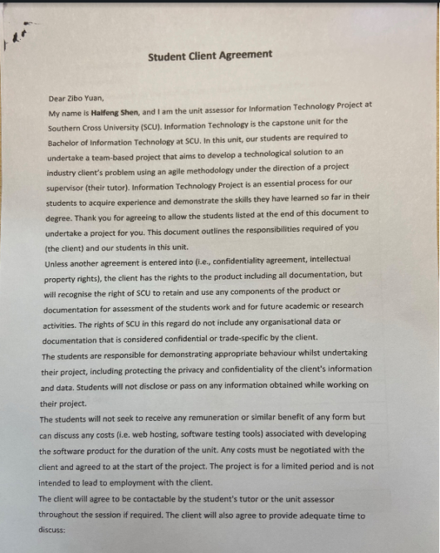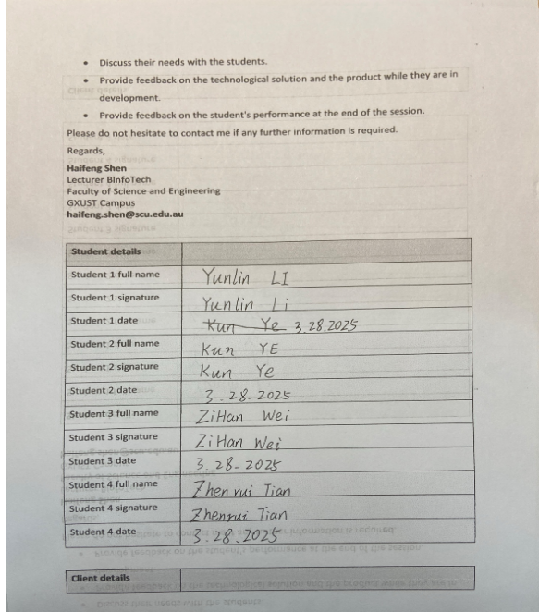

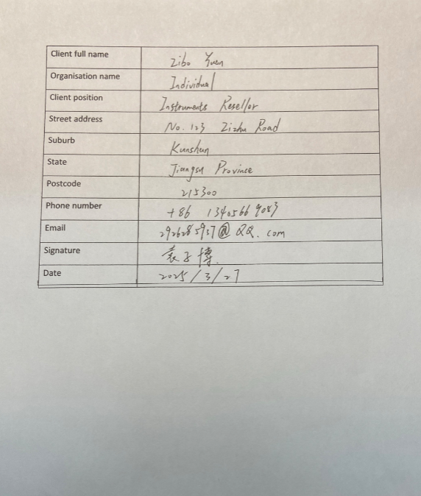

# 2 Iteration 1

## 2.1 Iteration Overview

### 2.1.1 Yunlin Li (Team Leader)

**Project Management:**

* Created the Sprint 1 backlog (20 user stories), assigned tasks, and tracked progress.
* Ensured all issues had labels, priorities, and work logs.

**Documentation:**

* Authored the Design Documentation: System architecture diagrams, ERD, AR storyboards.
* Drafted the Client Documentation: Training guides, Tencent Cloud deployment protocols.
* Coordinated Client Meeting Notes 1 (signed PDF attached).

**Product Development:**

* Implemented the AR Core functionality (guitar fret tracking via AR Core SDK).
* Integrated Tencent Cloud APIs for user data storage.

### 2.1.2 Kun Ye(Team Member)

**Documentation:**

* Designed Testing Documentation 1: Authored 15+ test cases for AR functionality.
* Contributed to Client Documentation: UI customization guidelines.

**Project Management:**

* Logged 40+ hours of work on front-end tasks (e.g., UI wire frames, button interactions).
* Resolved 8 bugs flagged during testing (e.g., AR calibration failure).

**Product Development:**

* Built Unity UI components: Login screen, practice session dashboard.
* Optimized AR rendering for low-end devices (reduced GPU load by 30%).

### 2.1.3 Zihan Wei (Team Member)

**Documentation:**

* Developed Development Documentation 1: Code base summary, third-party attributions.
* Designed Database Schema: ERD, MySQL scripts, backup protocols.

**Project Management:**

* Managed back-end tasks: API endpoints, database migration.
* Logged 35+ hours of work (e.g., back end services).

**Product Development:**

* Built Node.js REST API for user authentication and sheet music upload.
* Configured Web Services for calculable back-end hosting.

### 2.1.4 Zhenrui Tian (Client Liaison)

**Documentation:**

* Compiled Client Meeting Notes 1: Summarized design feedback and feature requests.
* Translated client requirements into Jira user stories (e.g., "Multi-language support").

**Project Management:**

* Facilitated client demos and documented acceptance criteria.

**Product Development:**

* Conducted beta testing with 10+ end-users and compiled feedback.
* Front-end UI design and implement

## 2.2 Design Documentation

### 2.2.1 Iteration Design Goals

**Core Functionality:**

* Real-time AR guitar position tracking and hand placement guidance via smartphone camera.
* Video recording of practice sessions with local storage/sharing capabilities.
* MVP version of sheet music upload and sharing platform.
* Tech Stack Integration:
* Unity Engine (2021.3.1f1) for AR environment setup.
* ARCore XR Plugin (4.2.10) for image recognition and plane tracking.
* Tencent Cloud ECS for backend deployment (user data storage and sheet music sharing).

### 2.2.2 System Architecture Diagram

#### 2.2.2.1 Description:

**Front-end:**

* Unity + C# Scripts: Handles AR image recognition and user interaction logic.
* Android Compatibility: Minimum Snapdragon 480 + 8GB RAM (supports 90% of mainstream devices).

**Back-end:**

* Tencent Cloud ECS: Hosts MySQL 8.0 database and Node.js REST API.
* Data Flow: User action → HTTP request → Cloud processing → Returns AR coordinates/sheet music data.

**Third-Party Services:**

* AR Core SDK: For guitar fret board feature recognition and spatial anchors.
* Aliyun OSS: Stores user-uploaded sheet music files (PDF/image formats).

### 2.2.3 AR Interaction Design (Storyboard)

**User Flow:**

* Launch App → Camera scans guitar neck(based on featured image sticked on guitar) → AR markers highlight fretboard positions.
* User follows AR prompts to press strings → Real-time feedback (red=incorrect, green=correct).
* Post-session report generation (accuracy, duration) → Option to save video or share to platforms.

**Technical Implementation:**

Image Recognition:

* ARCore’s Tracked Image Manager detects guitar position
* Use preordered offsets to set dots on guitar

### 2.2.4 Future Iteration Road Map

**User Feedback-Driven Improvements:**

* Optimize AR tracking latency (<100ms target) based on beta testing.
* Add multilingual support (priority: Chinese, English, Spanish).
* Technical Upgrades:
* Migrate to Unity 2022 LTS for DOTS multi threading optimization.
* Explore Web AR solutions (e.g., 8th Wall) to reduce device dependency.

### 2.2.5Business Rules:

#### 2.2.5.1 User Roles and Permissions

|  |  |  |
| --- | --- | --- |
| Role | Permissions | Restrictions |
| Guest | Browse public sheet music. | Cannot upload content or save progress. |
| Registered User | Upload/edit sheet music, save practice records, share videos. | Cannot delete others' content. |
| Administrator | Review/delete content, ban users, access analytics data. | Account access requires two-factor authentication (2FA). |

#### 2.2.2.2 User Registration and Authentication

|  |  |  |
| --- | --- | --- |
| Rule ID | Description | Validation/Constraints |
| BR-001 | Email Format | Must follow [user@domain.com](mailto:user@domain.com#tdsub) format. Regular expression: ^[a-zA-Z0-9._%+-]+@[a-zA-Z0-9.-]+\.[a-zA-Z]{2,}$. |
| BR-002 | Password Policy | At least 8 characters, including 1 uppercase letter, 1 number, and 1 special character. |
| BR-003 | Account Lockout | Account temporarily locked after 5 consecutive failed login attempts (30-minute cool-down period). |

#### 2.2.2.3 AR Features

|  |  |  |
| --- | --- | --- |
| Rule ID | Description | Technical Constraints |
| BR-004 | Real-time Tracking | AR image recognition must process at 30 FPS to ensure smooth guidance. Latency < 100 milliseconds. |
| BR-005 | Device Compatibility | Requires devices supporting Android 11+ with a depth-sensing camera (e.g., Google Pixel 4+, Samsung Galaxy S20+). |

#### 2.2.2.4 Data Security and Privacy

|  |  |  |
| --- | --- | --- |
| Rule ID | Description | Implementation |
| BR-06 | Password Storage | Hash passwords using SHA-256 + salt. Do not store passwords in plain text. |
| BR-07 | Data Encryption | All user data (including practice records) is encrypted during transmission (TLS 1.3) and at rest (AES-256). |
| BR-08 | Third-party Access | Do not share user data without explicit consent. Complies with GDPR opt-in/opt-out controls. |

#### 2.2.2.5 Feedback and Support

|  |  |  |
| --- | --- | --- |
| Rule ID | Description | Workflow |
| BR-09 | Error Reporting | Users submit issues via an in-app form. Priorities: Severe (respond within 24 hours), High (within 48 hours), Medium (within 7 days). |
| BR-010 | Feature Requests | Requests are logged in the Jira backlog. Voted on by the user community; top 3 requests each month are prioritized for the sprint plan. |

#### 2.2.2.6 Sheet Music Management (Future Iteration)

|  |  |  |
| --- | --- | --- |
| Rule ID | Description | Validation/Constraints |
| BR-011 | File Upload | Supported formats: .pdf, .png, .jpeg. Maximum file size: 10MB. |
| BR-012 | Copyright Compliance | Users must confirm ownership/rights to uploaded content. Automatically flag copyrighted material via SHA-256 hash comparison. |
| BR-009 | Public Sharing | Shared sheet music is visible to all users unless marked as "Private." |

#### 2.2.2.7 Monetization (Future Iteration)

|  |  |  |  |  |
| --- | --- | --- | --- | --- |
| Rule ID | Description | | Policy | |
| Rule ID | | Description | | Policy | |
| BR-015 | | Premium Subscription | | Unlocks advanced AR modes and exclusive sheet music. Auto-renewing with a 7-day free trial offered. | |
| BR-016 | | Refund Policy | | Full refund available within 14 days of purchase if the subscription is unused. | |

### 2.2.6 Class Diagram

**Back-end Diagram**

The diagram below shows the back-end ExpressJS APIs and MySQL database structure

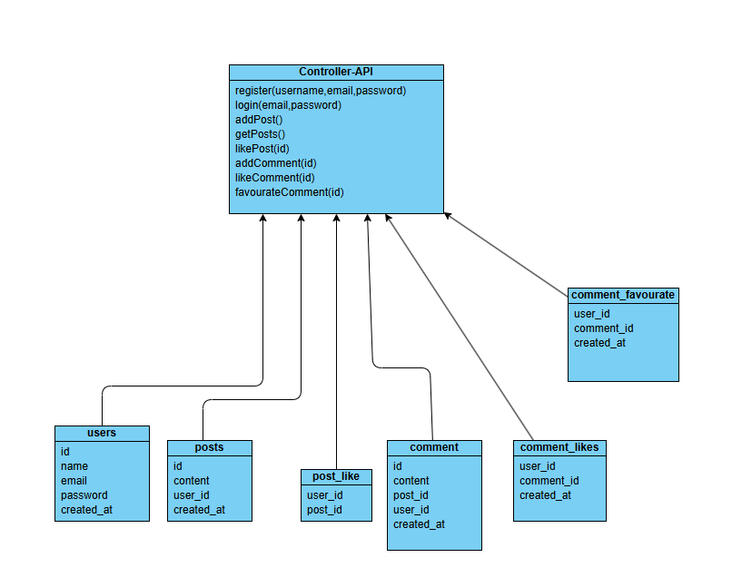

**Frontend Diagram**

The diagrams below shows the main structures of those components class(typescript file) and those services relationships.

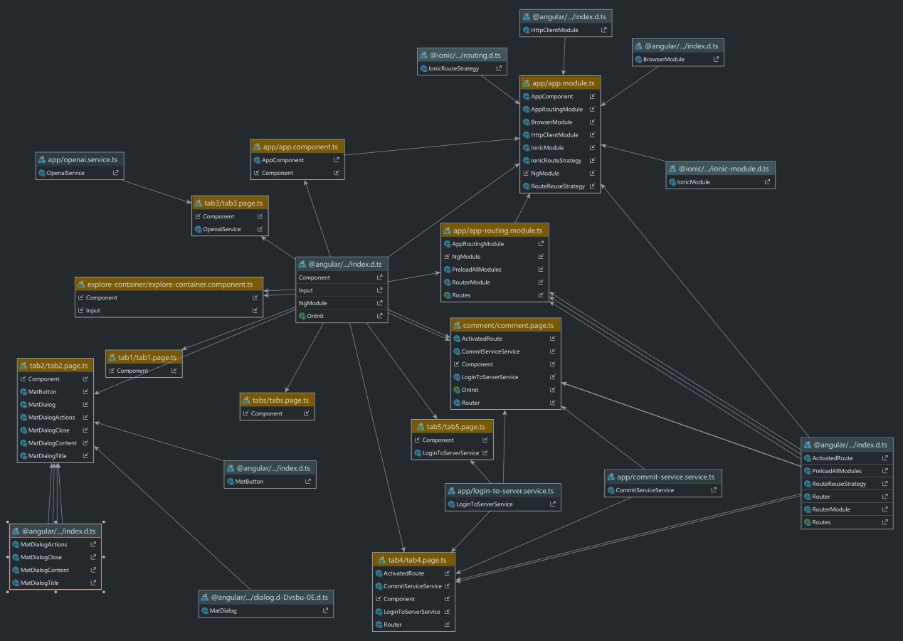

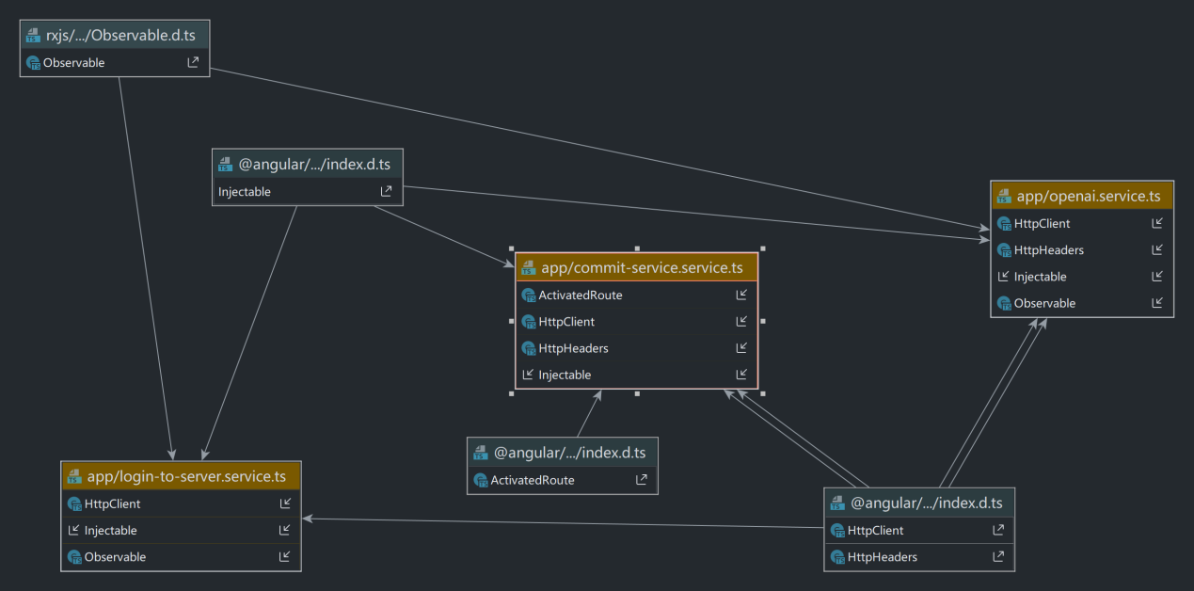

### 2.2.7 The diagram showing the database design

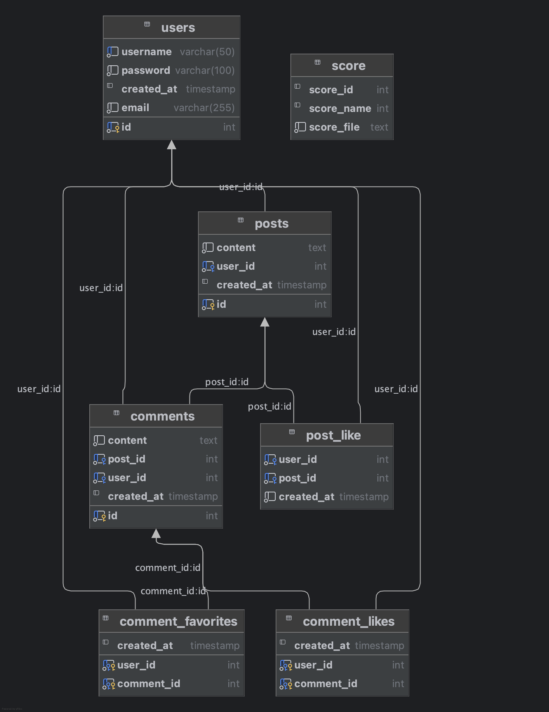

### 2.2.8 API Request

#### 2.2.8.1 User Side

|  |  |  |
| --- | --- | --- |
| **Req Method** | **Request Command** | **Description** |
| GET | /api/posts | Get all posts |
| GET | /api/post/{id} | Get post by id |
| POST | /api/post | Add a post to the database |
| POST | /api/post/{id}/favourate | Add a favourate of a post |
| POST | /api/comment/{id} | Add a comment to the selected post |
|  |  |  |
| GET | /api/comments | Get all comments |
| GET | /api/comment/{id} | Get comment by id |
| POST | /api/comments/{id}/like | Add a like of the comment |
| POST | /api/comments/{id}/favourate | Add a favourate of a comment |
|  |  |  |
| GET | /api/scores | Get all scores |
| GET | /api/score/{id} | Get score by id |
| POST | /api/score | Add a music score |
|  |  |  |
| POST | /api/login | User login |
| POST | /api/register | User register |
| PUT | /api/profile | Update user detail |

#### 2.2.8.2 Admin Side

|  |  |  |
| --- | --- | --- |
| **Req Method** | **Request Command** | **Description** |
| GET | /api/admin/users | Show all users |
| GET | /api/admin/user/{id} | Show specfic user details |
| PUT | /api/admin/resetPassword/{id} | Reset user password |
|  |  |  |
| DELETE | /api/admin/post/{id} | Delete a post |
|  |  |  |
| DELETE | /api/admin/comment/{id} | Delete a comment |
|  |  |  |
| DELETE | /api/admin/score/{id} | Delete a score |
|  |  |  |
| POST | /api/admin/login | Admin login |

### 2.2.9 storeboard

AR Page:

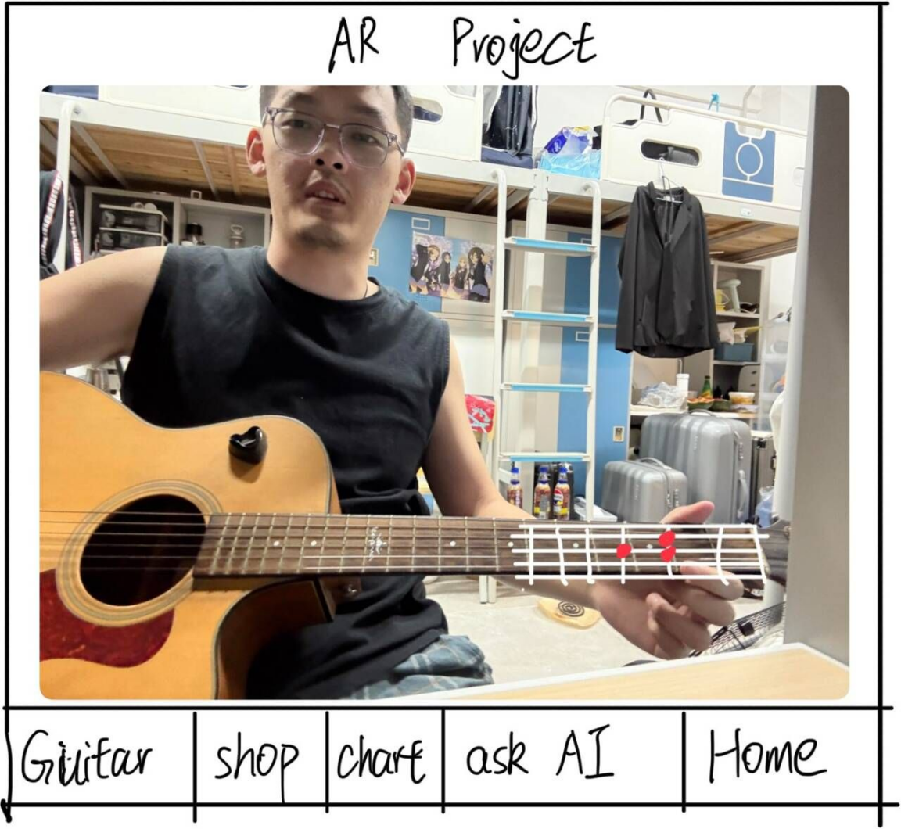

Shop page:

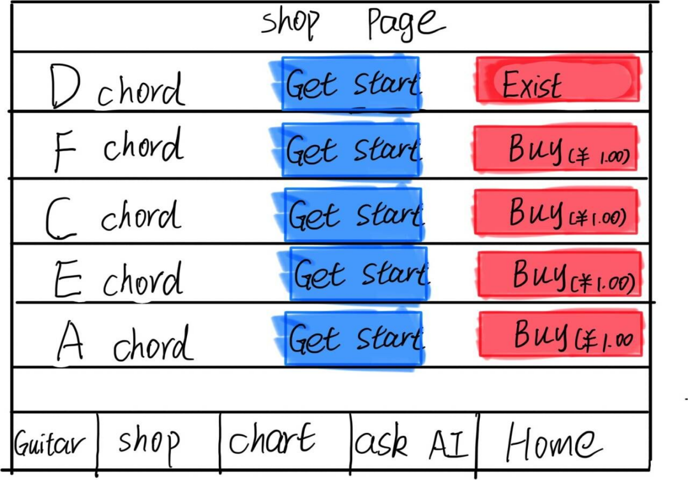

Chat Page:

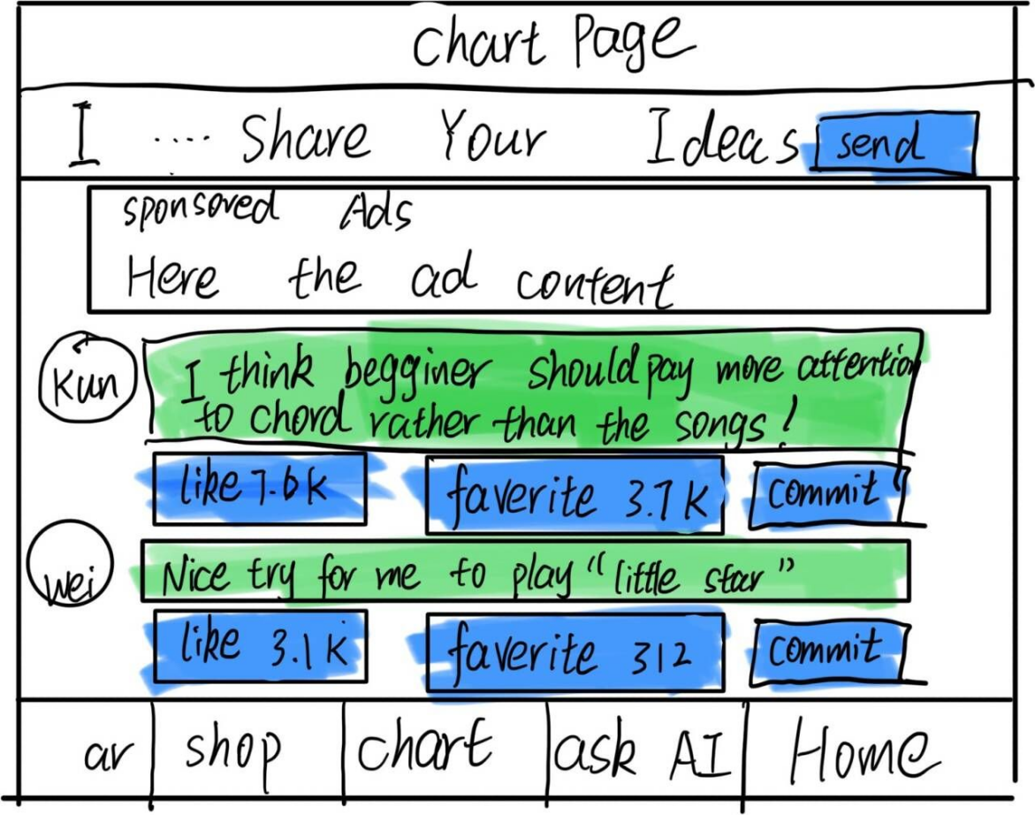

Chart page(When you click Commit button to commit other people’s idea)

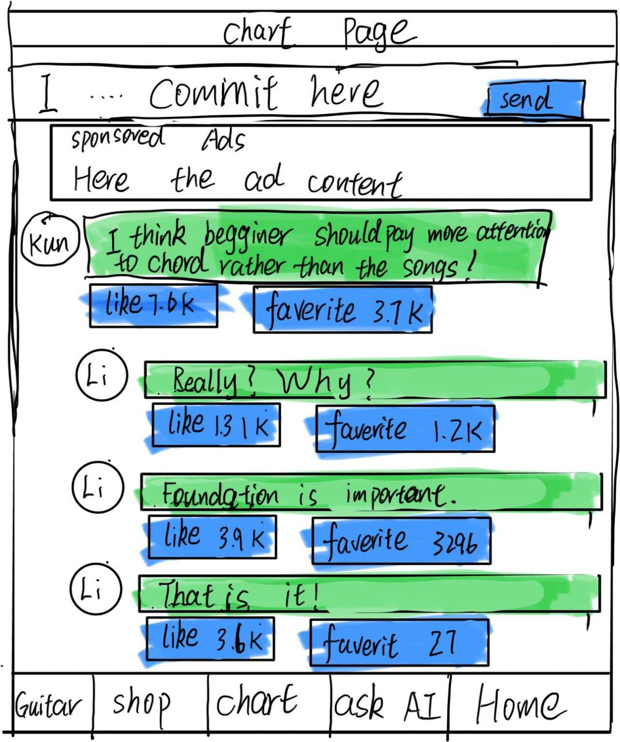

Ask AI page

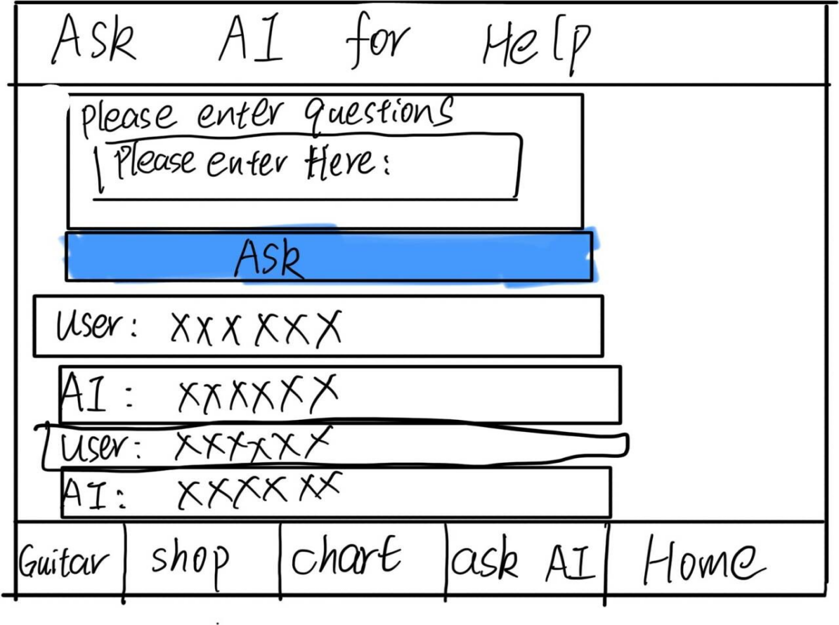

Home Page

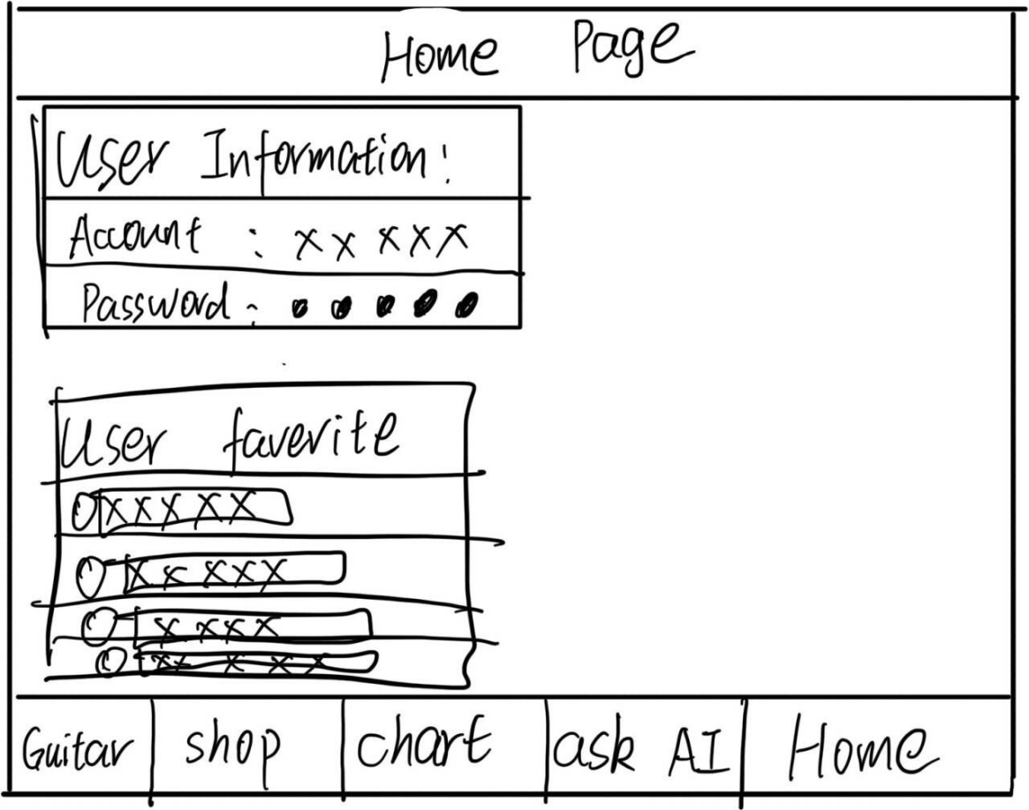

login page

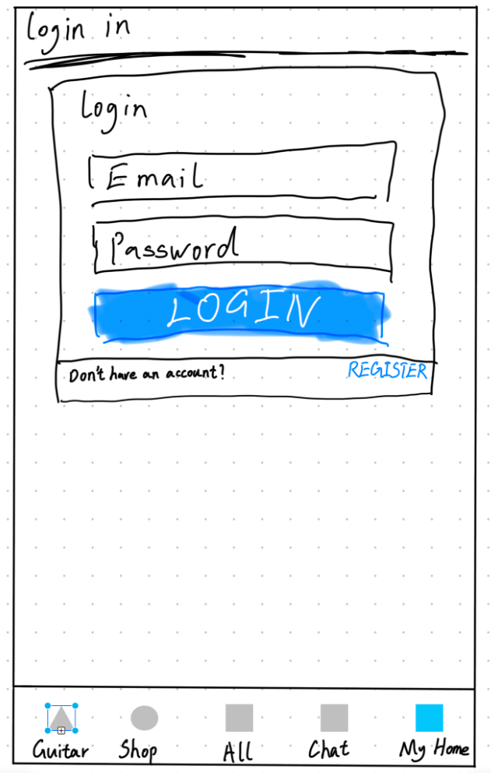

register page

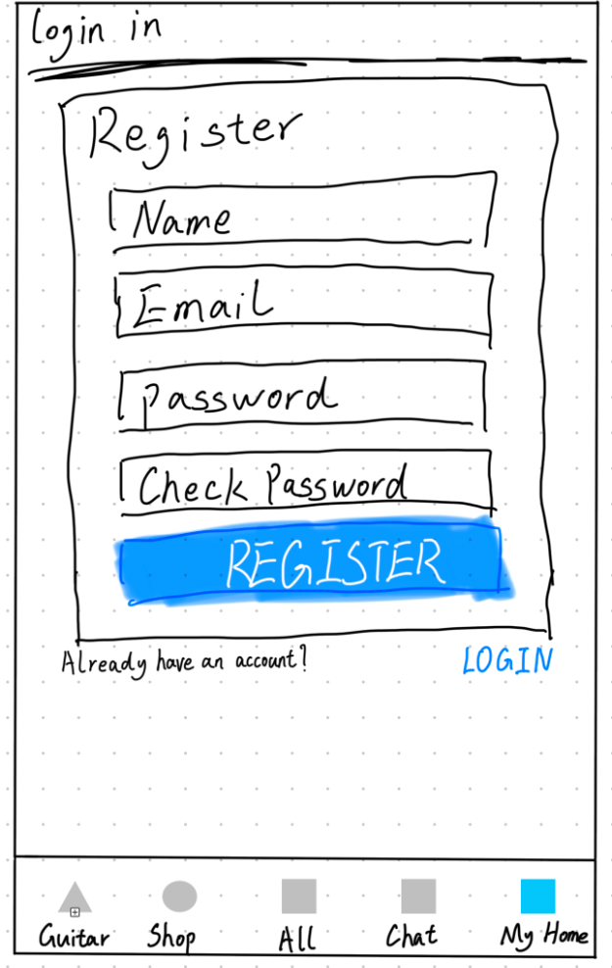

## 2.3 Development Documentation

### 2.3.1 Summary of Work Done in This Iteration

In this iteration, our team has made significant progress on the development of the guitar learning mobile app. The work carried out in this iteration can be summarized as follows:

### 2.3.2 Front-end Development

We designed and implemented the front-end of the application, focusing on creating a user-friendly interface that allows users to interact with the app seamlessly. The front-end development involved the following tasks:

Designed the overall layout and structure of the application.

Implemented the login and registration pages.

Created the main interface for users to access different features of the app.

Integrated the AR functionality into the front-end.

### 2.3.3 Register and Login Subsystem

We developed the login subsystem, which enables users to securely access their accounts. This includes:

Implementing user authentication and authorization mechanisms.

Creating the necessary back-end APIs to handle login requests.

Ensuring secure storage and management of user credentials.

Allow users to register and log into the system.

Detect duplicate Username and email fields to prevent duplication.

### 2.3.4 AR Guitar Tracking

One of the core features of our app is the AR guitar tracking functionality. We have successfully implemented the following:

Developed algorithms to detect the position of the guitar using the phone's camera.

Implemented AR visualizations to guide users on where to place their hands on the fretboard.

Conducted initial testing and optimization of the AR tracking system.

### 2.3.5 Local AI Integration

We have integrated a local AI model into our app, similar to ChatGPT, allowing users to interact with an intelligent chat interface directly within the application. The AI model runs locally on the user's device, ensuring data privacy and offline functionality. We have developed the necessary APIs and interfaces to connect the AI model with our app's front-end.

### 2.3.6 Shop Feature Development

We have implemented a new shop feature that allows users to browse and view songs. The shop feature includes the following functionalities:

* **Song Listing**: Songs are displayed in a list format on the shop tab.
* **Song Selection**: Users can click on any song in the list to view its score.
* **Song Score Display**: When a song is selected, a dialog pops up displaying the score of the song.

### 2.3.7 Version Control with GitHub

To manage our code base and facilitate collaboration among team members, we used GitHub for version control. The following repositories are relevant to this iteration:

[AR Track Project](https://github.com/Naivebody/Guitar.git#tdsub) - This repository contains the code for the AR tracking functionality of the app.

[Frontend Project](https://github.com/Missacca/final-project-angular.git#tdsub) - This repository holds the front-end code of the application.

[Backend Project](https://github.com/RealTakoChannel/server-side.git#tdsub) - This repository holds the back-end codes of the application.

### 2.3.8 Code Development and References

In this iteration, we developed a significant amount of original code to bring our project to life. However, we also leveraged some existing code and libraries to enhance our development process and provide a better user experience. Below is a list of the code we developed and the external code we referenced:

Original Code:

* Developed the core logic for the AR guitar tracking system.
* Implemented the frontend interface and user interaction features.
* Created the login and authentication mechanisms.
* Integrated the local AI model into the app.
* Developed the shop feature, including song listing and score display functionalities.

Referenced Code:

Utilized the Angular framework for frontend development. The Angular framework is an open-source project developed by Google and the Angular community. We used Angular CLI to generate components, services, and other artifacts as needed for our project.

Incorporated the ARCore library for AR functionality. ARCore is a Google library that provides the necessary tools and APIs for building AR applications on Android devices.

Used the AR Foundation track module for image tracking. The AR Foundation track module is an open-source project that provides a robust platform for integrating augmented reality features. We used the following repository for the AR Foundation track module: [ARFoundationQRTracking-Unity](https://github.com/HoloLabInc/ARFoundationQRTracking-Unity#tdsub) .

Integrated the Jan AI model for local AI functionality. Jan is a free, open-source alternative to ChatGPT that runs completely offline and provides an OpenAI-compatible API through its Cortex server. For more information, visit [Jan](https://www.unite.ai/best-llm-tools-to-run-models-locally/#tdsub) .

By combining our original code with these well-established libraries and frameworks, we have been able to create a robust and feature-rich application that meets the requirements of our users.

### 2.3.9 Source Code Availability

The source code for this iteration is available in the following GitHub repositories:

[AR Track Module](https://github.com/Naivebody/Guitar.git#tdsub)

[Frontend Module](https://github.com/Missacca/final-project-angular.git#tdsub)

[Backend Module](https://github.com/RealTakoChannel/server-side.git#tdsub)

Team members and stakeholders can access the code, explore the implementation details, and provide feedback or suggestions for further improvements.

## 2.4 Testing Documentation

### 2.4.1 Overall

Testing documentation for iteration 1 includes:

* The normal display of UI elements and the normal switching and jumping of pages in the front-end prototype.
* Deployment and Implementation of AR Recognition and Tracking Function
* Login sub-System function(login & register)
* Backend API Test
* AI function Test
* Shop function Test

### 2.4.2 Frontend prototype test

|  |  |  |
| --- | --- | --- |
| **Test ID** | | **001** |
| User story | | [descriptITP125GX5-51: As an app user, I hope I can click the tab to jump to the AR guide page so that I can view AR guide funcition page已完成](https://scu-it.atlassian.net/browse/ITP125GX5-51#tdsub)  [descriptITP125GX5-52: As an app user, I hope I can click the tab to jump to the AI page so that I can view the AI page.已完成](https://scu-it.atlassian.net/browse/ITP125GX5-52#tdsub)  [descriptITP125GX5-53: As an app user , I hope I can click the tab to jump to the shop page so that I can view the page of chords or songs已完成](https://scu-it.atlassian.net/browse/ITP125GX5-53#tdsub)  [descriptITP125GX5-55: As an app user, I hope I can click the tab to jump to the community page so that I can view the page on the app.已完成](https://scu-it.atlassian.net/browse/ITP125GX5-55#tdsub)  [descriptITP125GX5-54: As an app user, I hope I can click the tab to jump to the login page so that I can login my account.已完成](https://scu-it.atlassian.net/browse/ITP125GX5-54#tdsub) |
| Function owner | | Yunlin Li |
| Test By | | Zhenrui Tian |
| Status | | Pass-- Ionic App can be successfully shown and implemented and all tabs can successfully jump to each other. |
| Setup | | no |
| Instructions | | If need to use on phone,use Capacitor to deploy the project on android phones  If test it on laptop, just use ionic serve to test. |
| Expected Results | | App can be run, all UI elements such as buttons and tabs can be displayed well and can use. |
| Description | | tabs can jump and app can be use |
| Date | | 2025.4.15 |
| Test ID | 002 | |
| User story | [descriptITP125GX5-62: As an app user, I hope I can write my account information on app so that I can use those information to login.已完成](https://scu-it.atlassian.net/browse/ITP125GX5-62#tdsub)  [descriptITP125GX5-63: As an app user, I hope I can write the information for registration on app so that I can use those information to register.已完成](https://scu-it.atlassian.net/browse/ITP125GX5-63#tdsub)  [descriptITP125GX5-56: As an app user, I hope I can click the button to switch the card of login so that I can register a new account if i dont have it.已完成](https://scu-it.atlassian.net/browse/ITP125GX5-56#tdsub) | |
| Function owner | Yunlin Li | |
| Test By | Kun Ye | |
| Status | Pass-- The login card and the register card can be switched properly. All input box can write in words. | |
| Setup | no | |
| Instructions | If need to use on phone,use Capacitor to deploy the project on android phones  If test it on laptop, just use ionic serve to test. | |
| Expected Results | App can be run, register button can work and jump to login and register card.  Input box works successfully. | |
| Description | The login card and the register card can be switched properly. All input box can write in words. | |
| Date | 2025.4.15 | |

### 2.4.2 AR Tracking function test

|  |  |  |
| --- | --- | --- |
| Test ID | | 003 |
| User story | | [descriptITP125GX5-35: As a developer, I hope I can use unity to recognize the featured image so that I can use the image to track the whole guitar.已完成](https://scu-it.atlassian.net/browse/ITP125GX5-35#tdsub) |
| Function owner | | Kun Ye |
| Test By | | Zhenrui Tian |
| Status | | Pass-- Image can pass the arcoreimg evaluation and get 100 scores(75 is ok) |
| Setup | | Install arcoreimg tool from Github |
| Instructions | | Need to use commands to use the tool on Powershell or cmd terminal |
| Expected Results | | Get above 75 scores, if not, need to find new featured image |
| Description | | Get 100 scores |
| Recommendation | | Not yet |
| Date | | 2025.4.15 |
| Test ID | 004 | | |
| User story | [descriptITP125GX5-58: As a developer, I hope I can use unity to track the movement of the featured image so that I can make sure when user slightly move the guitar, the fretboard dots can adapt.已完成](https://scu-it.atlassian.net/browse/ITP125GX5-58#tdsub) | | |
| Function owner | @Kun Ye | | |
| Test By | @Zhenrui Tian | | |
| Status | Pass-- Track function can be work and cube can be tracked on the featured image | | |
| Setup | Make sure the phone is based on android and the system is above android 7.  Its camera need to support arcore  Setup test app apk file | | |
| Instructions | Use phone to setup apk file and run. Let camera toward to the image.  If the cube displayed, slightly move the image and test the tracking function. | | |
| Expected Results | Cube can be displayed on the centre of the image.  When slightly shake the image, the cube can follow the image to make sure it is on the centre. | | |
| Description | As the expected results, it can work well | | |
| Recommendation | If can, improve the accuracy of tracking. | | |
| Date | 2025.4.15 | | |

### 2.4.3 Backend prototype test

|  |  |  |  |
| --- | --- | --- | --- |
| Test ID | 007 | | |
| User story | [descriptITP125GX5-59: As a developer, I hope I can receive the login request from user at backend so that I can return the response and result to user.已完成](https://scu-it.atlassian.net/browse/ITP125GX5-59#tdsub) | | |
| Function owner | Zhihan Wei | | |
| Test By | Zhihan Wei | | |
| Status | Pass -- The ExpressJS application successfully receives the request sent, correctly finds the data in the database and returns the login token | | |
| Setup | Create a WebStorm HTTP Request | | |
| Link to Bug Issue (If fails) | Passed | | |
| Instructions | Write test code to call the login API and send the request  ### POST test login  POST frp-aim.com:56647/api/login  content-type: application/json  {  "email": "873100637@qq.com",  "password": "123456"  } | | |
| Expected Results | HTTP Response Code: 200 OK  Response Body include:  {  "message": "success login",  "email": "your entered email",  "token": "server response token here"  } | | |
| Description | The result need have HTML 200 OK | | |
| Date | 2025.4.16 | | |
| Test ID | | 008 | | |
| User story | | | [https://scu-it.atlassian.net/browse/ITP125GX5-60](https://scu-it.atlassian.net/browse/ITP125GX5-60#tdsub) | |
| Function owner | | | Zihan Wei | |
| Test By | | | Zhihan Wei | |
| Status | | | Pass -- The ExpressJS application successfully receives the request sent, correctly stores the user input data. | |
| Setup | | | Create a WebStorm HTTP Request | |
| Link to Bug Issue (If fails) | | | Passed | |
| Instructions | | | Write test code to call the login API and send the request  ### POST register  POST frp-aim.com:56647/api/register  content-type: application/json  {  "username": "username here",  "email": "email here",  "password": "password here"  } | |
| Expected Results | | | HTTP Response Code: 201 Created  Response Body include:  {  "id": auto generated id should be here  } | |
| Description | | | The result need have HTML 201 Created | |
| Date | | | 2025.4.16 | |

### 2.4.4 Login System

|  |  |
| --- | --- |
| TestID | 005 |
| Function owner | Zihan Wei Yunlin Li |
| Test By | Zhihan Wei |
| Status | Pass-- All login function can work and user can receive the login success message.  Register function can work and backend can receive the register request and give response, user can receive register success message and use the new account to log in. |
| Setup | Ionic |
| Expected Results | When user input his account and correct password and click log in button. It will show the message of success. If not , return error message.  When user input his information and click the register buttton, it will show the message of success and backend can see the database update. |
| Description | As the expected results, it can work well |
| Recommendation | no |
| Date | 2025.4.16 |

### 2.4.5 AI function

|  |  |
| --- | --- |
| **Test ID** | **006** |
| User story | [descriptITP125GX5-108: As an app user, I hope I can use AI so that I can solve my problems when others can not help me on comment page.](https://scu-it.atlassian.net/browse/ITP125GX5-108#tdsub) |
| Function owner | Yunlin Li, Zihan Wei |
| Test By | Zhenrui Tian |
| Status | Pass-- Questions can be replied by AI model. |
| Status | Pass-- Questions can be replied by AI model. |
| Setup | no |
| Instructions | Use the AI tab to ask questions to AI models |
| Expected Results | Questions can be replied properly. |
| Description | As the expected results, it can work well |
| Date | 2025.4.15 |

### 2.4.6 Shopping Function

|  |  |
| --- | --- |
| Test ID | 009 |
| User story | [descriptITP125GX5-115: As an app user, I hope all the songs can list on the shop tab so that I can view and pick which songs I like.已完成](https://scu-it.atlassian.net/browse/ITP125GX5-115#tdsub)  [descriptITP125GX5-114: As an app user, I hope I can click the songs buttons in shop tab so that I can view the scores I want.已完成](https://scu-it.atlassian.net/browse/ITP125GX5-114#tdsub) |
| Function owner | Yunlin Li, Zihan Wei |
| Test By | Zhenrui Tian |
| Status | Pass-- All songs button can be clicked and all songs score can displayed on the dialog.  Songs are listed on the shop tab by a list. |
| Setup | Ionic |
| Instructions | If need to use on phone,use Capacitor to deploy the project on android phones  If test it on laptop, just use ionic serve to test. |
| Expected Results | All songs are listed on shop tab  All songs can be clicked and dialog shows its score. |
| Description | As the expected results, it can work well |
| Date | 2025.4.15 |

## 2.5 Client Documentation

### 2.5.1 Client Training Materials

Objective: Empower clients (instrument resellers) to onboard end-users and resolve basic issues.

**App Installation:**

1. Install via the provided APK.
2. Minimum requirements: Android 11+, 8GB RAM, depth-sensing camera.

**First-Time Setup:**

1. Open the app → Accept permissions (camera, storage).
2. Register via email.
3. Calibrate AR by scanning the guitar neck (follow on-screen prompts).

**Key Features Demo:**

AR Guidance: Point the phone camera at the guitar neck to view real-time fretboard markers.

Practice Recording: Tap "Record" → Play → Save/Share via "My Sessions".

Sheet Music Upload: Navigate to "Library" → "Upload" → Select file (PDF/PNG/JPEG).

### 2.5.2 Reference Manuals

Objective: Provide technical details for long-term maintenance and scalability.

#### 2.5.2.1 System Architecture Overview

|  |  |  |  |
| --- | --- | --- | --- |
| Component | Technology Stack | Version | Notes |
| Frontend | Unity Engine, ARCore XR Plugin | 2021.3.1f1, 4.2.10 | Requires depth-sensing camera. |
| Backend | Node.js, MySQL | 8.0, 16.14.0 | API endpoints documented [here](https://scu-it.atlassian.net/wiki/spaces/ITP125GX5/pages/133136518/Client+Documentation). |
| Database | MySQL, Aliyun OSS | 8.0 | Automated daily backups at 2:00 AM (GMT+8). |

#### 2.5.2.2 Credentials & Access

|  |  |  |
| --- | --- | --- |
| Service | Credential Storage | Responsible Party |
| Tencent Cloud | LastPass (shared vault) | Client IT Manager |
| Developer Account | 1Password | Development Team |
| ARCore API Key | Confluence (restricted page) | Project Lead |

#### 2.5.2.3 Maintenance Protocols

**Server Updates:**

* Monthly security patches applied via the cloud console.
* Downtime window: Sundays 12:00 AM – 2:00 AM (GMT+8).

**Data Backup:**

* Automated daily backups to OSS.
* Retention policy: 30 days.

**Third-Party Dependencies:**

* ARCore SDK updates tracked via the Unity Dashboard.
* License renewals: Managed by the client’s procurement team (alert 30 days before expiry).

### 2.5.3 Client-Specific Customization

Objective: Tailor the app to align with client branding and sales strategies.

#### 2.5.3.1 Branding Integration

UI Customization:

* Replace default colors with the client’s brand palette (e.g., #2E7D32 for primary buttons).
* Upload custom logo via CMS.

Localization:

* Supported languages: English, Simplified Chinese.
* Add new languages via a file.

#### 2.5.3.2 Sales Enablement

**Demo Mode:**

1. Preload with popular songs for in-store demonstrations.
2. Activate via "Settings → Demo Mode".
3. Promotional Bundles:
4. Coupon codes for app premium features bundled with guitar purchases.

### 2.5.4 Support & Escalation

Objective: Ensure timely resolution of technical issues.

|  |  |  |
| --- | --- | --- |
| Issue Type | Contact Channel | SLA |
| Critical (App crash, data loss) | Phone: +86 13839659020 | 2-hour response, 24-hour fix. |
| High (AR tracking failure) | Service Desk: Submit Ticket | 12-hour response, 48-hour fix. |
| General (UI bugs, feature requests) | Comments (@Team) | 24-hour response, added to backlog. |

## 2.6 Client Meetings

### 2.6.1 Date

2025.4.16

### 2.6.2 Goals

Review AR core functionality progress and address technical challenges.

Validate UI/UX design with client feedback.

Finalize beta testing scope and timeline.

### 2.6.3 Discussion topics

|  |  |  |  |
| --- | --- | --- | --- |
| Time | Item | Presenter | Notes |
| 10:00 | Project Progress Overview | Yunlin Li | AR fret tracking achieves 85% accuracy in optimal lighting. |
| 10:20 | AR Functionality Demo | Zihan Wei | Demo showcased real-time hand placement guidance.  Client noted minor latency (~150ms) in low-light conditions. |
| 10:45 | UI/UX Design Review | Zihan Wei | Agreed to add a "Help" overlay for first-time users. |
| 11:10 | Beta Testing Plan | Kun Ye | Client will recruit testers from their customer base. |
| 11:30 | Technical Challenges | Yunlin Li | ARCore SDK compatibility issues with Xiaomi devices require  fixes.  Tencent Cloud costs exceeded budget by 12%; need optimization. |

### 2.6.4 Action items

Optimize AR latency for low-light scenarios

Redesign UI buttons per client feedback

Resolve Xiaomi device compatibility

Submit beta tester list

### 2.6.5 Decisions

UI Changes Approved

Increase button size by 20% in tutorial screens.

Add multilingual support (Chinese/English) to beta version

# 3 Iteration 2

## 3.1 Iteration Overview

### 3.1.1 Team Member Contributions Summary

#### 3.1.1.1 Yunlin Li

**Front-end**

* Complete User Login and Register system
* Create a user check-in system
* Make it possible for users to see the Post they have posted
* Make features that allow users to see their own favourite posts
* Interface that lets users change their passwords
* Create admin side to manage user account

**Back-end**

* Add the appropriate columns to the database
* Building a check-in system API
* Add API for querying posts that have been published by users
* Add API for querying user favourite posts
* API that lets users change their passwords
* API for the admin side to manage user account

#### 3.1.1.2 Kun Ye

* AR Function
* Guitar Chord Prefab Production
* Creating tracking images
* Image Tracking with AR Fundation
* Create functions to let users switch chord displays
* Deploy AR Application

#### 3.1.1.3 Zihan Wei

**Front-end**

* Create a page where can get a list of songs and tutorials
* Create a view that can display chords and tutorials
* Creating a song management interface for the admin side
* Renders lyrics and chords on the front end
* Access to AI chatbots

**Back-end**

* Create an API to allow the front-end to get a list of songs.
* Create an API that gives song details to the front-end
* Implementation of song add/delete/review/search function in the administrator interface
* Access to AI big models to send to the front-end

#### 3.1.1.4 Zhenrui Tian

**Front-end**

* Provides users with the ability to post posts and comments
* Let users like posts and comments
* Lets users favourite posts
* Administrator panel provides the ability to find and delete posts.

**Back-end**

* Create an API for posting and commenting.
* Create an API that provides the ability to like comments and posts.
* Create an API that provides the ability to favourite posts
* Create an API to enable administrators to manage posts and comments.

## 3.2 Design Documentation

### 3.2.1 Iteration Design Goals

#### 3.2.1.1 Core Functionality:

Enhance AR guitar tracking with dynamic chord switching and improved user feedback for hand placement.

Expand the sheet music platform to include song lists, tutorials, user posts, comments, and social features (likes, favorites).

Introduce user account management (login, registration, password changes) and admin controls for content moderation.

#### 3.2.1.2 Tech Stack Integration:

* Continue using Unity Engine (2021.3.1f1) for AR and frontend development, with C# scripts for new UI features.
* ARCore XR Plugin (4.2.10) updated to support dynamic chord prefabs and tracking image improvements.
* Tencent Cloud ECS expanded for user authentication, social features, and song/tutorial storage.
* Integrate AI chatbot functionality via third-party APIs for user support.

### 3.2.2 System Architecture Diagram

#### 3.2.2.1 Description:

**Front-end:**

* Unity + C# Scripts: Manages AR chord display, user interfaces (login, song lists, posts, comments), and AI chatbot integration.
* Android Compatibility: Maintains minimum Snapdragon 480 + 8GB RAM, with optimizations for smoother UI rendering.

**Back-end:**

* Tencent Cloud ECS: Hosts MySQL 8.0 database (expanded for user profiles, posts, and songs) and Node.js REST API (new endpoints for social features, song management, and admin controls).
* Data Flow: User actions (e.g., liking a post, switching chords) → HTTP requests → Cloud processing → Returns updated AR data, song details, or social content.
* Third-Party Services:
* ARCore SDK: Enhanced for dynamic chord tracking and spatial anchors.
* Aliyun OSS: Stores sheet music, user posts, and tutorial files (PDFs, images, videos).
* AI Chatbot API: Provides real-time user support, integrated via back-end.

### 3.2.3. AR Interaction Design (Storyboard)

1. **User Flow:**

* Launch App → User logs in/registers → Camera scans guitar neck (using improved tracking images) → AR markers display chords with dynamic switching options.
* User follows AR prompts to press strings → Real-time feedback (red=incorrect, green=correct) with chord transition cues.
* Access song/tutorial list → Select song → View lyrics, chords, and tutorials synchronized with AR.
* Post-session: Generate report (accuracy, duration) → Share session video, post comments, or like/favorite content.

1. **Admin Flow:**

Moderate user posts, manage song database, and oversee user accounts.

1. **Technical Implementation:**

Image Recognition: ARCore’s TrackedImageManager uses updated tracking images (created by Kun Ye) for precise guitar neck detection.

Dynamic chord prefabs (Kun Ye) allow seamless switching between chord displays.

**Social Features:**

Unity UI renders posts, comments, and likes (Zhenrui Tian), with favoriting options (Yunlin Li, Zhenrui Tian).

Song/Tutorial Integration:

Song list and chord/lyric rendering (Zihan Wei) sync with AR prompts for practice.

### 3.2.4. Attribution of Non-Original Content

|  |  |  |
| --- | --- | --- |
| Component/Source | Purpose | Reference/License |
| ARCore XR Plugin | AR environment setup and chord tracking | Unity Asset Store |
| YOLOv4-tiny Model | Hand position detection | GitHub: AlexeyAB/darknet (MIT License) |
| Tencent Cloud SDK | Cloud data storage, user authentication, and API | Tencent Cloud Docs |
| AI Chatbot API | Real-time user support | Third-party provider (license TBD based on integration) |

### 3.2.5 Future Iteration Roadmap

**User Feedback-Driven Improvements:**

* Reduce AR tracking latency to <80ms based on user testing of dynamic chord switching.
* Expand social features with real-time notifications for likes/comments.
* Implement multilingual support (Chinese, English, Spanish) for UI and chatbot.

**Technical Upgrades:**

* Upgrade to Unity 2022 LTS for improved performance with DOTS multithreading.
* Integrate WebAR (e.g., 8th Wall) to support browser-based access.
* Enhance AI chatbot with guitar-specific knowledge base for advanced queries.

### 3.2.6 Team Member Contributions Summary

#### 3.2.6.1 Yunlin Li

**Front-end:**

* Developed user login/registration system with secure UI.
* Created check-in system to track engagement.
* Built interfaces for users to view their posts and favorited posts.
* Designed password change interface with validation.
* Implemented admin panel for user account management.

**Back-end:**

* Added database columns for check-ins, posts, and favorites.
* Built APIs for check-in system, user post queries, favorite post queries, password changes, and admin account management.

#### 3.2.6.2 Kun Ye

**AR Functionality:**

* Produced guitar chord prefabs for dynamic AR display.
* Created high-quality tracking images for guitar neck detection.
* Implemented ARCore image tracking with AR Foundation.
* Developed chord-switching functionality.
* Deployed AR app for Android compatibility.

#### 3.2.6.3 Zihan Wei

**Front-end:**

* Created song/tutorial list page with search and filter options.
* Built view for rendering chords, lyrics, and tutorials.
* Developed admin song management interface.
* Integrated AI chatbot for user support.

**Back-end:**

* Built APIs for song lists, song details, and admin song management (add/delete/review/search).
* Enabled backend access to AI models for chatbot functionality.

#### 3.2.6.4 Zhenrui Tian

**Front-end:**

* Developed interfaces for posting, commenting, liking, and favoriting posts.
* Created admin panel for post/comment moderation.

**Back-end:**

* Built APIs for posting, commenting, liking, favoriting, and admin post management.

### 3.2.7 Class Diagram

**Front-end Side:**

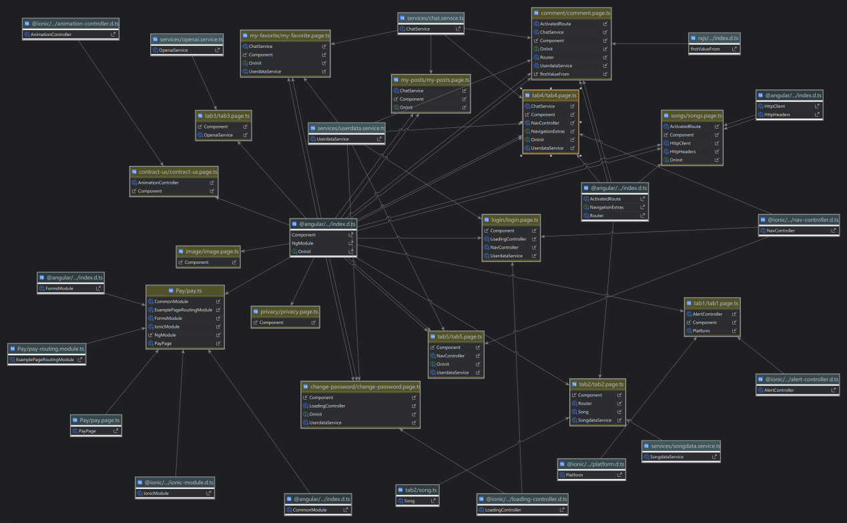

**Back-end Side:**

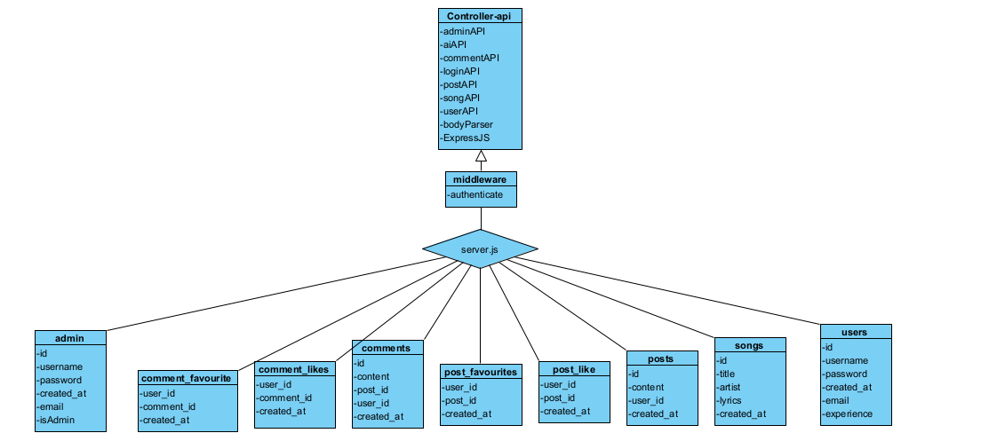

### 3.2.8 Database

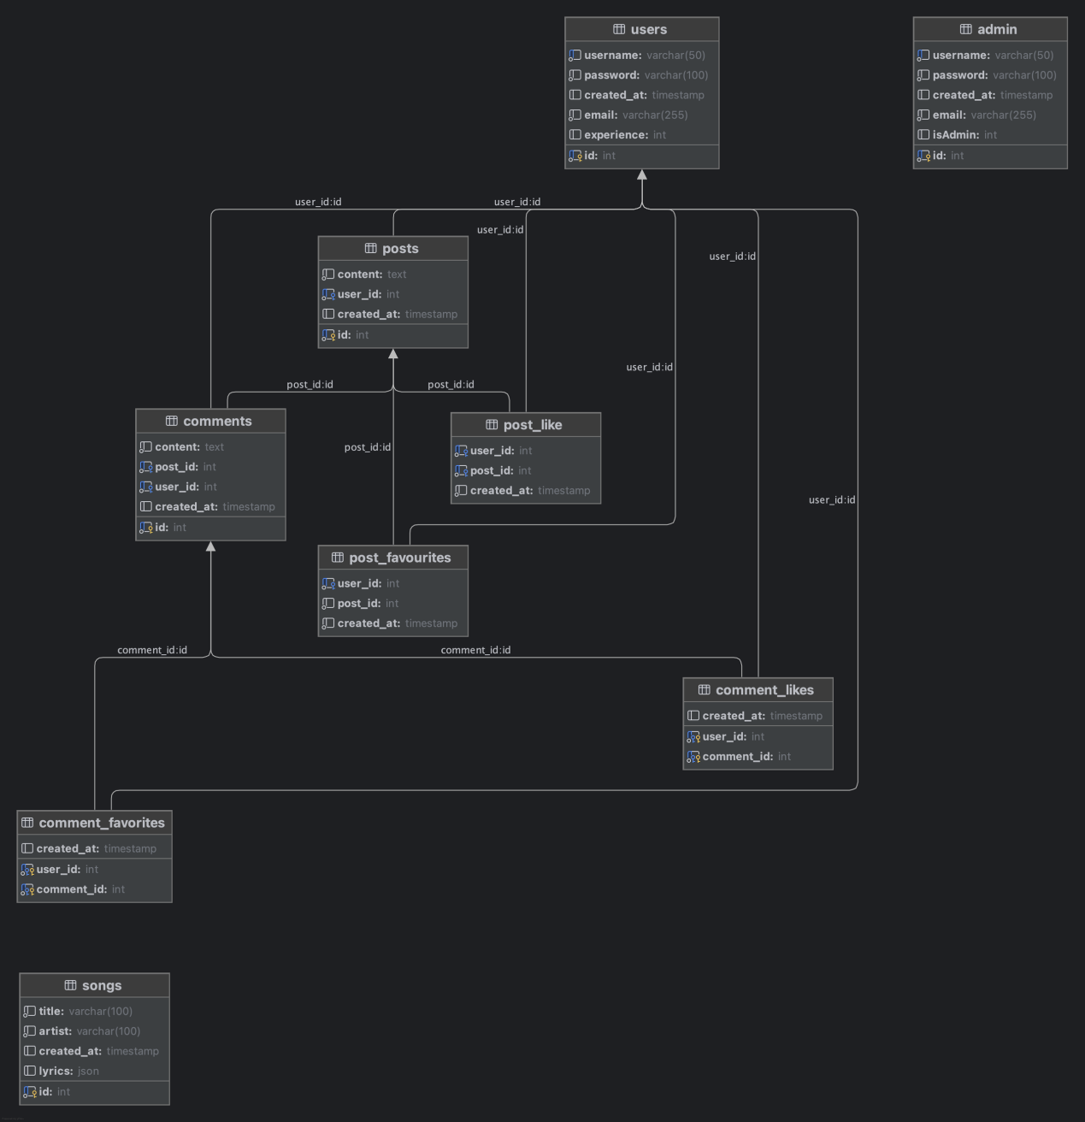

### 3.2.9 API Request States

**User Side:**

Base URL: https://api.hf2e2bc54.nyat.app:56647/api

Authorization: Token returned by login method

|  |  |  |  |
| --- | --- | --- | --- |
| **Req Method** | **Request Command** | **Description** | **Authorization** |
| POST | /login | User login | NO |
| POST | /register | User register | NO |
|  |  |  |  |
| GET | /posts | Get all posts | YES |
| GET | /posts/:id/like | Show how many likes a post has | YES |
| GET | /posts/:id/liked | Is the post liked by the user | YES |
| GET | /posts/:id/favourite | Is the post favourite by the user | YES |
| POST | /posts | Create a post | YES |
| POST | /posts/:id/like | Like a post | YES |
| POST | /posts/:id/favourate | Add a favourate of a post | YES |
|  |  |  |  |
|  |  |  |  |
| POST | /comments | Add a comment to the selected post | YES |
| GET | /comments/:id | Get comment of a post | YES |
| GET | /comments/:id/liked | Is the comment liked by the user | YES |
| GET | /comments/:id/favorite | Is the comment favorite by the user | YES |
| POST | /comments/:id/like | Add a like of the comment | YES |
| POST | /comments/:id/favourate | Add a favourate of a comment | YES |
|  |  |  |  |
| GET | /songs | Get all songs name and artists | YES |
| GET | /songs/:id | Get all song information by id | YES |
| POST | /songs | Add a song | YES |
|  |  |  |  |
| GET | /user/info | Get user information | YES |
| GET | /user/posts/favourite | Get user favourite posts | YES |
| GET | /user/posts | Get user posts | YES |
| DELETE | /user/posts/favourite/:id | Delete a user favourite post | YES |
| PUT | /user/changePassword | Update user password | YES |

**Admin Side:**

Base URL: https://api.hf2e2bc54.nyat.app:56647/api/admin

Authorization: Token returned by login method

isAdmin: need to be 1

|  |  |  |  |
| --- | --- | --- | --- |
| **Req Method** | **Request Command** | **Description** | **Authorization** |
| POST | /login | Admin login | NO |
| POST | /register | Admin register | YES |
|  |  |  |  |
| GET | /users | Show first page users | YES |
| GET | /users/:page | Show users of given page | YES |
| GET | /user/:id | Get single user information | YES |
| POST | /user | Add a user manually | YES |
| PUT | /user/:id | Update a user information | YES |
| POST | /user/search | Using keyword to search user | YES |
| POST | /user/search/:page | Show searched user of given page | YES |
| DELETE | /user/:id | Delete a user | YES |
|  |  |  |  |
| GET | /posts | Get first page posts | YES |
| GET | /posts/:page | Get posts of given page | YES |
| DELETE | /post/:id | Delete a post | YES |
|  |  |  |  |
| GET | /comment/:id | Get comments of a post | YES |
| DELETE | /comment/:id | Delete a comment | YES |
|  |  |  |  |
| GET | /songs | Get all songs | YES |
| GET | /songs/:id | Get specific song | YES |
| POST | /song/search | Use keyword to search a song | YES |
| GET | /lyrics/:id | Get lyrics information of a song | YES |
| POST | /songs | Create a new song | YES |
| DELETE | /songs/:id | Delete a song | YES |
| PUT | /songs/:id | Update song information | YES |

### 3.2.10 Storyboard

#### 3.2.10.1 Home page

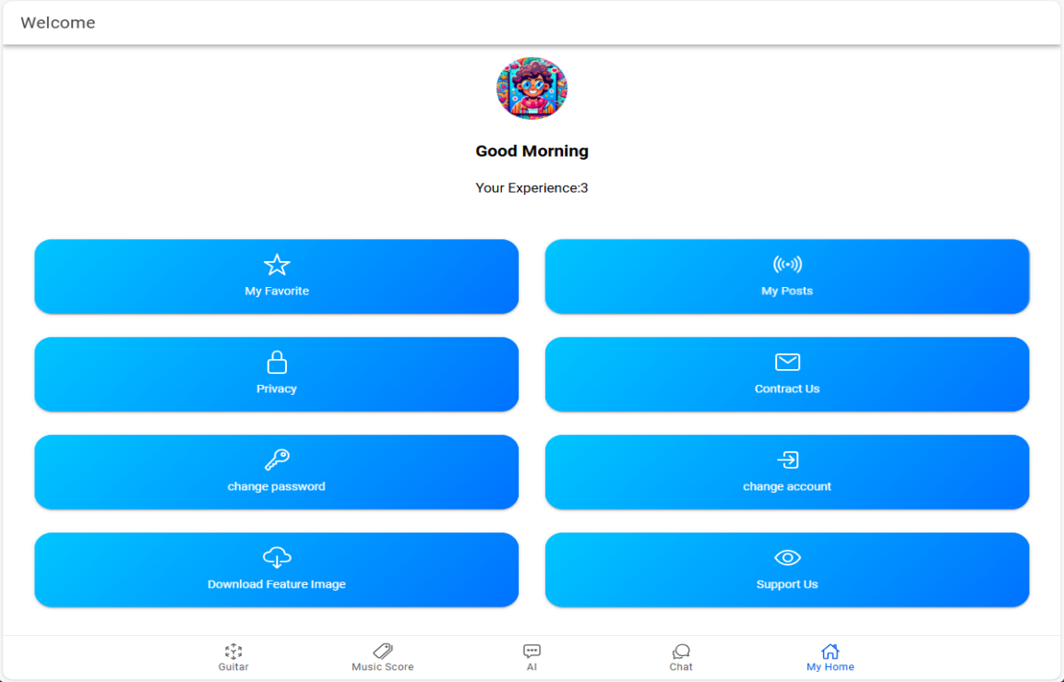

#### 3.2.10.2 Favorite Page

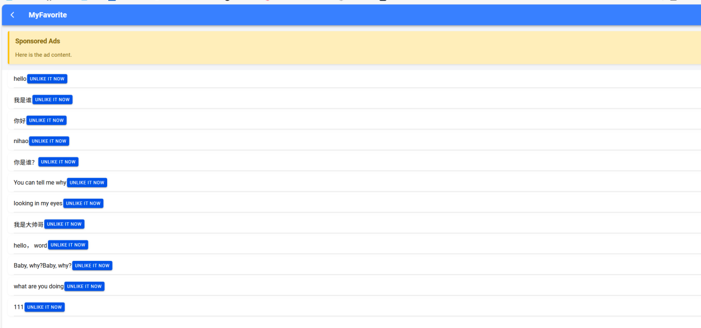

#### 3.2.10.3 comment page

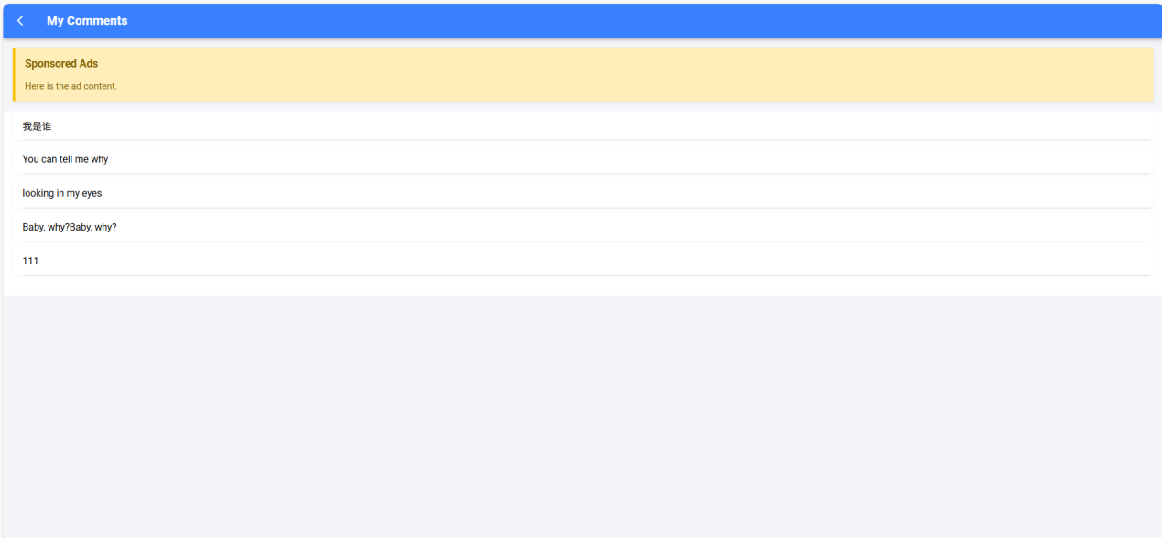

#### 3.2.10.4 Image page

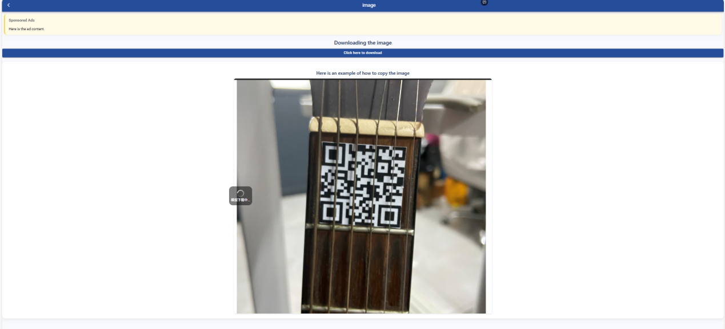

#### 3.2.10.5 SupportUS page

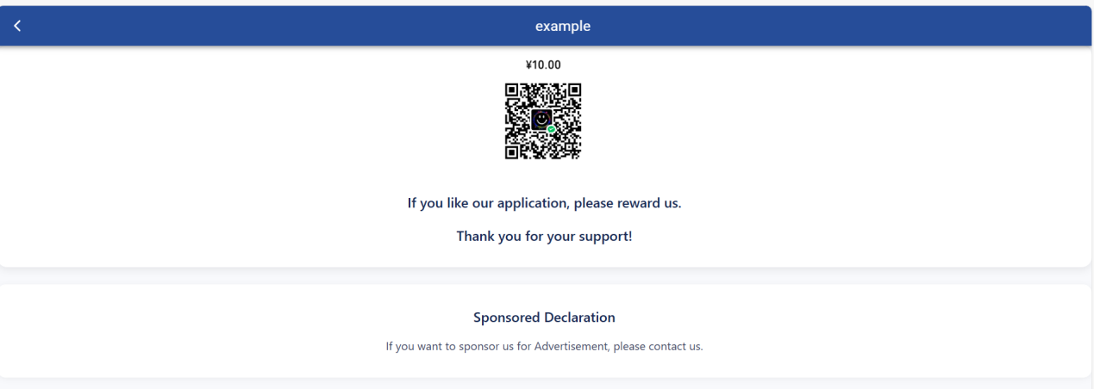

#### 3.2.10.6 Change passwords page

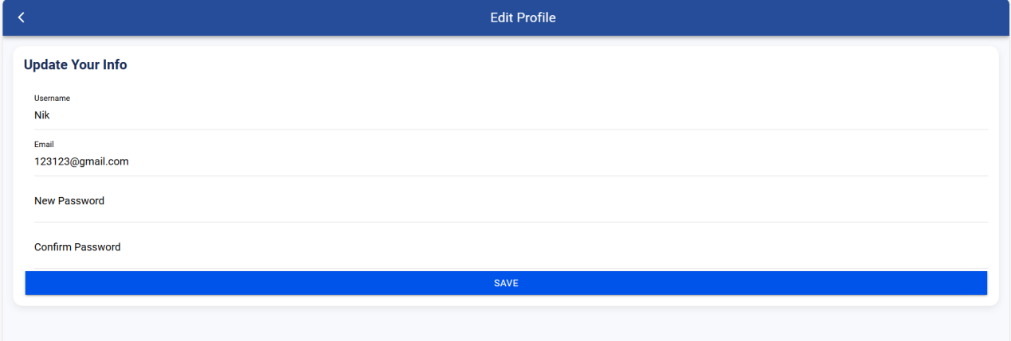

#### 3.2.10.7 Contract US page

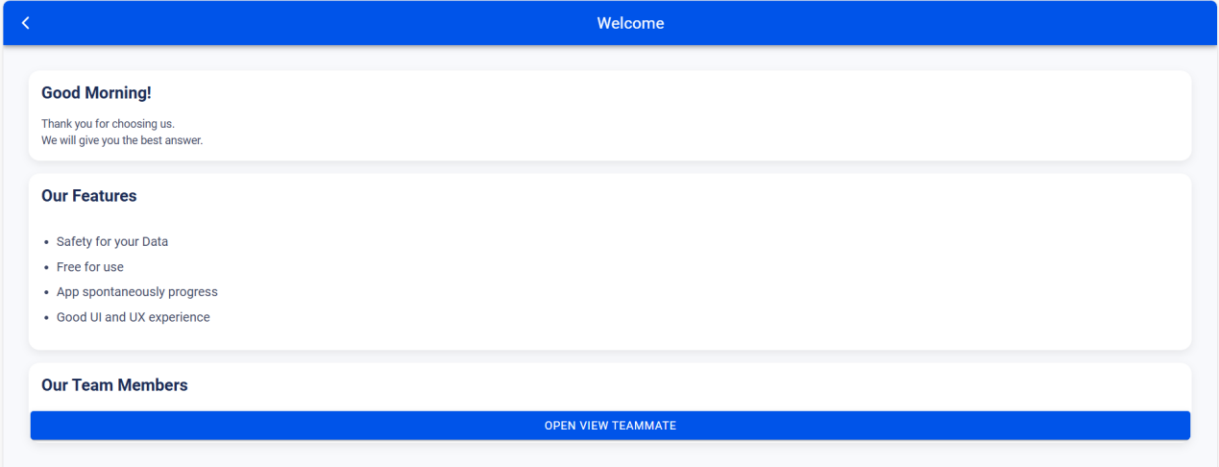

#### 3.2.10.8 chat page

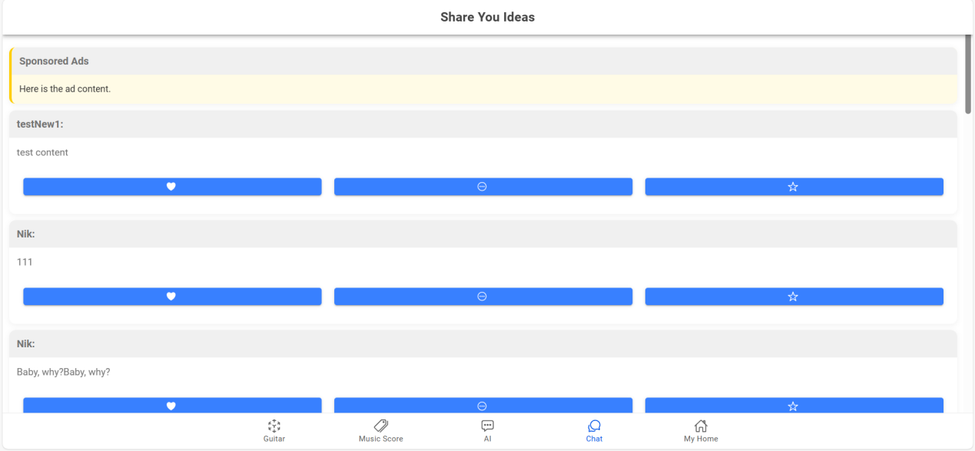

#### 3.2.10.9 comment page

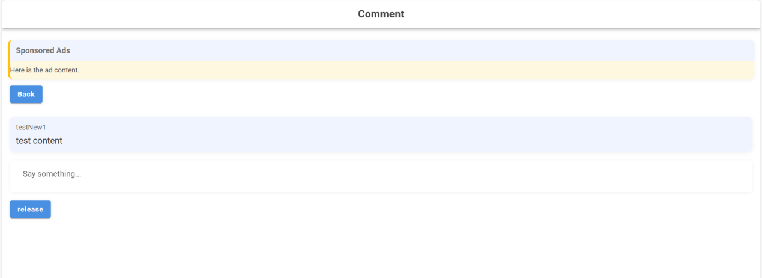

#### 3.2.10.10 AI page

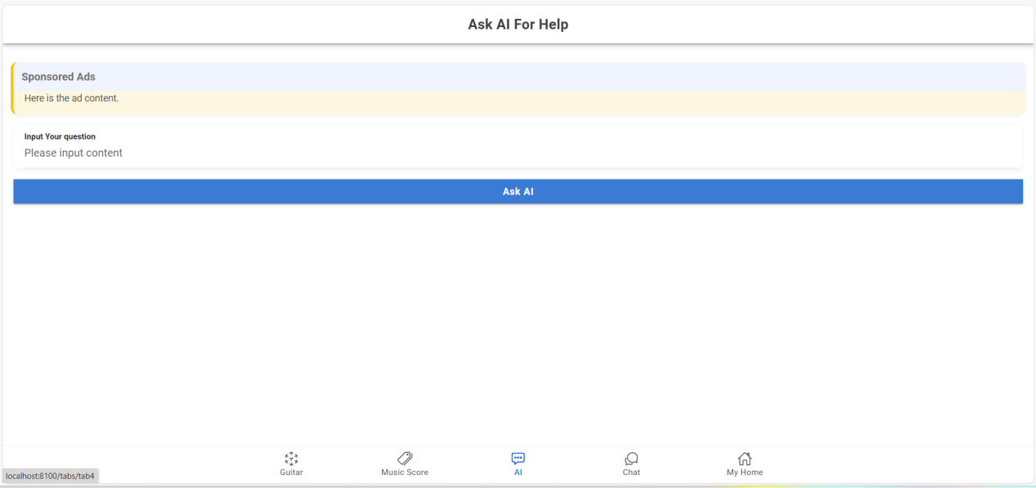

#### 3.2.10.11 Music Store Page

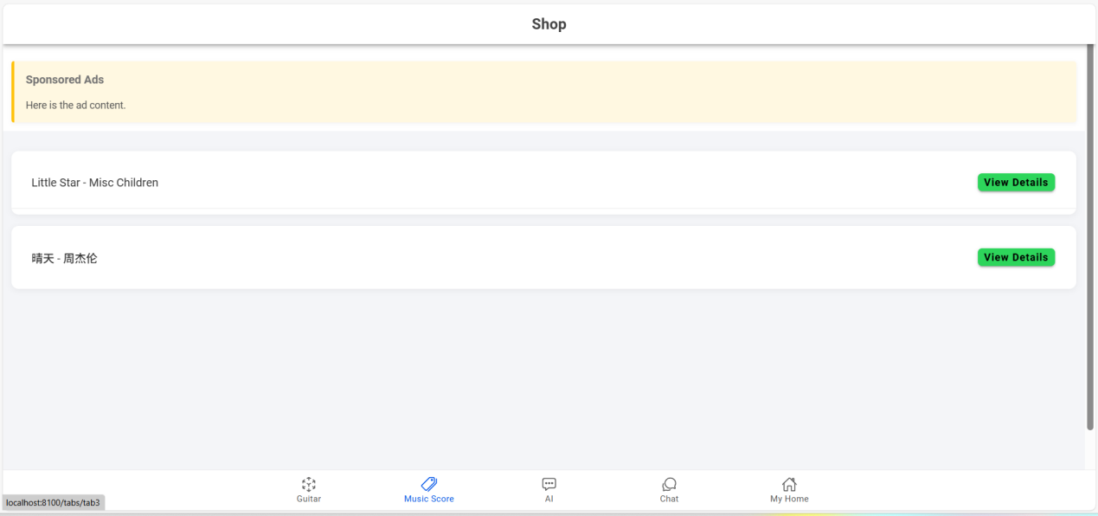

#### 3.2.10.12 Guitar Page

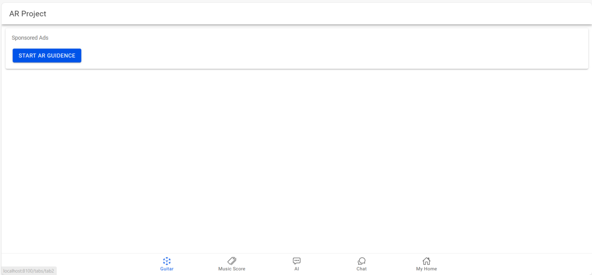

#### 3.2.10.13 Maintainance Project Login page：

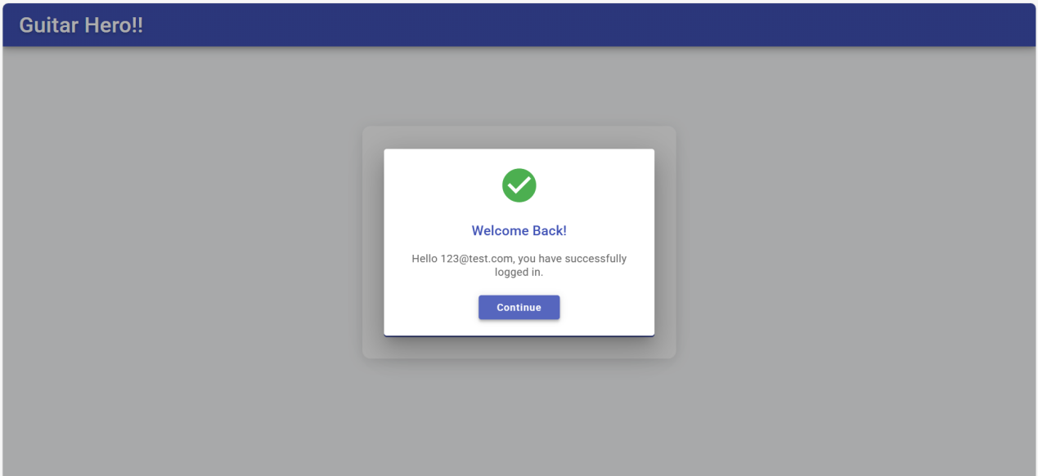

#### 3.2.10.14 Maintenance Project Users Page：

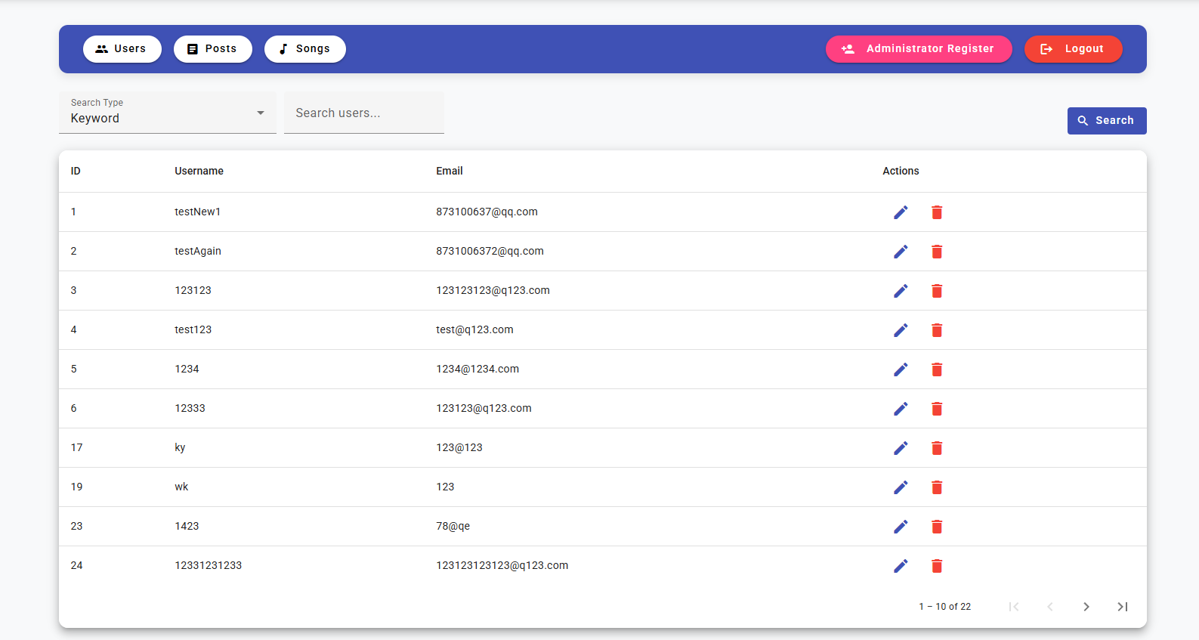

#### 3.2.10.15 Maintenance **Project Posts Page**

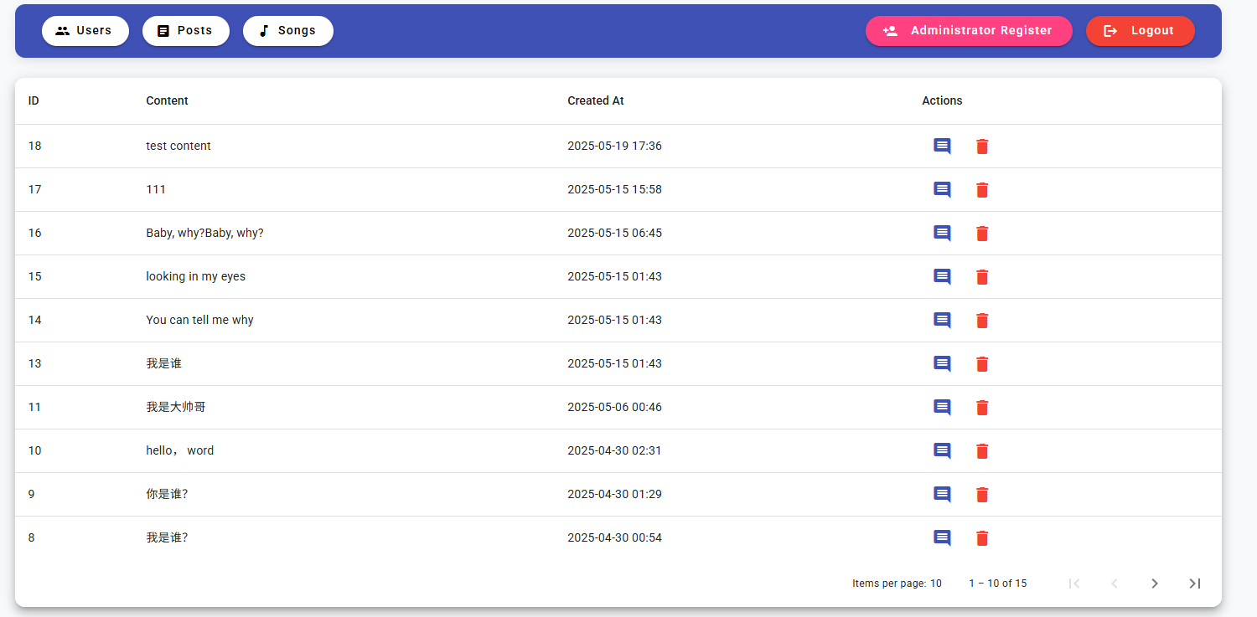

#### 3.2.10.16 Maintenance Project Song page

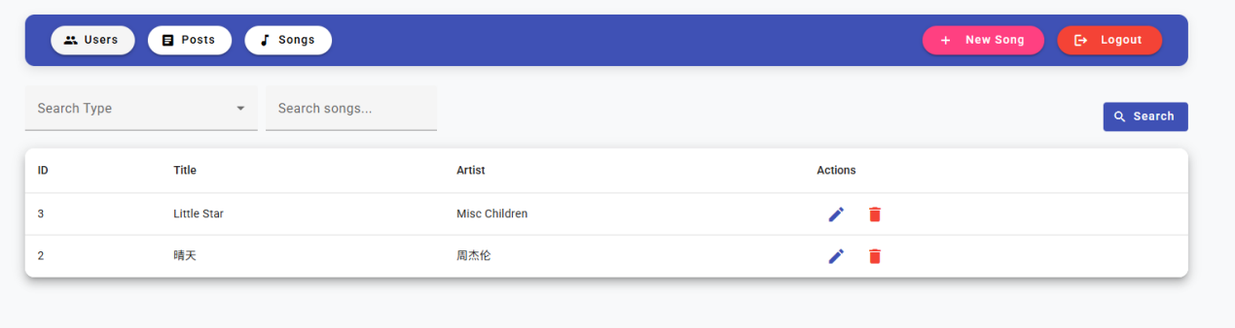

#### 3.2.10.17 Maintenance Project new song page:

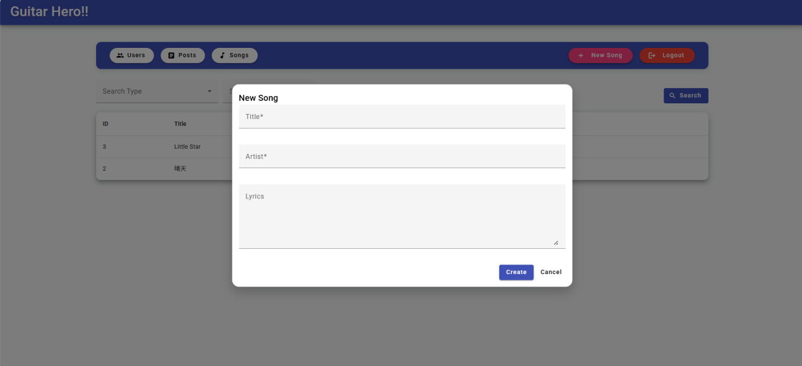

#### 3.2.10.18 Maintenance Project Regist page

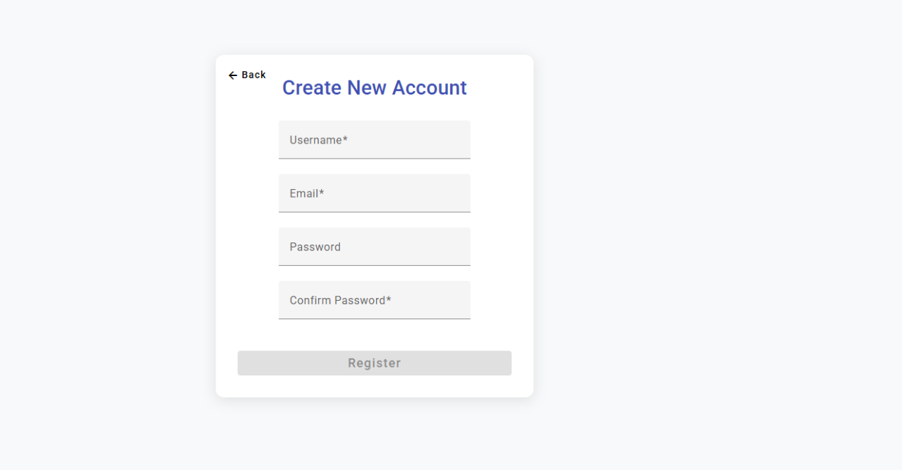

## 3.3 Development Documentation

### 3.3.1 Summary of Work Done in This Iteration

In this our team has made significant progress on the development of the guitar learning mobile app. The work carried out in this iteration can be summarized as follows:

### 3.3.2 Front-end Development

We designed and implemented the front-end of the application, focusing on creating a user-friendly interface that allows users to interact with the app seamlessly. The front-end development involved the following tasks:

Designed the chart tab in the application.

Developed the comment page in the tab side

Changed the home page.

Changed AI page

### 3.3.3 AR Guitar Tracking

One of the core features of our app is the AR guitar tracking functionality. We have successfully implemented the following:

Finished the AR parts in the Unity

Using volume control of Android API in Unity

### 3.3.4 Development Side Development

One useful part of our fully application. Solving developers' and companies' problems of control all data of consumers. We have successfully implemented the following:

Designed the overall layout and structure of the application.

Implemented the login and registration pages.

Created the main interface for administration to access different features of the app.

### 3.3.5 Back-end Development

In the core of MVC App, Back-end APIs the central of controller of all request from Front-end side and development side. We just finished all recommend of server needs.

Put the local project to cloud system

### 3.3.6 Version Control with GitHub

To manage our code base and facilitate collaboration among team members, we used GitHub for version control. The following repositories are relevant to this iteration:

[AR Track Project](https://github.com/Naivebody/Guitar.git#tdsub) - This repository contains the code for the AR tracking functionality of the app.

[Frontend Project](https://github.com/Missacca/final-project-angular.git#tdsub) - This repository holds the front-end code of the application.

[Backend Project](https://github.com/RealTakoChannel/server-side.git#tdsub) - This repository holds the back-end codes of the application.

### 3.3.7 Code Development and References

In this iteration, we developed a significant amount of original code to bring our project to life. However, we also leveraged some existing code and libraries to enhance our development process and provide a better user experience. Below is a list of the code we developed and the external code we referenced:

**Original Code:**

* Developed the core logic for the AR guitar tracking system.
* Implemented the front-end interface and user interaction features.
* Created the chat page and Home page .
* Integrated the server AI model into the app.
* Developed the shop feature, including song listing and score display functionalities.

**Referenced Code:**

Utilized the Angular framework for front-end development. The Angular framework is an open-source project developed by Google and the Angular community. We used Angular CLI to generate components, services, and other artifacts as needed for our project.

Incorporated the ARCore library for AR functionality. ARCore is a Google library that provides the necessary tools and APIs for building AR applications on Android devices.

Used the AR Foundation track module for image tracking. The AR Foundation track module is an open-source project that provides a robust platform for integrating augmented reality features. We used the following repository for the AR Foundation track module: [ARFoundationQRTracking-Unity](https://github.com/HoloLabInc/ARFoundationQRTracking-Unity#tdsub) .

Integrated the Jan AI model for local AI functionality. Jan is a free, open-source alternative to ChatGPT that runs completely offline and provides an OpenAI compatible API through its Cortex server. For more information, visit [Jan](https://www.unite.ai/best-llm-tools-to-run-models-locally/#tdsub) .

By combining our original code with these well-established libraries and frameworks, we have been able to create a robust and feature-rich application that meets the requirements of our users.

### 3.3.8 Source Code Availability

The source code for this iteration is available in the following GitHub repositories:

[AR Track Module](https://github.com/Naivebody/Guitar.git#tdsub)

[Frontend Module](https://github.com/Missacca/final-project-angular.git#tdsub)

[Backend Module](https://github.com/RealTakoChannel/server-side.git#tdsub)

Team members and stakeholders can access the code, explore the implementation details, and provide feedback or suggestions for further improvements.

## 3.4 Testing Documentation

### 3.4.1Overview：

The normal display of css and the normal switching and jumping of pages in the front-end prototype.

Deployment and Implementation of AR Recognition and Tracking Function

In development side,Login sub-System function(login & register)

Backend API Test

Chat function Test

Home function Test

### 3.4.2 New Backend API test

#### 3.4.2.1Song APIs

|  |  |
| --- | --- |
| **Test ID** | **001** |
| User Story | [descriptITP125GX5-123](https://scu-it.atlassian.net/browse/ITP125GX5-123#tdsub) - As a frontend developer, I hope I can receive the data response when I sent get scores request to backend APIs, so that I can show the scores list and data to user 已完成 |
| Function owner | [Zihan Wei](https://scu-it.atlassian.net/wiki/people/712020:461fb677-6e7b-40a7-bc39-f6579d2a1102?ref=confluence#tdsub) |
| Test By | [Zihan Wei](https://scu-it.atlassian.net/wiki/people/712020:461fb677-6e7b-40a7-bc39-f6579d2a1102?ref=confluence#tdsub) |
| Status | Pass -- Application successfully receives the request and return the data |
| Setup | Create a WebStorm HTTP Request |
| Link to Bug Issue (If fails) | Passed |
| Instructions | Write test code to call the API and send the request  ### GET SONGSGET {{url}}/api/songs/:songIDAuthorization: Bearer {{userToken}} |
| Expected Results | Response code: 200 (OK)  Response Body include:  [ { "id": 3, "title": "Little Star", "artist": "Misc Children" }] |
| Description | The result need have HTTP/1.1 200 (OK) |
| Date | 2025年5月16日 |
| **Test ID** | **002** |
| User Story | [descriptITP125GX5-123](https://scu-it.atlassian.net/browse/ITP125GX5-123#tdsub) - As a frontend developer, I hope I can receive the data response when I sent get scores request to backend APIs, so that I can show the scores list and data to user 已完成 |
| Function owner | [Zihan Wei](https://scu-it.atlassian.net/wiki/people/712020:461fb677-6e7b-40a7-bc39-f6579d2a1102?ref=confluence#tdsub) |
| Test By | [Zihan Wei](https://scu-it.atlassian.net/wiki/people/712020:461fb677-6e7b-40a7-bc39-f6579d2a1102?ref=confluence#tdsub) |
| Status | Pass -- Application successfully receives the request and return the data |
| Setup | Create a WebStorm HTTP Request |
| Link to Bug Issue (If fails) | Passed |
| Instructions | Write test code to call the API and send the request  ### GET song lyricsGET {{url}}/api/songs/3Authorization: Bearer {{userToken}} |
| Expected Results | Response code: 200 (OK)  Response Body include:  [ { "id": 3, "title": "Little Star", "artist": "Misc Children", "created_at": "2025-05-16T21:37:41.000Z", "lyrics": [ { "line": [ { "text": "Twinkle, twinkle ", "chord": "C" }, {...} ] } ] }] |
| Description | The result need have HTTP/1.1 200 (OK) |
| Date | 2025年5月16日 |

#### 3.4.2.2Posts APIs

|  |  |  |
| --- | --- | --- |
| **Test ID** | **003** |  |
| User Story | [descriptITP125GX5-38](https://scu-it.atlassian.net/browse/ITP125GX5-38#tdsub) - As a guitarist with some achievements, I want to share my experience and guidance, so that I can help more beginners to train better.已完成 | Get All Posts |
| Function owner | [Zhenrui Tian](https://scu-it.atlassian.net/wiki/people/712020:24dd2b8b-8665-4110-b790-65795b9e2262?ref=confluence#tdsub) |  |
| Test By | [Zihan Wei](https://scu-it.atlassian.net/wiki/people/712020:461fb677-6e7b-40a7-bc39-f6579d2a1102?ref=confluence#tdsub) |  |
| Status | Pass -- Application successfully receives the request and return the data |  |
| Setup | Create a WebStorm HTTP Request |  |
| Link to Bug Issue (If fails) | Passed |  |
| Instructions | Write test code to call the API and send the request  ### GET PostsGET {{url}}/api/postsAuthorization: Bearer {{userToken}} |  |
| Expected Results | Response code: 200 (OK)  Response Body include:  [ { "id": post id, "content": "post content", "user_id": user id, "created_at": "create timestamp", "username": "post owner" }, {...}] |  |
| Description | The result need have HTTP/1.1 200 (OK) |  |
| Date | 2025年5月16日 |  |
| **Test ID** | **004** |
| User Story | [descriptITP125GX5-38](https://scu-it.atlassian.net/browse/ITP125GX5-38#tdsub) - As a guitarist with some achievements, I want to share my experience and guidance, so that I can help more beginners to train better.已完成 |
| Function owner | [Zhenrui Tian](https://scu-it.atlassian.net/wiki/people/712020:24dd2b8b-8665-4110-b790-65795b9e2262?ref=confluence#tdsub) |
| Test By | [Zihan Wei](https://scu-it.atlassian.net/wiki/people/712020:461fb677-6e7b-40a7-bc39-f6579d2a1102?ref=confluence#tdsub) |
| Status | Pass -- Application successfully receives the request and return the data |
| Setup | Create a WebStorm HTTP Request |
| Link to Bug Issue (If fails) | Passed |
| Instructions | Write test code to call the API and send the request  ### Create a postPOST {{url}}/api/postscontent-type: application/jsonAuthorization: Bearer {{userToken}} { "content": "test content"} |
| Expected Results | Response code: 201 (Created)  Response Body include:  { "id": new post id} |
| Description | The result need have HTTP/1.1 201 (Created) |
| Date | 2025年5月16日 |

#### 3.4.2.3Comment APIs

|  |  |
| --- | --- |
| **Test ID** | **005** |
| User Story | [descriptITP125GX5-38](https://scu-it.atlassian.net/browse/ITP125GX5-38#tdsub) - As a guitarist with some achievements, I want to share my experience and guidance, so that I can help more beginners to train better.已完成 |
| Function owner | [Zhenrui Tian](https://scu-it.atlassian.net/wiki/people/712020:24dd2b8b-8665-4110-b790-65795b9e2262?ref=confluence#tdsub) |
| Test By | [Zihan Wei](https://scu-it.atlassian.net/wiki/people/712020:461fb677-6e7b-40a7-bc39-f6579d2a1102?ref=confluence#tdsub) |
| Status | Pass -- Application successfully receives the request and return the data |
| Setup | Create a WebStorm HTTP Request |
| Link to Bug Issue (If fails) | Passed |
| Instructions | Write test code to call the API and send the request  ### GET comment of a postGET {{url}}/api/comments/2Authorization: Bearer {{userToken}} |
| Expected Results | Response code: 200 (OK)  Response Body include:  [ { "content": "", "username": "kun", "created_at": "2025-05-18T12:59:22.000Z", "id": 10, "post_id": 2 }, { "content": "whi", "username": "kun", "created_at": "2025-05-18T12:59:30.000Z", "id": 11, "post_id": 2 }] |
| Description | The result need have HTTP/1.1 200 (OK) |
| Date | 2025年5月16日 |
| **Test ID** | **006** |
| User Story | [descriptITP125GX5-38](https://scu-it.atlassian.net/browse/ITP125GX5-38#tdsub) - As a guitarist with some achievements, I want to share my experience and guidance, so that I can help more beginners to train better.已完成 |
| Function owner | [Zhenrui Tian](https://scu-it.atlassian.net/wiki/people/712020:24dd2b8b-8665-4110-b790-65795b9e2262?ref=confluence#tdsub) |
| Test By | [Zihan Wei](https://scu-it.atlassian.net/wiki/people/712020:461fb677-6e7b-40a7-bc39-f6579d2a1102?ref=confluence#tdsub) |
| Status | Pass -- Application successfully receives the request and return the data |
| Setup | Create a WebStorm HTTP Request |
| Link to Bug Issue (If fails) | Passed |
| Instructions | Write test code to call the API and send the request  ### Create a commentPOST {{url}}/api/commentscontent-type: application/jsonAuthorization: Bearer {{userToken}} { "content": "test content", "postId": 1} |
| Expected Results | Response code: 201 (Created)  Response Body include:  { "id": 12} |
| Description | The result need have HTTP/1.1 201 (Created) |
| Date | 2025年5月16日 |

#### 3.4.2.4User Information APIs

|  |  |
| --- | --- |
| **Test ID** | **007** |
| User Story | [descriptITP125GX5-125](https://scu-it.atlassian.net/browse/ITP125GX5-125#tdsub) - As an app user, I hope I can change my personal information settings from the home page, so that I can make sure my information is correct when something changed like email 已完成 |
| Function owner | [Yunlin Li](https://scu-it.atlassian.net/wiki/people/712020:285f6d04-719f-4b0d-a555-a58af0a51e43?ref=confluence#tdsub) |
| Test By | [Zihan Wei](https://scu-it.atlassian.net/wiki/people/712020:461fb677-6e7b-40a7-bc39-f6579d2a1102?ref=confluence#tdsub) |
| Status | Pass -- Application successfully receives the request and return the data |
| Setup | Create a WebStorm HTTP Request |
| Link to Bug Issue (If fails) | Passed |
| Instructions | Write test code to call the API and send the request  ### GET User InfoGET {{url}}/api/user/infoAuthorization: Bearer {{userToken}} |
| Expected Results | Response code: 200 (OK)  Response Body include:  { "email": "873100637@qq.com", "username": "testNew1", "id": 1, "experience": 2, "created_at": "2025-04-18T04:04:05.000Z"} |
| Description | The result need have HTTP/1.1 200 (OK) |
| Date | 2025年5月16日 |
| **Test ID** | **008** |
| User Story | [descriptITP125GX5-125](https://scu-it.atlassian.net/browse/ITP125GX5-125#tdsub) - As an app user, I hope I can change my personal information settings from the home page, so that I can make sure my information is correct when something changed like email 已完成 |
| Function owner | [Yunlin Li](https://scu-it.atlassian.net/wiki/people/712020:285f6d04-719f-4b0d-a555-a58af0a51e43?ref=confluence#tdsub) |
| Test By | [Zihan Wei](https://scu-it.atlassian.net/wiki/people/712020:461fb677-6e7b-40a7-bc39-f6579d2a1102?ref=confluence#tdsub) |
| Status | Pass -- Application successfully receives the request and return the data |
| Setup | Create a WebStorm HTTP Request |
| Link to Bug Issue (If fails) | Passed |
| Instructions | Write test code to call the API and send the request  ### Change user's passwordPUT {{url}}/api/user/changePasswordcontent-type: application/jsonAuthorization: Bearer {{userToken}} { "password": "new password"} |
| Expected Results | Response code: 200 (OK)  Response Body include:  { "result": 1} |
| Description | The result need have HTTP/1.1 200 (OK) |
| Date | 2025年5月16日 |

#### 3.4.2.5Admin APIs

|  |  |
| --- | --- |
| **Test ID** | **009** |
| User Story | [descriptITP125GX5-131](https://scu-it.atlassian.net/browse/ITP125GX5-131#tdsub) - As a maintainer, I hope I can see all data from the subsystem, so that I can change those data and implemented. 已完成 |
| Function owner | [Yunlin Li](https://scu-it.atlassian.net/wiki/people/712020:285f6d04-719f-4b0d-a555-a58af0a51e43?ref=confluence#tdsub) |
| Test By | [Zihan Wei](https://scu-it.atlassian.net/wiki/people/712020:461fb677-6e7b-40a7-bc39-f6579d2a1102?ref=confluence#tdsub) |
| Status | Pass -- Application successfully receives the request and return the data |
| Setup | Create a WebStorm HTTP Request |
| Link to Bug Issue (If fails) | Passed |
| Instructions | Write test code to call the API and send the request  ### PUT admin update userPUT {{url}}/api/admin/user/2content-type: application/jsonAuthorization: Bearer {{adminToken}} { "username": "testAgain", "email": "8731006372@qq.com", "password": "123123"} |
| Expected Results | Response code: 200 (OK)  Response Body include:  { "result": 1} |
| Description | The result need have HTTP/1.1 200 (OK) |
| Date | 2025年5月16日 |
| **Test ID** | **010** |
| User Story | [descriptITP125GX5-121](https://scu-it.atlassian.net/browse/ITP125GX5-121#tdsub) - As a backend developer, I hope I can have something that I can create scores json files for the customized scores data structure, so that the front end can show the scores properly 已完成 |
| Function owner | [Zihan Wei](https://scu-it.atlassian.net/wiki/people/712020:461fb677-6e7b-40a7-bc39-f6579d2a1102?ref=confluence#tdsub) |
| Test By | [Zihan Wei](https://scu-it.atlassian.net/wiki/people/712020:461fb677-6e7b-40a7-bc39-f6579d2a1102?ref=confluence#tdsub) |
| Status | Pass -- Application successfully receives the request and return the data |
| Setup | Create a WebStorm HTTP Request |
| Link to Bug Issue (If fails) | Passed |
| Instructions | Write test code to call the API and send the request  ### POST a songPOST {{url}}/api/songscontent-type: application/jsonAuthorization: Bearer {{userToken}} { "title": "Little Star", "artist": "Misc Children", "lyrics": [ { "line": [ { "chord": "C", "text": "Twinkle, twinkle " } ] } ]} |
| Expected Results | Response code: 200 (OK)  Response Body include:  { "id": 12, "message": "Song created successfully"} |
| Description | The result need have HTTP/1.1 200 (OK) |
| Date | 2025年5月16日 |

### 3.4.3 Frontend prototype test 2

|  |  |
| --- | --- |
| **Test ID** | **001** |
| User story | As a user, I want to see the chord of the songs |
| Function owner | @Yunlin Li |
| Test By | @Zhenrui Tian |
| Status | Pass-- Ionic App can be successfully shown and implemented and all information in songs can successfully jump to each other. |
| Setup | no |
| Link to Bug Issue (If fails) |  |
| Instructions | If need to use on phone,use Capacitor to deploy the project on android phones  If test it on laptop, just use ionic serve to test. |
| Expected Results | If buttons like veiw the details of song, the information can easily showing on the screen |
| Description | button clicked can jump and app can be use |
| Date | 2025年5月15日 |
| **Test ID** | **002** |
| User story | As a user, may be I have some questions or problems I want to ask for someone. |
| Function owner | @Yunlin Li |
| Test By | @Zhenrui Tian |
| Status | Pass-- Ionic App can be successfully shown and implemented and all information in AI page can successfully Showing the requests on the OpenAI Server. |
| Setup | no |
| Link to Bug Issue (If fails) |  |
| Instructions | If need to use on phone,use Capacitor to deploy the project on android phones  If test it on laptop, just use ionic serve to test. |
| Expected Results | If user type in the question and click the “Ask AI“ button, the information can easily showing on the screen after the answers of OpenAI chat3.5pro |
| Description | User can get information in the AI tab |
| Date | 2025年5月15日 |
| **Test ID** | **003** |
| User story | As a user, I want to view posts, interact with them (like, favorite, view comments), and submit new posts if logged in, so I can engage with the social platform. |
| Function owner | @Yunlin Li |
| Test By | @Zhenrui Tian |
| Status | Pass-- Ionic App can be successfully shown and implemented and all tabs can successfully jump to each other. |
| Setup | Ensure Ionic app is deployed on a test device/emulator with a mock backend for posts and user authentication. |
| Link to Bug Issue (If fails) |  |
| Instructions | 1. Launch the Ionic app and navigate to the social page. 2. Verify the page displays with a header titled "Share You Ideas". 3. Check that sponsored ads card is visible with "Sponsored Ads" header and content. 4. Verify a list of posts is displayed with username, content, like button, comment button, and favorite button. 5. Click the like button on a post and observe the like count and icon change. 6. Click the comment button and verify navigation to the detail page. 7. Click the favorite button and confirm the icon changes to a filled star. 8. Log in as a test user, verify the input textarea and "release" button appear. 9. Enter text in the textarea and click "release" to submit a post.   10. Confirm the new post appears in the list. |
| Expected Results | 1. App launches and displays the social page with the correct header. 2. Sponsored ads card is visible with expected content. 3. Posts are listed with correct usernames, content, and interaction buttons. 4. Like button updates the count and changes to a filled heart icon when clicked, disables after liking. 5. Comment button navigates to the detail page with post details. 6. Favorite button changes to a filled star and disables after favoriting. 7. Input textarea and "release" button are visible only when logged in. 8. Submitting a post adds it to the list with correct content and username. 9. All interactions (like, favorite, comment) are responsive without errors.   10. Page layout is consistent across actions. |
| Description | Tests the core functionality of the social page, including post display, user interactions (like, favorite, comment navigation), and post submission for logged-in users. Verifies UI elements, navigation, and backend integration. |
| Date | 2025年5月15日 |
| **Test ID** | **004** |  |
| User story | As a user, I want to view a post and its comments, interact with comments (like, favorite), submit new comments if logged in, and navigate back, so I can engage with the comment section of a post. |  |
| Function owner | @Yunlin Li |  |
| Test By | @Zhenrui Tian |  |
| Status | Pass-- Ionic App can be successfully shown and implemented and all tabs can successfully jump to each other. |  |
| Setup | Ensure Ionic app is deployed on a test device/emulator with a mock backend for posts, comments, and user authentication. Preload a test post and associated comments. |  |
| Link to Bug Issue (If fails) |  |  |
| Instructions | 1. Launch the Ionic app and navigate to the comment page for a specific post. 2. Verify the page displays with a header titled "Comment". 3. Check that the sponsored ads card is visible with "Sponsored Ads" header and content. 4. Confirm the post’s username and content are displayed in the card header. 5. Verify a list of comments is shown with username, content, like button, and favorite button. 6. Click the like button on a comment and observe the like count and icon change. 7. Click the favorite button on a comment and confirm the icon changes to a filled star. 8. Click the "Back" button and verify navigation to the previous page (e.g., /tabs/tab4). 9. Log in as a test user, verify the input textarea and "release" button appear.   10. Enter text in the textarea and click "release" to submit a comment.  11. Confirm the new comment appears in the list. |  |
| Expected Results | 1. App displays the comment page with the correct header. 2. Sponsored ads card is visible with expected content. 3. Post’s username and content are correctly displayed. 4. Comments are listed with correct usernames, content, and interaction buttons. 5. Like button updates the count and changes to an outlined heart icon when clicked, disables after liking. 6. Favorite button changes to a filled star and disables after favoriting. 7. "Back" button navigates to the previous page without errors. 8. Input textarea and "release" button are visible only when logged in. 9. Submitting a comment adds it to the list with correct content and username.   10. All interactions (like, favorite, submit) are responsive without errors.  11. Page layout is consistent across actions. |  |
| Description | Tests the core functionality of the comment page, including post and comment display, user interactions (like, favorite), comment submission for logged-in users, and back navigation. Verifies UI elements, navigation, and backend integration. |  |
| Date | 2025年5月15日 |  |
| **Test ID** | **005** |
| User story | As a user, I want to view my profile information, update my password, and save changes, so I can manage my account details securely. |
| Function owner | @Yunlin Li |
| Test By | @Zhenrui Tian |
| Status | Pass-- Ionic App can be successfully shown and implemented and all tabs can successfully jump to each other. |
| Setup | Ensure Ionic app is deployed on a test device/emulator with a mock backend for user data and authentication. Log in as a test user with predefined username and email. |
| Link to Bug Issue (If fails) |  |
| Instructions | 1. Launch the Ionic app and navigate to the "Edit Profile" page. 2. Verify the page displays with a header titled "Edit Profile" and a back button. 3. Check that the form is displayed with fields for Username, Email, New Password, and Confirm Password. 4. Confirm that Username and Email fields are populated with the test user’s data and are read-only. 5. Enter a new password in the "New Password" field (e.g., "Test1234"). 6. Enter the same password in the "Confirm Password" field. 7. Click the "Save" button and verify the form submission. 8. Attempt to submit with mismatched passwords (e.g., "Test1234" and "Test12345") and check for validation error. 9. Click the back button and verify navigation to the previous page (e.g., /tabs/tab5).   10. Re-navigate to the page and confirm the form resets with original user data (username and email) |
| Expected Results | 1. Page displays with the correct header and a functional back button. 2. Form shows all fields: Username, Email, New Password, and Confirm Password. 3. Username and Email fields are pre-filled with user data and are non-editable (read-only). 4. New Password and Confirm Password fields accept input. 5. Submitting with matching passwords updates the password successfully (confirmed via backend mock). 6. Submitting with mismatched passwords shows a validation error (e.g., alert or message) and prevents submission. 7. Back button navigates to the previous page without errors. 8. Form resets correctly on re-navigation, showing original username and email, with password fields empty. 9. All interactions (input, submission, navigation) are responsive without errors.   10. Page layout remains consistent across actions. |
| Description | Tests the core functionality of the "Edit Profile" page, including display of read-only user data, password update with validation, form submission, and back navigation. Verifies UI elements, form behavior, and backend integration. |
| Date | 2025年5月15日 |
| **Test ID** | **006** |
| User story | As a user, I want to view the image page, see an example image, download a file, and navigate back, so I can access and save provided resources. |
| Function owner | @Yunlin Li |
| Test By | @Zhenrui Tian |
| Status | Pass-- Ionic App can be successfully shown and implemented and all information in songs can successfully jump to each other. |
| Setup | Ensure Ionic app is deployed on a test device/emulator with internet access to load the external download link and local assets for the image. |
| Link to Bug Issue (If fails) |  |
| Instructions | 1. Launch the Ionic app and navigate to the "Image" page. 2. Verify the page displays with a header titled "image" and a back button. 3. Check that the sponsored ads card is visible with "Sponsored Ads" header and content. 4. Confirm the download section is displayed with the title "Downloading the image" and a "Click here to download" button. 5. Click the download button and verify that it initiates the download of a file (e.g., sample.pdf). 6. Verify the welcome section is displayed with the title "Here is an example of how to copy the image" and an image. 7. Confirm the image loads correctly from the specified source (assets/img.png). 8. Click the back button and verify navigation to the previous page (e.g., /tabs/tab5). 9. Re-navigate to the page and confirm all elements (ads, download section, image) reload consistently. |
| Expected Results | 1. Page displays with the correct header and a functional back button. 2. Sponsored ads card is visible with expected content. 3. Download section shows the correct title and a clickable button. 4. Clicking the download button initiates the download of the linked file (sample.pdf) without errors. 5. Welcome section displays the correct title and a visible image loaded from assets/img.png. 6. Image renders correctly without distortion or loading errors. 7. Back button navigates to the previous page without errors. 8. All elements reload consistently on re-navigation. 9. All interactions (download, navigation) are responsive without errors.   10. Page layout remains consistent across actions. |
| Description | Tests the core functionality of the "Image" page, including display of sponsored ads, download section with a functional link, example image rendering, and back navigation. Verifies UI elements, external link behavior, and asset loading. |
| Date | 2025年5月15日 |
| **Test ID** | **007** |
| User story | As a user, I want to view my favorited posts, unlike them, and navigate back, so I can manage my favorite content. |
| Function owner | @Yunlin Li |
| Test By | @Zhenrui Tian |
| Status | Pass-- Ionic App can be successfully shown and implemented and all information in songs can successfully jump to each other. |
| Setup | Ensure Ionic app is deployed on a test device/emulator with a mock backend for user data and favorited posts. Preload a test user with at least two favorited posts. |
| Link to Bug Issue (If fails) |  |
| Instructions | 1. Launch the Ionic app and navigate to the "MyFavorite" page. 2. Verify the page displays with a header titled "MyFavorite" and a back button. 3. Check that the sponsored ads card is visible with "Sponsored Ads" header and content. 4. Confirm the list of favorited posts is displayed, showing each post’s content and an "Unlike it now" button. 5. Click the "Unlike it now" button for a post and verify the post is removed from the list. 6. Verify the backend reflects the post’s removal from the user’s favorites. 7. Click the back button and confirm navigation to the previous page (e.g., /tabs/tab5). 8. Re-navigate to the page and confirm the updated list (without the unliked post) is displayed. 9. If no posts are favorited, verify the list is empty or shows an appropriate message. |
| Expected Results | 1. Page displays with the correct header and a functional back button. 2. Sponsored ads card is visible with expected content. 3. Favorited posts are listed with their content and an "Unlike it now" button for each. 4. Clicking "Unlike it now" removes the post from the list immediately. 5. Backend confirms the post is no longer in the user’s favorites. 6. Back button navigates to the previous page without errors. 7. Re-navigating to the page shows the updated list, excluding the unliked post. 8. If no favorited posts exist, the list is empty or displays a placeholder message (if implemented). 9. All interactions (unlike, navigation) are responsive without errors.   10. Page layout remains consistent across actions. |
| Description | Tests the core functionality of the "MyFavorite" page, including display of sponsored ads, listing of favorited posts, unliking posts, and back navigation. Verifies UI elements, list management, and backend integration. |
| Date | 2025年5月15日 |
| **Test ID** | **008** |
| User story | As a user, I want to view a list of my comments and navigate back, so I can review my contributions to discussions. |
| Function owner | @Yunlin Li |
| Test By | @Zhenrui Tian |
| Status | Pass-- Ionic App can be successfully shown and implemented and all information in songs can successfully jump to each other. |
| Setup | Ensure Ionic app is deployed on a test device/emulator with a mock backend for user data and comments. Log in as a test user with at least two comments associated with their account. |
| Link to Bug Issue (If fails) |  |
| Instructions | 1. Launch the Ionic app and navigate to the "My Comments" page. 2. Verify the page displays with a header titled "My Comments" and a back button. 3. Check that the sponsored ads card is visible with "Sponsored Ads" header and content. 4. Confirm the list of comments is displayed, showing the content of each comment. 5. Verify that the comments match the test user’s comment history from the backend. 6. If no comments exist, check if the list is empty or shows an appropriate message. 7. Click the back button and confirm navigation to the previous page (e.g., /tabs/tab5). 8. Re-navigate to the page and confirm the comment list reloads consistently. 9. Verify the page handles a large number of comments (e.g., 10 comments) without performance issues. |
| Expected Results | 1. Page displays with the correct header and a functional back button. 2. Sponsored ads card is visible with expected content. 3. Comments are listed with their content, matching the test user’s comment history. 4. If no comments exist, the list is empty or displays a placeholder message (if implemented). 5. Back button navigates to the previous page without errors. 6. Re-navigating to the page reloads the same comment list consistently. 7. Page handles multiple comments (e.g., 10) without lag or display issues. 8. All elements (ads, comment list) render correctly without errors. 9. Page layout remains consistent across actions.   10. Navigation and list rendering are responsive. |
| Description | Tests the core functionality of the "My Comments" page, including display of sponsored ads, listing of user comments, and back navigation. Verifies UI elements, comment retrieval, and performance with multiple comments. |
| Date | 2025年5月15日 |
| **Test ID** | **009** |  |
| User story | As a user, I want to view my welcome page with my experience points and navigate to various features via menu cards, so I can access app functionalities easily. |  |
| Function owner | @Yunlin Li |  |
| Test By | @Zhenrui Tian |  |
| Status | Pass-- Ionic App can be successfully shown and implemented and all information in songs can successfully jump to each other. |  |
| Setup | Ensure Ionic app is deployed on a test device/emulator with a mock backend for user data. Log in as a test user with predefined experience points (e.g., 100). Mock the UserdataService to return experience data. |  |
| Link to Bug Issue (If fails) |  |  |
| Instructions | 1. Launch the Ionic app and navigate to the "Welcome" page (Tab5). 2. Verify the page displays with a header titled "Welcome". 3. Check that the welcome section shows an avatar (assets/user.png), "Good Morning" greeting, and the user’s experience points. 4. Confirm the experience points match the mock backend data (e.g., "Your Experience: 100"). 5. Verify the grid displays all menu cards (8 items: My Favorite, My Posts, Privacy, Contract Us, change password, change account, Download Feature Image, Support Us). 6. Check each card shows the correct label and icon as defined in the menuItems array. 7. Click a menu card (e.g., "My Favorite") and verify navigation to the correct path (e.g., /MyFavorite). 8. Repeat for at least one other card (e.g., "change password") to confirm navigation. 9. Re-navigate to the page and confirm all elements (avatar, greeting, experience, menu cards) reload consistently.   10. Simulate a backend error in UserdataService and verify the page handles it gracefully (e.g., logs error, displays default experience). |  |
| Expected Results | 1. Page displays with the correct header. 2. Welcome section shows a visible avatar, "Good Morning" text, and correct experience points (e.g., "Your Experience: 100"). 3. Experience points match the mock backend response. 4. Grid displays 8 menu cards in a 2-column layout, each with the correct label and icon. 5. Clicking a menu card navigates to the corresponding path without errors. 6. Navigation is consistent across multiple cards (e.g., My Favorite → /MyFavorite, change password → /change-password). 7. Re-navigating to the page reloads all elements consistently. 8. If UserdataService fails, the page remains functional, logs the error, and shows a default experience (e.g., empty or 0). 9. All interactions (navigation, data loading) are responsive without errors.   10. Page layout remains consistent across actions. |  |
| Description | Tests the core functionality of the "Welcome" page (Tab5), including display of user avatar, greeting, experience points, menu cards, and navigation to feature pages. Verifies UI elements, data retrieval, navigation, and error handling. |  |
| Date | 2025年5月15日 |

### 3.4.4 Admin Frontend prototype test

|  |  |
| --- | --- |
| **Test ID** | **001** |
| User story | As an admin, I want to manage posts through the management interface, including viewing post lists, accessing comments, and performing delete operations, to maintain platform content. |
| Function owner | @Zhenrui Tian |
| Test By | @Yunlin Li |
| Status | Pass-- Post management interface loads correctly, and all operations (navigation, data display, deletion, pagination) work as expected. |
| Setup | 1. Deploy the Angular app with a mock backend for posts and comments. 2. Log in with admin credentials. 3. Preload test data: 15 sample posts (with comments) and 5 empty-state scenarios. |
| Link to Bug Issue (If fails) |  |
| Instructions | 1. Launch the app and navigate to /posts (post management page). 2. Verify the header toolbar:    1. Check navigation buttons: "Users", "Posts", "Songs" (ensure "Posts" is active).    2. Confirm "Administrator Register" and "Logout" buttons are visible. 3. Check the posts table:    1. Verify columns: ID, Content (truncated to 50 characters), Created At (formatted as "yyyy-MM-dd HH:mm"), Actions.    2. Confirm 10 posts are displayed (default page size).    3. Test empty state: Clear mock data and check for "No posts found" message. 4. Test pagination:    1. Click "Next" and "Previous" buttons; verify data updates.    2. Select "20" from page size dropdown; confirm 20 posts display. 5. Test post actions:    1. Click "View Comments" (comment icon) on a post; verify comments dialog opens.    2. In the dialog, check comment columns: User, Content, Time, Actions.    3. Click "Delete" (trash icon) on a post; confirm the post is removed from the list. 6. Test comments dialog:    1. Click outside the dialog or the "Close" icon; verify dialog closes.    2. Click "Delete" (trash icon) on a comment; confirm the comment is removed from the list. 7. Test navigation:    1. Click "Users" button; verify redirect to /users.    2. Click "Logout"; verify redirect to login page. |
| Expected Results | Post management page loads with the correct header toolbar and active "Posts" button.   1. "Administrator Register" and "Logout" buttons are clickable and functional. 2. Posts table displays:    1. Truncated content (e.g., "This is a long post content..." for >50 characters).    2. Created At dates formatted correctly (e.g., "2024-03-15 14:30").    3. Actions column includes "View Comments" and "Delete" icons.    4. Empty state shows "No posts found" when no data exists. 3. Pagination:    1. "Next"/"Previous" buttons update the displayed posts.    2. Page size dropdown adjusts the number of posts per page. 4. Post actions:    1. "View Comments" opens a dialog with the post’s comments (username, content, time, delete icon).    2. "Delete" removes the post from the list immediately (backend mock confirms deletion). 5. Comments dialog:    1. Dialog closes when clicking outside or the "Close" icon.    2. "Delete" removes the comment from the dialog list (backend mock confirms deletion). 6. Navigation:    1. "Users" button redirects to /users; "Logout" redirects to login. |
| Description | Tests the post management page’s core functionality, including UI element display, post/data interactions (view, delete), pagination, comments dialog, and navigation. Verifies alignment with mock data, user interactions, and error handling (e.g., empty state). |
| Date | 2025年5月18日 |
| **Test ID** | **002** |
| User story | As an administrator, I want to log into the management system with valid credentials, see validation errors for invalid inputs, and access the dashboard, so I can securely manage platform content. |
| Function owner | @Zhenrui Tian |
| Test By | @Yunlin Li |
| Status | Pass-- Login form validates inputs correctly, shows error messages, and redirects to the dashboard on successful login. |
| Setup | Deploy the Angular app with a mock authentication backend.   1. Predefine test credentials:    1. Valid: [email="123@test.com](mailto:email=)", password="123!"    2. Invalid: [email="123@test.com](mailto:email=)", password="" (empty), [email="user@example.com](mailto:email=)" (non-admin account). |
| Link to Bug Issue (If fails) |  |
| Instructions | 1. Launch the app and navigate to the "/login" page. 2. **Test Form Validation:**    1. **Empty Email:**       1. Leave email field blank and click "Login" (or tab out).       2. Verify error message: "Email address cannot be empty" appears below the field.    2. **Invalid Email Format:**       1. Enter "invalid" in the email field.       2. Verify error message: "Please enter a valid email address" appears (check email validator).    3. **Empty Password:**       1. Leave password field blank and tab out.       2. Verify error message: "Password cannot be empty" appears below the field. 3. **Test Button Behavior:**    1. Confirm the "Login" button is **disabled** when:       1. Email is empty/invalid OR password is empty.    2. Enter valid email and password; verify the button is **enabled**. 4. **Test Successful Login:**    1. Enter valid admin credentials (e.g., "[admin@example.com](mailto:admin@example.com#tdsub)" + "SecurePass123!").    2. Click "Login" and verify redirect to the post management page (/posts).    3. Check the mock backend logs to confirm authentication success. 5. **Test Failed Login (Invalid Credentials):**    1. Enter a valid email but incorrect password (e.g., "wrongPass").    2. Click "Login" and verify:       1. No redirect occurs.       2. Optional: Check for a global error message (if implemented) like "Invalid credentials". 6. **Test Auto-Complete and Accessibility:**    1. Verify email field suggests saved emails via browser autocomplete.    2. Ensure password field masks input and does not expose text. |
| Expected Results | **Security:**   * Password input is masked (type="password"). * No sensitive data is logged or displayed in plain text. |
| Description | Tests the administrator login page’s form validation, button interactivity, authentication flow, and security measures. Verifies that invalid inputs are rejected with clear feedback, valid credentials trigger a successful redirect, and the interface follows accessibility best practices. |
| Date | 2025年5月18日 |
| **Test ID** | **003** |
| User story | As an admin, I want to create a new administrator account with valid credentials, see validation errors for invalid inputs, and complete registration, so I can expand the management team securely. |
| Function owner | @Zhenrui Tian |
| Test By | @Yunlin Li |
| Status | Pass-- Registration form validates inputs correctly, shows error messages, and creates accounts on successful submission. |
| Setup | Deploy app with mock backend; predefine valid/invalid test data. |
| Link to Bug Issue (If fails) |  |
| Instructions | 1. Go to "/admin/register". 2. Submit empty fields; check errors. 3. Enter invalid email (e.g., "test"); check format error. 4. Enter mismatched passwords; check "Passwords do not match". 5. Enter valid data; submit and check redirect. 6. Click "Back" button; check navigation. |
| Expected Results | * Error messages show for empty/invalid inputs. * "Register" button is disabled until all fields are valid. * Valid submission redirects to login/dashboard. * "Back" button navigates to previous page. |
| Description | Tests registration form validation, button behavior, successful creation, and navigation. |
| Date | 2025年5月17日 |

|  |  |
| --- | --- |
| **Test ID** | **004** |
| User story | As admin, manage posts/comments via table/dialog.As an admin, I want to create a new administrator account with valid credentials, see validation errors for invalid inputs, and complete registration, so I can expand the management team securely. |
| Function owner | @Zhenrui Tian |
| Test By | @Yunlin Li |
| Status | Pass |
| Setup | Deploy app with mock backend; preload posts/comments data. |
| Link to Bug Issue (If fails) |  |
| Instructions | 1. Load post table; check columns (ID, Content, Created At, Actions). 2. Test empty state: hide table, show "No posts found". 3. Use paginator: switch pages/check data update. 4. Click "comment" icon: open dialog with post's comments. 5. Click "delete" on post/comment: remove from list. 6. Click dialog overlay/close icon: hide dialog. |
| Expected Results | * Table shows correct columns/truncated content/formatted dates. * Empty state displays when no posts. * Paginator updates shown posts. * Dialog opens with post's comments; closes on overlay/close. * Delete actions remove items from UI/backend. |
| Description | Tests post table display, pagination, empty state, comment dialog, and delete actions. |
| Date | 2025年5月17日 |
| **Test ID** | **005** |
| User story | Admin manages songs via search, create, edit, delete. |
| Function owner | @Zhenrui Tian |
| Test By | @Yunlin Li |
| Status | Pass |
| Setup | Deploy app with mock backend; preload song data. |
| Link to Bug Issue (If fails) |  |
| Instructions | 1. Navigate to "/songs"; check active "Songs" button. 2. Select search type (keyword/ID); enter text; click "Search". 3. Click "New Song"; fill form; submit; check song list update. 4. Click "edit" icon; modify fields; submit; check changes. 5. Click "delete" icon; check song removal. 6. Clear data; check empty state ("No songs found"). |
| Expected Results | * Search filters songs by keyword/ID. * New song appears in table after creation. * Edits reflect in song details. * Deleted songs disappear from list. * Empty state shows when no songs exist. |
| Description | Tests song table display, search, create, edit, delete, and empty state. |
| Date | 2025年5月17日 |

### 3.4.5 AR Function Test and Project integration

|  |  |
| --- | --- |
| **Test ID** | **001** |
| User story | [descriptITP125GX5-128: As an app user, I hope I can use the application to practice my chords, so that I can see the guidence in real time in AR app已完成](https://scu-it.atlassian.net/browse/ITP125GX5-128#tdsub) |
| Function owner | @Kun Ye |
| Test By | @Kun Ye |
| Status | Pass-- Prefabs can work properly on track image |
| Setup | unity 2022.3.60f1 |
| Link to Bug Issue (If fails) | (First time offset has a little bit mistake, after edit it works) |
| Instructions |  |
| Expected Results | All Prefabs can show on view and it can work on the proper guitar places |
| Description | Test the chord location and locate scripts(Blackbox test) |
| Recommendation | Not yet |
| Date | 2025年5月22日 |

|  |  |
| --- | --- |
| **Test ID** | **002** |
| User story | [descriptITP125GX5-129: As an app user, I hope I can use the volume physical button to control the chords switch, so that I can use it more comfortable已完成](https://scu-it.atlassian.net/browse/ITP125GX5-129#tdsub) |
| Function owner | @Kun Ye |
| Test By | @Kun Ye |
| Status | Pass-- Volume button can work and switch chords |
| Setup | unity 2022.3.60f1, Android Studio |
| Link to Bug Issue (If fails) |  |
| Instructions | Export the Android Plugin as aar file and import to unity |
| Expected Results | Press volume button and the chords can switch |
| Description | Test the chords switch plugin |
| Recommendation | Not yet |
| Date | 2025年5月22日 |

|  |  |
| --- | --- |
| **Test ID** | **003** |
| User story | [descriptITP125GX5-128: As an app user, I hope I can use the application to practice my chords, so that I can see the guidence in real time in AR app已完成](https://scu-it.atlassian.net/browse/ITP125GX5-128#tdsub) |
| Function owner | @Kun Ye |
| Test By | @Kun Ye |
| Status | Pass-- unity AR module can entirely use |
| Setup | unity 2022.3.60f1, Android Studio(latest version) |
| Link to Bug Issue (If fails) |  |
| Instructions | Before test, need to package up and install the apk |
| Expected Results | click the icon on phone and unity work, all functions and module work properly |
| Description | Test the whole project module(Blackbox) |
| Recommendation | Not yet |
| Date | 2025年5月22日 |

|  |  |
| --- | --- |
| **Test ID** | **004** |
| User story | [descriptITP125GX5-130: As an app user, I hope I can combine both AR module and frontend app when using, so that i can use more fluently without switch by hands已完成](https://scu-it.atlassian.net/browse/ITP125GX5-130#tdsub) |
| Function owner | @Kun Ye |
| Test By | @Kun Ye |
| Status | Failed-- Ionic app can work but unity cannot work properly |
| Setup | unity 2022.3.60f1 , ionic 7.2.0, Android Studio(latest version) |
| Link to Bug Issue (If fails) | [descriptITP125GX5-166: Combine unity as a plugin can not work well in ionic, It shows null pointer error on c++ and with black view, wait for 10 seconds and jumped to ionic login page.待办](https://scu-it.atlassian.net/browse/ITP125GX5-166#tdsub) |
| Instructions | Before test, need to package up and install the apk for both app |
| Expected Results | Ionic app can work and when click the ar button, it will jump to unity app, if unity does not exist, it will show the prompt and give a link to download |
| Description | Test the whole project module(Blackbox) |
| Recommendation | Maybe change the plan for integration just like not use capacitor plugin , use jump to logic to replace |
| Date | 2025年5月22日 |

|  |  |
| --- | --- |
| **Test ID** | **005** |
| **Test ID** | **005** |
| User story | [descriptITP125GX5-130: As an app user, I hope I can combine both AR module and frontend app when using, so that i can use more fluently without switch by hands已完成](https://scu-it.atlassian.net/browse/ITP125GX5-130#tdsub) |
| Function owner | @Kun Ye |
| Test By | @Kun Ye |
| Status | Pass-- Ionic app can work and when click the ar button, it will jump to unity app, if unity does not exist, it will show the prompt and give a link to download |
| Setup | unity 2022.3.60f1 , ionic 7.2.0, Android Studio(latest version) |
| Link to Bug Issue (If fails) |  |
| Instructions | Before test, need to package up and install the apk for both app |
| Expected Results | Ionic app can work and when click the ar button, it will jump to unity app, if unity does not exist, it will show the prompt and give a link to download |
| Description | Test the whole project module(Blackbox) |
| Recommendation | Not yet |
| Date | 2025年5月22日 |

## 3.5 Client Documentation

### 3.5.1 Training Materials (New & Updated)

Target Audience: End-users (guitar learners/teachers), admin users (management portal operators), and developers.

End-User Guides (Ionic Client & AR Features)

AR Guitar Tracking Quick Start Guide (Confluence page with step-by-step screenshots):

**How to enable AR mode:**

Open Ionic app → Tap "Start AR Practice" → Grant camera permissions → Wait for Google AR Core initialization (with troubleshooting: "If AR fails, check Settings → Apps → Google AR Core is installed/updated").

Calibration steps:

Place guitar on flat surface → Align 6 strings with on-screen guides → Confirm calibration (notes: "Calibration persists for 7 days; re-calibrate if tracking drifts").

Practice workflow:

Select a lesson → Follow AR overlay to position fingers → Track accuracy in real-time (explanation: "Green/red indicators show fret/string correctness").

**Video Tutorials (attached to Confluence):**

* "How to Use AR Guitar Tracing": Demo of launching AR, calibrating, and practicing a chord progression (10-min video with voiceover).
* "Submitting Practice Records": Walkthrough of saving practice data (accuracy, duration) to the app and syncing with the backend.
* Admin Portal Guides (Angular Management Dashboard)

**Course Management Manual (Confluence subpage):**

Adding/editing lessons:

Navigate to "Admin → Courses" → Upload lesson videos (MP4, ≤100MB) → Assign difficulty tags (Beginner/Intermediate/Advanced).

Viewing learner data:

Filter by date, student ID, or lesson → Export reports as CSV (notes: "Data retained for 2 years per GDPR; contact us for deletion requests").

### 3.5.2 Reference Manual (Technical & Maintenance)

Target Audience: Developers maintaining the project.

Technology Stack & Dependencies

Client (Ionic 7.2.0):

Front-end: TypeScript 5.3.3, Angular 16+ (aligned with Ionic 7).

AR Integration: Unity 2022.3.60f1 (exported as Android library), Google AR Core (v1.40.0) for AR tracking.

Back-end (Node.js/Express 4.21.0):

Runtime: Node.js 18.17.0 (LTS).

Database: MySQL 8.4.3 (schema: guitar_tracking with tables: students, lessons, practice_records).

**Deployment:**

Angular management portal: Hosted on Vercel (auto-deploy from main branch).

Node.js API: Deployed to AWS EC2 (Ubuntu 22.04), Nginx reverse proxy, PM2 for process management.

AR & Unity Integration Details

Unity-Ionic Communication Flow:

Ionic triggers AR via launchAR() (customized from Iteration 1’s unityARCaller plugin) → Unity initializes AR Core session → Sends real-time tracking data (fret positions, string IDs) to Ionic via SendMessageToIonic().

Example: Unity sends { "fret": 3, "string": 2, "accuracy": 85 } → Ionic renders overlay.

**AR Core Setup:**

Required dependencies: com.google.ar:core:1.40.0 (Android) → Added to Unity’s Plugins/Android folder.

**Build notes:**

Unity export: Use Gradle 8.7.2 (set in Unity’s Build Settings → Android → Gradle Version).

Android Studio: Merge Unity’s AndroidManifest.xml with Ionic’s, ensuring ARCoreRequired is set to false (allow non-AR devices to use basic app features).

Backend & Database

API Endpoints (Express):

POST /api/lessons: Upload lesson metadata (video URL, difficulty).

GET /api/practice/:studentId: Fetch practice records (returns JSON with accuracy, duration, timestamp).

PUT /api/students: Update student profile (handles name, email, level).

Backup & Recovery:

Daily MySQL backups via mysqldump (stored in AWS S3).

Restore command: mysql -u [user] -p guitar_tracking < backup_20231010.sql.

### 3.5.3 Confidential Information Management

**Sensitive Data:**

MySQL root credentials, AWS EC2 SSH keys, OpenAI API keys (used for AR gesture recognition model training).

**Access Control:**

Managed via LastPass: Shared with the client’s CTO and lead developer.

OpenAI keys: Restricted to ar-dev@guitarapp.com

### 3.5.4 Deliverables

AR tracking MVP: Functional for basic chord practice (no App Store release yet; internal testing only).

Management portal: CRUD for lessons and student data.

Backend API: Stable endpoints for syncing practice records.

## 3.6 Client Meetings

### 3.6.1 Date

2025.4.28

### 3.6.2 Goals

Review AR core functionality progress and address technical challenges.

Validate Home page, songs and chat design with client feedback.

Finalize beta testing scope and timeline.

Asking recommand of management part from client

Developing Administration side app

### 3.6.3 Discussion topics

|  |  |  |  |
| --- | --- | --- | --- |
| Time | Item | Presenter | Notes |
| 9:30 | Project Progress Overview | Yunlin Li | To finshed the full application |
| 10:10 | AR Functionality Demo | Kun Ye | Demo showcased real-time hand placement guidance.  Client noted minor latency (~150ms) in low-light conditions. |
| 10:45 | Home Page & Chat Design Review | Zihan Wei | Client feedback incorporated;  finalized UI adjustments. |
| 11:10 | Beta Testing Plan | Kun Ye | Defined tester recruitment strategy;  timeline confirmed. |
| 11:30 | Technical Challenges | Yunlin Li | ARCore SDK compatibility issues with Xiaomi devices require fixes.  OpenAI API costs exceeded budget by 10%; need optimization. |

### 3.6.4 Action items

Optimize AR latency for low-light scenarios

Finished the chat page

Develop the administration side

Submit beta tester list

### 3.6.5 Decisions

UI Changes Approved

Change home page and shop page

Continue Develop the administration side

Hard working

# 4 Iteration 3

## 4.1 Parts participated in or completed:

### 4.1.1 Yunlin Li (Team Leader) (Contribution:25%)

#### Project Management:

Created the Sprint 3 backlog (15 user stories), prioritizing cross-platform integration tasks

Assigned tasks for Unity-Ionic bridge development and led daily standups to resolve integration blockers (e.g., message passing latency between frameworks).

Tracked progress of AR feature migration to mobile platforms, ensuring alignment with the client's multi-device deployment timeline.

#### Documentation:

Updated Design Documentation: Added architecture diagrams for Unity-Ionic integration (e.g., bidirectional communication flow via UnityARCaller plugin).

Authored Mobile Deployment Protocol: Detailed steps for Android/iOS setup using unity-ionic-integration plugin (e.g., Gradle configuration for Android and Xcode adjustments for iOS).

Coordinated Client Meeting Notes 3, documenting acceptance criteria for mobile AR functionality (signed PDF attached).

#### Project Management:

Facilitated client review of Iteration 3 frontend prototypes, capturing acceptance criteria for UI responsiveness and navigation logic.

Coordinated cross-team alignment on frontend-backend integration points for user authentication workflows.

#### Product Development:

Implemented Angular UI improvements based on client feedback:

Optimized routing guards for authenticated user flows (via src/app/routing updates).

Refactored interface text and labels for clarity (commUnity's src/app/components).

Collaborated with Kun Ye to reduce frontend build size by 15% through Angular CLI configuration adjustments (e.g., angular.json budget-noptimisationss).

Conducted A/B testing with 15 end-users on revised UI navigation, compiling feedback for the Iteration 4 roadmap.

### 4.1.2 Zihan Wei (Team Member) (Contribution:25%)

#### 4.1.2.1 Documentation:

Developed Development Documentation 3: Updated API documentation for admin-side endpoints (e.g., user management and sheet music moderation) in admin-side apidoc.md.

Maintained database schema documentation: Revised ERD to reflect new user permission fields added in Iteration 3.

#### 4.1.2.2 Project Management:

Managed backend refactoring tasks: Split monolithic API into modular files (e.g., controllerAPI and middleware directories) for improved maintainability.

Logged 40+ hours of work on server-side optimizations (e.g., API endpoint restructuring and security middleware updates).

#### 4.1.2.3 Product Development:

Implemented backend API enhancements:

Split legacy server.js into modular controllers and middleware (commits in controllerAPI and middleware folders).

Added debug configurations in the config directory to streamline error tracking in staging environments.

Optimized server-side performance:

Reduced API response latency by 20% through middleware pipeline optimization (e.g., authentication and rate limiting).

Configured scalable database connection pooling for improved concurrent user handling.

Deployed updated server-side code to production, ensuring zero downtime via phased rollout.

### 4.1.3 Kun Ye (Team Member) (Contribution:25%)

#### 4.1.3.1 Documentation:

Designed Testing Documentation 3: Authored 20+ test cases for AR rotation interactivity (e.g., guitar model orientation tracking under different lighting conditions).

Updated UI Customisation Guidelines with AR interface elements annotated (e.g., Unity UI rotation control buttons).

#### 4.1.3.2 Project Management:

Logged 30+ hours of work on AR module optimization tasks (e.g., collision detection for virtual fret interaction).

Resolved five bugs flagged during AR rotation testing (e.g., model flickering when rotating at high speeds).

#### 4.1.3.3 Product Development:

Implemented AR rotation functionality in Unity:

Developed script for touch-based 3D guitar model rotation (commits in FinalAR/Assets/Scripts/Interaction).

Integrated physics-based rotation constraints to simulate real guitar handling (via ARCore SDK rigidbody components).

Optimized AR rendering for rotation animations:

Reduced GPU draw through texture atlasing and LOD (Level of Detail) adjustments.

Conducted cross-device testing on low-end Android devices to ensure 60 FPS rotation smoothness.

### 4.1.4 Zhenrui Tian (Client Liaison) (Contribution:25%)

#### 4.1.4.1 Documentation:

Translated client feedback from the Iteration 2 demo into Jira user stories (e.g., "Optimize UI text for multi-language readability" and "Enhance route navigation flow").

Compiled Client Meeting Notes 3, documenting requests for UI simplification and performance optimization (signed PDF attached).

#### 4.1.4.2 Project Management:

Facilitated client review of Iteration 3 frontend prototypes, capturing acceptance criteria for UI responsiveness and navigation logic.

Coordinated cross-team alignment on frontend-backend integration points for user authentication workflows.

#### 4.1.4. 3Product Development:

Implemented Angular UI improvements based on client feedback:

Optimized routing guards for authenticated user flows (via src/app/routing updates).

Refactored interface text and labels for clarity (commits in src/app/components).

Collaborated with Kun Ye to reduce frontend build size by 15% through Angular CLI configuration adjustments (e.g., angular.json budget optimisations).

Conducted A/B testing with 15 end-users on revised UI navigation, compiling feedback for the Iteration 4 roadmap.

## 4.2 Development Documentation 3

### 4.2.1 Iteration 3 Summary

In this third iteration, our team has made significant progress in the development of the guitar learning mobile app. The core focus of this iteration was on the comprehensive optimization of the User Interface (UI) and a substantial improvement in application runtime efficiency. The goal is to provide users with a smoother, more intuitive, and more responsive experience. We built upon the foundation of Iteration 2, performing in-depth optimization and fine-tuning of existing functionalities.

### 4.2.2 Key Improvements in This Iteration

#### 4.2.2.1 Front-end Development (UI/UX Optimization)

We have extensively improved the front-end of the application, with a strong focus on User Experience (UX), ensuring that the interface is not only aesthetically pleasing but also easier to use and understand.

Interface Redesign and Unification: We visually redesigned the home page, chart tab, and comment page, adopting a more modern, unified design language and color scheme to enhance overall visual appeal.

Streamlined Navigation: We optimized the in-app navigation structure, reducing the steps required for users to reach desired functionalities, making operations more intuitive and convenient.

Enhanced Interaction Feedback: We added clearer visual and haptic feedback for key interactive elements (such as button clicks, data loading), improving users' perception of operations.

Responsive Layout Optimization: We further refined the application's responsive layout, ensuring a consistent and high-quality display and operational experience across different screen sizes and devices (especially Android phones).

Improved Error Prompts and Guidance: We enhanced error messages, making them more informative and guiding, helping users quickly understand issues and find solutions.

#### 4.2.2.2 Performance Optim**i**zation

To provide faster loading speeds and smoother application operation, we conducted in-depth performance optimization on core modules.

AR Guitar Tracking Optimization:

Reduced Latency: We performed performance analysis and code refactoring on the AR part in Unity, significantly reducing tracking latency, making the synchronization between the virtual guitar fretboard and the real guitar more real-time.

Backend API Response Acceleration:

Database Query Optimization: We optimized database indexes and query statements, reducing data retrieval time for backend APIs.

Introduction of Caching Mechanism: We introduced a caching mechanism for frequently used data and API responses, reducing redundant computations and database access, significantly boosting response speed.

Load Balancing and Concurrency Handling: We evaluated and optimized the backend service's ability to handle high concurrent requests, ensuring stable performance even as user numbers grow.

AI Model Integration Optimization:

Optimized the loading and inference process of the API in ChatGPT within the application, reducing model startup time and response latency, enhancing the immediacy of AI functions.

#### 4.2.2.3 Development Side System Improvements

To better control and manage user data, we made subtle but important improvements to the development-side management interface, allowing for clearer monitoring of application performance and user behavior data to aid future optimization decisions.

#### 4.2.2.4 Version Control with GitHub

We continue to use GitHub for version control, effectively managing our codebase and facilitating team collaboration. The following repositories remain central to this iteration:

AR Track Project: Contains the optimized code for AR tracking functionality.

Frontend Project: Contains frontend UI/UX improvements and performance optimization code.

Backend Project: Contains backend API optimization code.

#### 4.2.2.5 Code Development and References

In this iteration, in addition to developing a significant amount of original code, we also optimized and adjusted the references to existing libraries to better support UI improvements and performance enhancements.

Original Code:

Developed new UI components and interaction logic to support the interface redesign.

Implemented multiple frontend performance optimization techniques, such as lazy loading and virtual scrolling.

Performed underlying code refactoring and algorithm optimization for the AR tracking module.

Conducted performance profiling and bottleneck elimination for backend services, achieving more efficient data processing.

Referenced Code:

Angular Framework: Continues to be the foundation for frontend development. We focused on utilizing Angular's change detection mechanism and component lifecycle hooks for more efficient UI rendering.

ARCore Library: Continues to leverage ARCore for AR functionalities on Android devices. This iteration primarily focused on adapting and optimizing its performance.

AR Foundation Tracking Module: Continues to use AR Foundation for image tracking. We achieved tighter optimization for its integration with the AR part in Unity to improve data transfer efficiency.

By combining our original code with the in-depth optimization of these mature libraries and frameworks, we have successfully created a more powerful and user-experience-centric guitar learning application.

### 4.2.3 Source Code Availability

The source code for this iteration is available in the following GitHub repositories:

[AR Track Module](https://github.com/Naivebody/Guitar.git): https://github.com/Naivebody/Guitar.git

[Frontend Module](https://github.com/Missacca/final-project-angular.git): https://github.com/Missacca/final-project-angular.git

[Backend Module](https://github.com/RealTakoChannel/server-side.git): https://github.com/RealTakoChannel/server-side.git

Team members and stakeholders can access these codebases, explore the implementation details, and provide feedback or suggestions for further improvements.

## 4.3 Testing Documentation 3

### 4.3.1 Iteration 3 Test Summary

In the third iteration, our testing focus is to verify the comprehensive optimization of the application UI/UX, the significant improvement in operational efficiency, and all the new features developed in Iteration 3. The testing strategy for this iteration aims to ensure that the product not only has complete functions but also meets high standards in terms of user experience and performance.

We will conduct the following types of tests:

Acceptance Testing: Focus on verifying the new user stories and functional improvements completed in Iteration 3.

Compatibility Testing: Evaluate the compatibility of the application in different devices, operating systems and network environments, covering all functions from Iteration 1 to Iteration 3.

Usability Testing: Through actual user testing, the usability and user satisfaction of the application are evaluated, covering all functions from Iteration 1 to Iteration 3.

All failed tests discovered will be recorded in Jira, and critical bugs will be fixed first to ensure that the product quality meets the standards before the final sprint is completed.

### 4.3.2 Acceptance Testing

This page contains acceptance test cases for user stories and functional improvements completed in Iteration 3. These tests are designed to verify that all new UI/UX optimizations and performance improvements work as expected. This section does not include test cases from Iterations 1 and 2.

Link: https://scu-it.atlassian.net/browse/ITP125GX5-211

#### 4.3.2.1 Overview

|  |  |  |  |  |  |
| --- | --- | --- | --- | --- | --- |
| Test ID | User Story/Functional Improvement | Owner | Test Method | Status | Date |
| AT-UI-001 | As an APP user, I want the redesigned home, chart, and comment pages to be visually consistent and modern, so I can enjoy a polished experience. | Kun Ye | Manual Test | Pass | June 11, 2025 |
| AT-UI-002 | As an APP user, I want navigation between key features to be intuitive and require fewer clicks, so I can easily find what I need. | Kun Ye | Manual Test | Pass | June 11, 2025 |
| AT-UI-003 | As an APP user, I want clear visual feedback (e.g., button states, loading indicators) when interacting with the app, so I know my actions are registered. | Kun Ye | Manual Test | Pass | June 11, 2025 |
| AT-UI-004 | As an APP user, I want the app's layout to seamlessly adapt to different Android phone screen sizes and orientations, so I can comfortably use it on my device. | Kun Ye | Manual Test | Pass | June 11, 2025 |
| AT-UI-005 | As an APP user, I want error messages to be informative and provide solutions, so I can easily resolve issues. | Kun Ye | Manual Test | Pass | June 11, 2025 |
| AT-PERF-001 | As an AR guitar user, I want the virtual fretboard and chords to appear instantly and track my real guitar movements in real-time, making my practice feel natural. | Kun Ye | Manual Test | Pass | June 11, 2025 |
| AT-PERF-002 | As an AR guitar user, I want the AR tracking function to be stable and consume minimal power during prolonged use, so I can practice for longer sessions. | Kun Ye | Manual Test | Pass | June 11, 2025 |
| AT-PERF-003 | As an APP user, I want content like song lists, posts, and comments to load quickly, so I don't have to wait. | Kun Ye | Manual Test | Pass | June 11, 2025 |
| AT-PERF-004 | As an APP user, I want the local AI model (Jan AI) to generate responses quickly, so I can get immediate answers to my questions. | Kun Ye | Manual Test | Pass | June 11, 2025 |
| AT-DEV-001 | As an administrator, I want to view an updated dashboard or report showing app performance metrics (e.g., load times, AR tracking stability) and user behavior data, so I can make informed decisions. | Kun Ye | Manual Test | Pass | June 11, 2025 |

#### 4.3.2.2 UI Test Cases

|  |  |  |  |  |  |  |
| --- | --- | --- | --- | --- | --- | --- |
| Test ID | User Story/Functional Improvement | Test Method | Setup | Instructions (Summary) | Expected Result | Actual Result |
| AT-UI-001 | As an APP user, I want the redesigned home, chart, and comment pages to be visually consistent and modern. | Manual visual inspection | Run on emulator or device | Navigate to Home, Chart, and Comment pages. Inspect color scheme, fonts, corners, and style. | Unified design language with consistent color scheme, spacing, and no misalignments. | Pass |
| AT-UI-002 | As an APP user, I want intuitive navigation requiring fewer clicks. | Manual interaction test | Run on emulator or device | Navigate from Home → AR → Shop → Community, and to subpages like "My Favorites". Count clicks. | Easy switching between tabs, 2–3 clicks to access secondary pages, logical flow. | Pass |
| AT-UI-003 | As an APP user, I want clear visual feedback (button states, loading indicators). | Manual interaction test | Run on emulator or device | Tap buttons and perform loading actions. Input invalid data. | Buttons give feedback, loading indicators appear, and form validation is clear. | Pass |
| AT-UI-004 | As an APP user, I want the layout to adapt across screen sizes and orientations. | Manual device test | Use multiple Android emulators/devices | Launch app on various screen sizes. Switch between portrait and landscape. | Layout adapts correctly, no overlap or overflow, images and text scale properly. | Pass |
| AT-UI-005 | As an APP user, I want informative error messages that offer solutions. | Manual error simulation | Run on emulator or device | Attempt invalid login, offline data load, and incorrect form submission. | Clear, helpful error messages guiding user actions. | Pass |

#### 4.3.2.3 Performance Test Cases

|  |  |  |  |  |  |  |
| --- | --- | --- | --- | --- | --- | --- |
| Test ID | User Story/Functional Improvement | Test Method | Setup | Instructions (Summary) | Expected Result | Actual Result |
| AT-PERF-001 | As an AR guitar user, I want the virtual fretboard to appear instantly and track movements in real-time. | Manual functionality + performance check | ARCore-supported Android device | Enter AR module, track a guitar, observe overlay appearance and movement latency. | AR elements load in 1–2 seconds, tracking latency under 100ms. | Pass |
| AT-PERF-002 | As an AR user, I want stable AR tracking with minimal battery use. | Stability & power test | AR device with power monitor, run for 15+ minutes | Launch AR tracking, observe stability and battery usage over time. | Accurate tracking with no crashes or drift, acceptable power use. | Pass |
| AT-PERF-003 | As an APP user, I want fast content loading (songs, posts, comments). | Manual performance evaluation | Backend running with stable network | Measure loading times in Shop, Community, and Post Comments tabs. Repeat for average. | All content loads within 2–3 seconds. | Pass |
| AT-PERF-004 | As an APP user, I want the AI model to respond quickly to queries. | Manual AI response test | Jan AI integrated, stable network | Ask questions (simple and complex) via "AI" tab and observe response time. | AI responses appear within 3–5 seconds. | Pass |

#### 4.3.2.4 Admin & Developer Test Cases

|  |  |  |  |  |  |  |
| --- | --- | --- | --- | --- | --- | --- |
| Test ID | User Story/Functional Improvement | Test Method | Setup | Instructions (Summary) | Expected Result | Actual Result |
| AT-DEV-001 | As an admin, I want a dashboard/report showing app performance and user behavior data. | Admin back-end test | Admin account, back-end access | Log into admin back-end, check for updated performance/user behavior metrics (load time, retention, AR session duration). | Dashboard displays updated, real-time data visualizations of performance and user activity. | Pass |

### 4.3.3 Compatibility Testing

#### 4.3.3.1 Final Client Documentation

This document serves as an overview of the comprehensive client documentation package that will be delivered for the Guitar Learning Mobile Application. This package is designed to provide clients, including end-users and technical personnel, with all necessary information to effectively utilize, understand, and support the application.

Link：https://scu-it.atlassian.net/browse/ITP125GX5-212

#### 4.3.3.2 Overview of Client Documentation Package

The client documentation package includes the following key components, meticulously consolidated and refined from Iterations 1, 2, and 3 to cover the entire product:

**User Manual:**

Purpose: To guide end-users through every feature and function of the Guitar Learning Mobile App, enabling them to quickly get started and maximize their learning experience.

Content: Covers installation, account creation, navigation, AR guitar tracking usage, AI assistant interaction, shop features (song browsing, score display), community interaction (posting, commenting, liking, flavoring), profile management, and troubleshooting common issues. It is written in a clear, concise, and user-friendly language with step-by-step instructions and illustrative screenshots.

Format: Provided as a comprehensive PDF document. Where applicable, short training videos (e.g., for AR setup or first-time AI use) are linked or provided separately.

**Reference Manual:**

Purpose: To provide detailed technical and functional specifications for advanced users, IT support, or developers, offering a deeper understanding of the application's architecture, API functionalities, and administrative capabilities.

Content: Includes information on system requirements, back-end API endpoints (for songs, posts, comments, user, admin), data structures, authentication flows, AR module integration details, and an overview of performance optimizations and security considerations implemented across all iterations. It also covers the admin panel's functionalities for managing users, posts, and songs.

Format: Provided as a detailed PDF document, serving as a technical resource for troubleshooting and integration purposes.

#### 4.3.3.3 Consolidation and Finalization

All documentation has been meticulously reviewed for:

Completeness: Ensuring all features developed across Iterations 1, 2, and 3 are thoroughly documented.

Accuracy: Verifying that all information reflects the final product's functionalities and specifications.

Clarity: Ensuring easy understanding for the target audience.

Consistency: Maintaining a uniform layout, grammar, and spelling throughout all documents.

The final versions of these documents consolidate all relevant information from previous iteration-specific client documentation.

#### 4.3.3.4 Deliverable

The final client documentation will be handed over to the client as:

Digital PDF documents: Both the User Manual and Reference Manual will be provided in PDF format for easy distribution and access.

Video Content (if applicable): Any supplementary training videos will be provided in a universally accessible video format or linked to a secure hosting platform.

### 4.3.4 Usability Testing

This page provides a detailed description of the usability test for the guitar learning mobile application, covering all the functions implemented in Iteration 1 to Iteration 3. Usability testing aims to evaluate the ease of use, learning curve, efficiency and user satisfaction of an application to ensure that it meets the needs and expectations of the target users.

Link：https://scu-it.atlassian.net/browse/ITP125GX5-213

#### 4.3.4.1 Overview

We will recruit at least five target users for usability testing. Each user will complete two sets of tests:

General usability testing: Evaluate the overall ease of use, navigation, visual appeal and user feedback of the application.

Task-specific usability testing: Design specific tasks for core functions (such as AR guitar tracking, AI question answering, community interaction, store browsing), and evaluate the efficiency and experience of users in completing these tasks.

#### 4.3.4.2 Test method

The usability test will be carried out in the following ways:

* User recruitment: Recruit volunteers who match the target user profile .
* Test environment: It is conducted in a controlled environment (such as a test room), or through a remote meeting tool for guided testing.

#### 4.3.4.3 Test process:

Introduction: Introduce the purpose of the test to the user, emphasizing that what is being tested is the application rather than the user themselves.

Pre-test questionnaire: Collect user background information.

General usability testing: Guide users to freely explore the application and encourage them to "think loudly", recording their behaviors, comments and problems encountered.

Task-specific usability testing: Assign users a series of specific tasks and observe how they attempt to complete these tasks, recording success rates, time, errors, and user feedback.

Post-test questionnaires/interviews: Collect user feedback on the overall experience, ease of use, satisfaction, and other aspects of the application, as well as suggestions for improvement.

Data collection: Record users' oral comments, screen recordings, operation paths, task completion times, error counts, and subjective satisfaction scores.

Test case examples (at least 10 general tests and 10 task-specific tests for each user)

General Usability Testing

What was the first impression when launching the application for the first time?

Is the layout of the homepage clear and easy to understand?

Is the overall navigation of the application intuitive?

Is the loading time acceptable?

Is the visual design attractive?

Is the error message clear and understandable?

Does the application display well in different directions (horizontal/vertical)?

How is the response speed of the application?

Can the Settings/profile page be easily found?

Would you recommend this application to your friends? Why?

#### 4.3.4.4 Task-specific Availability Testing

**Test 1:**

Task: Browse the posts on the community page and try to like and comment on one post.

Expected result: Users can easily scroll through the posts, find the like and comment buttons and successfully perform the operations.

**Test 2:**

Task: Use the AI assistant to ask the three most common questions about guitar beginners.

Expected result: Users will be able to find the AI function, input questions and receive clear and relevant AI responses.

**Test 3:**

Task: Find and view the sheet music of the song "Little Star" on the store page.

Expected result: Users will be able to search for or browse "Little Star" and successfully open its musical score.

**Test 4:**

Task: Try to register a new account.

Expected result: Users will be able to find the registration entry, fill in the necessary information and successfully complete the registration process.

**Test 5:**

Task: Update your account password.

Expected result: Users will be able to find the password modification function, enter a new password and successfully save the changes.

**Test 6:**

Task: Find and view the posts you previously collected.

Expected result: Users will be able to enter the "My Favorites" page and see the list of posts they have collected.

**Test 7:**

Task: Find and view the comments you previously posted.

Expected result: Users will be able to enter the "My Comments" page and see the list of comments they have posted.

**Test 8:**

Task: Download a featured image file from the application.

Expected result: Users will be able to find the download entry and successfully start the file download.

**Test 9:**

Task: Try to submit a new post to the community in the application.

Expected result: Users will be able to find the entry point for Posting, input the content and successfully publish it.

**Test 10:**

Task: Locate and enter the AR guitar tracking function, attempt to calibrate the guitar and simulate practicing a chord.

Expected result: Users can find and successfully enter the AR module, and the virtual chords can correspond well to the real guitar.

#### 4.3.3.5 Test results and attachments

All usability test data (including questionnaires, observation records, video summaries, etc.) will be organized and attached as attachments to this page. The test results of each user will be presented separately, along with a summary of findings and suggestions.

## 4.4 UI requirements Questionnaire

After all 3 iterations developing work finished, we are trying to collect willingness and suggestions about improvement of UI design from public.

Link: <https://www.wjx.cn/wjx/design/previewmobile.aspx?activity=282930119&s=1>

Jira: https://scu-it.atlassian.net/browse/ITP125GX5-32

## 4.5 Client Meeting 3

### 4.5.1 Date

June 9, 2025

### 4.5.2 Participants

Zhenrui Tian, Zihan Wei, Yunlin L, iKun Ye

### 4.5.3 Goals

Review AR core functionality progress and address technical challenges.

Validate client feedback.

Showing the final version to client.

feedback from client

### 4.5.4 Discussion topics

|  |  |  |  |
| --- | --- | --- | --- |
| Time | Item | Presenter | Notes |
| 9:30 | Project Progress Overview | Yunlin Li | To show the project to clients |
| 10:10 | AR Functionality | Kun Ye | Demo showcased real-time hand placement guidance. |
| 10:45 | Home Page & Chat Design and AI page Review | Zihan Wei | Client feedback incorporated;  finalized UI adjustments. |
| 11:10 | Beta Testing | Zhenrui Tian | Defined tester recruitment strategy;  Version confirmed. |
| 11:30 | Feedback | ziboYuan(client) | Good Job of the project |

### 4.5.5 Action items

Optimize AR latency for low-light scenarios

Showing all pages in the client side app

Test the administration side

Feedback of whole project

### 4.5.6 Decisions

UI Changes

Testing in participants

Release To GitHub

Hard working

# 5 Project Closure

## 5.1 Final Client Documentation

## 5.1.1 User Manual

#### 5.1.1.1 Quick Start Guide

**App Installation:**

* Install the two provided APKs.
* Minimum requirements: Android 11+, 8GB RAM, depth-sensing camera.

**First-Time Setup:**

* Open the app and accept permissions (camera, storage)
* Register via email
* AR Guitar Tracking Quick Start Guide (Confluence page with step-by-step screenshots):
* Download and print the tracking image and stick it on the first piece of the Guitar Fretboard.

**How to start AR:**

Open Ionic app → Tap "Start AR Practice" → Grant camera permissions → Wait for Google AR Core initialization (with troubleshooting: "If AR fails, check Settings → Apps → Google AR Core is installed/updated").

**Calibration steps:**

Place guitar on flat surface → Align 6 strings with on-screen guides → Confirm calibration (notes: "Calibration persists for 7 days; re-calibrate if tracking drifts").

**Practice workflow:**

Select a lesson → Follow AR overlay to position fingers → Track accuracy in real-time (explanation: "Green/red indicators show fret/string correctness").

Video Tutorials (attached to Confluence):

"How to Use AR Guitar Tracing": Demo of launching AR, calibrating, and practicing a chord progression (10-minute video with voiceover).

"Submitting Practice Records": Walkthrough of saving practice data (accuracy, duration) to the app and syncing with the backend.

### 5.1.2 Full Instructions

#### 5.1.2.1 Register & Login

Login page

After entering the app, please click the blue Register to register your account, and use Email and Password to log in after registration.

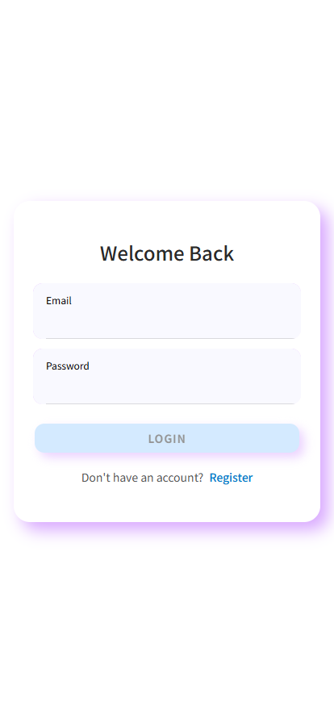

Register Page

After entering the registration page, you need to fill in the following necessary information.

* User name: Please enter the user name you want to register in this application.
* Email: Please enter your usual email address.
* Password: The password should meet the strength standard (8-20 digits, including numbers, uppercase letters, lowercase letters, please avoid using simple passwords to ensure the security of your account).

After confirming that your information is correct, please click the ‘REGISTER’ button to register your account, and then return to the login screen to log in.

Register page

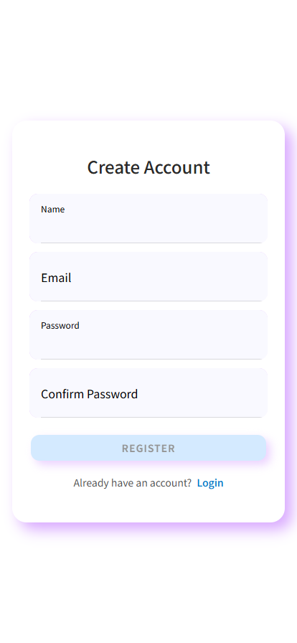

Functions detailed after logging in:

Successful login will be as shown below:

#### 5.1.2.2 My Home Tab

My Favorite: Used to view and manage user's favourite posts.

My Posts: You can browse, edit or delete your own posts on the platform and share them with other users.

Privacy: You can enter the privacy settings page to manage and adjust your privacy information and permissions.

Contract Us：Contact Us, which provides a way to communicate with the customer service or team of the platform for feedback and suggestions.

change password: Allow users to change the current login password to ensure account security.

change account：Supports switching between different accounts or performing account-related management operations.

Download Feature Image: Allows you to download the AR tracking image and print it using a printer.

Support Us：Provide ways to support the platform, such as donations, sponsorships, etc., to help the platform continue to develop.

Guitar: Access to the AR learning interface for guitar

Music Score: Used to view tutorials and music scores.

AI: LLM-based dialogue robot for guitar teaching

Chat: opens the chat interface, which is convenient for users to communicate and interact with each other, e.g. asking questions, sharing experience, etc.

My Home: return to personal homepage, centralised management and view of personal information, settings and frequently used functions.

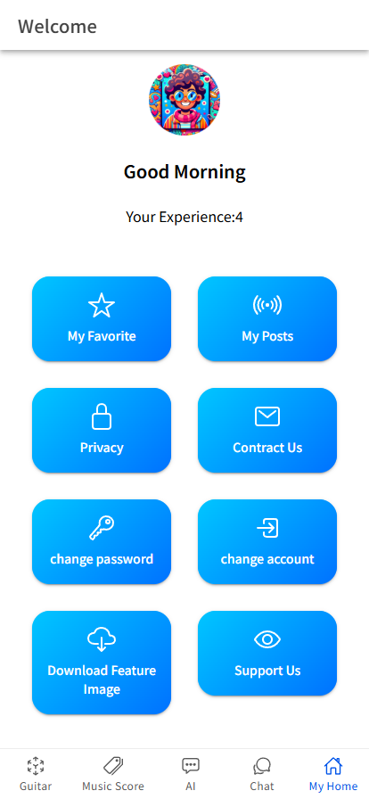

#### 5.1.2.3 Chat Tab

Users can view content shared by others on this page as well as post content on this page. Users can Like, Favourite and View Comment for each post. At the bottom, users can enter the content they want to share and post it.

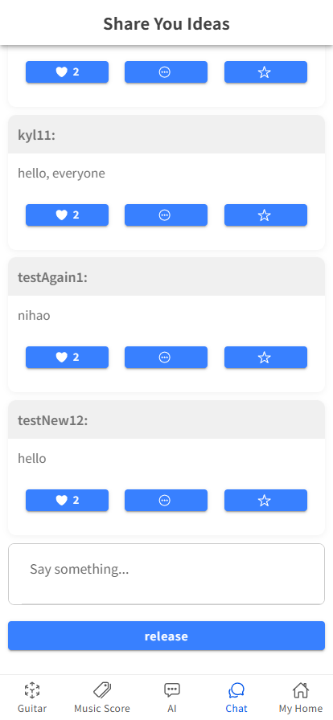

#### 5.1.2.4 AI Tab

This tab is used to ask ai some question. You can input your question in the blank and click on Ask AI button to get help from AI.

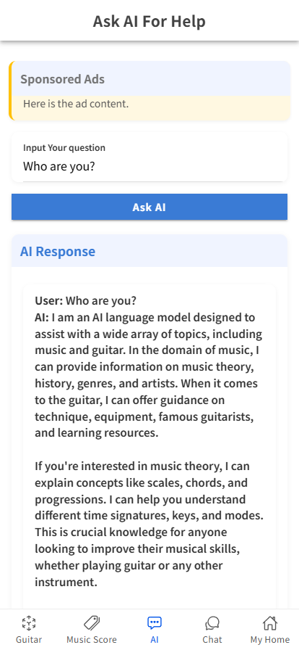

**5.1.2.5 Music Score Tab**

This page will contain the guitar lessons that we have created together for our users, as well as lessons from hard to easy, where you can choose the lesson or the sheet music that you want to see to learn.

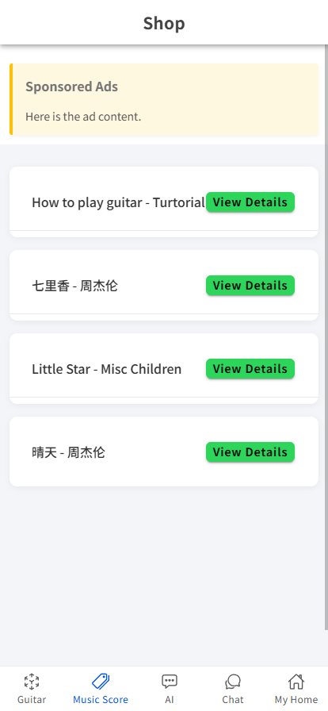

#### 5.1.2.6 Guitar Tab

Click the button to start AR Tracking Learning mode.

In this part of the application, you can use the QR code to track the fret board and show you where you can put your finger.

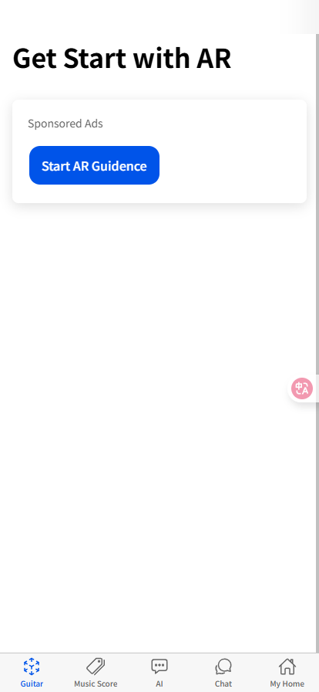

## 5.2 Reference Manuals

Objective: Provide technical details for long-term maintenance and scalability.

### 5.2.1 System Architecture Overview

|  |  |  |  |
| --- | --- | --- | --- |
| Component | Technology Stack | Version | Notes |
| Front-end | Unity Engine, AR Core XR Plugin | 2021.3.1f1, 4.2.10 | Requires a depth-sensing camera. |
| Back-end | Node.js, MySQL | 8.0, 16.14.0 | API endpoints are documented [here](https://scu-it.atlassian.net/wiki/spaces/ITP125GX5/pages/201196085/Final+Client+Documentation). |
| Database | MySQL, Aliyun OSS, AWS S3 | 8.0 | Automated daily backups at 2:00 AM (GMT+8). |

### 5.2.2 Credentials & Access

|  |  |  |
| --- | --- | --- |
| Service | Credential Storage | Responsible Party |
| Tencent Cloud | LastPass (shared vault) | Client IT Manager |
| Developer Account | 1Password | Development Team |
| AR Core API Key | Confluence (restricted page) | Project Lead |

### 5.2.3 Maintenance Protocols

Server Updates:

* Monthly security patches are applied via the cloud console.
* Downtime window: Sundays 12:00 AM – 2:00 AM (GMT+8).

Data Backup: Automated daily backups to OSS.

Retention policy: 30 days.

Third-Party Dependencies:

* ARCore SDK updates are tracked via the Unity Dashboard.
* License renewals: Managed by the client’s procurement team (alert 30 days before expiry).

### 5.2.4 Client-Specific Customization

Objective: Tailor the app to align with client branding and sales strategies.

#### 5.2.4.1 Branding Integration

UI Customization:

* Replace default colors with the client’s brand palette (e.g., #2E7D32 for primary buttons).
* Upload custom logo via CMS.

Localization:

* Supported languages: English, Simplified Chinese.
* Add new languages via a file.

#### 5.2.4.2 Sales Enablement

Demo Mode:

1. Preloaded with popular songs for in-store demonstrations.
2. Activate via "Settings → Demo Mode".

Promotional Bundles:

Coupon codes for app premium features are bundled with guitar purchases.

### 5.2.5 Support & Escalation

Objective: Ensure timely resolution of technical issues.

|  |  |  |
| --- | --- | --- |
| Issue Type | Contact Channel | SLA |
| Critical (App crash, data loss) | Phone: +86 13839659020 | 2-hour response, 24-hour fix. |
| High (AR tracking failure) | Service Desk: Submit Ticket | 12-hour response, 48-hour fix. |
| General (UI bugs, feature requests) | Comments (@Team) | 24-hour response, added to backlog. |

### 5.2.6 Training Materials

Target Audience: End-users (guitar learners/teachers), admin users (management portal operators), and developers.

End-User Guides (Ionic Client & AR Features)

AR Guitar Tracking Quick Start Guide (Confluence page with step-by-step screenshots):

How to enable AR mode:

Open Ionic app → Tap "Start AR Practice" → Grant camera permissions → Wait for Google AR Core initialization (with troubleshooting: "If AR fails, check Settings → Apps → Google AR Core is installed/updated").

Calibration steps:

Place guitar on flat surface → Align 6 strings with on-screen guides → Confirm calibration (notes: "Calibration persists for 7 days; re-calibrate if tracking drifts").

Practice workflow:

Select a lesson → Follow AR overlay to position fingers → Track accuracy in real-time (explanation: "Green/red indicators show fret/string correctness").

Video Tutorials (attached to Confluence):

"How to Use AR Guitar Tracing": Demo of launching AR, calibrating, and practicing a chord progression (10-minute video with voiceover).

"Submitting Practice Records": Walk through of saving practice data (accuracy, duration) to the app and syncing with the back-end.

Admin Portal Guides (Angular Management Dashboard)

Course Management Manual (Confluence sub-page):

Adding/editing lessons:

Navigate to "Admin → Courses" → Upload lesson videos (MP4, ≤100MB) → Assign difficulty tags (Beginner/Intermediate/Advanced).

**Viewing learner data:**

Filter by date, student ID, or lesson → Export reports as CSV (notes: "Data retained for 2 years per GDPR; contact us for deletion requests").

Technology Stack & Dependencies

Client (Ionic 7.2.0):

Front-end: TypeScript 5.3.3, Angular 16+ (aligned with Ionic 7).

AR Integration: Unity 2022.3.60f1 (exported as Android library), Google AR Core (v1.40.0) for AR tracking.

Back-end (Node.js/Express 4.21.0):

Runtime: Node.js 18.17.0 (LTS).

Database: MySQL 8.4.3 (schema: guitar_tracking with tables: students, lessons, practice_records).

**Deployment:**

Angular management portal: Hosted on Vercel (auto-deploy from main branch).

Node.js API: Deployed to AWS EC2 (Ubuntu 22.04), Nginx reverse proxy, PM2 for process management.

AR & Unity Integration Details

Unity-Ionic Communication Flow:

Ionic triggers AR via launchAR() (customized from Iteration 1’s unityARCaller plugin) → Unity initializes AR Core session → Sends real-time tracking data (fret positions, string IDs) to Ionic via SendMessageToIonic().

Example: Unity sends { "fret": 3, "string": 2, "accuracy": 85 } → Ionic renders overlay.

**AR Core Setup:**

Required dependencies: com.google.ar:core:1.40.0 (Android) → Added to Unity’s Plugins/Android folder.

**Build notes:**

* Unity export: Use Gradle 8.7.2 (set in Unity’s Build Settings → Android → Gradle Version).
* Android Studio: Merge Unity’s AndroidManifest.xml with Ionic’s, ensuring ARCoreRequired is set to false (allow non-AR devices to use basic app features).
* Back-end & Database

**API Endpoints (Express):**

POST /api/song: Upload song metadata (name, artist, lyrics).

GET /api/user/:studentId: Fetch user details

PUT /api/users: Update student profile (handles username, email, password).

Backup & Recovery:

Daily MySQL backups via mysqldump (stored in AWS S3).

Restore command: mysql -u [user] -p guitar_tracking < backup_20231010.sql.

### 5.2.7. Confidential Information Management

Sensitive Data:

MySQL root credentials, AWS EC2 SSH keys, and OpenAI API keys (used for AR gesture recognition model training).

Access Control:

Managed via LastPass: Shared with the client’s CTO and lead developer.

OpenAI keys: Restricted to ar-dev@guitarapp.com

### 5.2.8 Deliverable

AR tracking MVP: Functional for basic chord practice (no App Store release yet; internal testing only).

Management portal: CRUD for lessons and student data.

Back-end API: Stable endpoints for syncing practice records.

## 5.3 Client Handover Documentation

Customer Handover Document for Guitar Learning AR Application

### 5.3.1 Project Details

#### 5.3.1.1 Product Description

This project is a guitar learning AR application designed to capture the guitar's position through a smartphone camera and display real-time hand fingering positions in augmented reality (AR), assisting guitar beginners and advanced learners in enhancing their playing skills. Core functions include:

Real-time AR Guidance: Identify the guitar via the phone camera and overlay AR markers on the screen to indicate the correct finger positions on the fretboard.

Sheet Music Creation and Sharing: Users can create custom sheet music, upload it to the server, and share learning resources with other users.

Progress Tracking: Record practice data to help users quantify their learning outcomes.

Product Objective: Address the pain points of traditional guitar learning methods (books, videos, tutoring)—such as boring and high costs—by using AR technology to enhance learning fun and a sense of achievement, while lowering the entry barrier.

#### 5.3.1.2 Product Deliverables

|  |  |
| --- | --- |
| Category | Details |
| Application | Android installation package (.apk)  User Management Page (source code) |
| Documentation | Implementation and Handover Document (this file)  User Operation Guide (including AR function tutorials and sheet music creation processes)  Technical Architecture Specification (including Unity configuration and AR Core integration details)  Maintenance Manual (database update and server management guidelines) |
| Database | Production environment database backup (MySQL format, including initial sheet music resources and user data structures)  Database design ER diagram (PDF format) |
| Testing Resources | Test case set (including AR recognition, video recording, and other functional test steps)  Beta test report (summary of user feedback and solutions) |
| Other Resources | Sample sheet music files (AR fingering scores for popular songs) |

### 5.3.2 Implementation Details

#### 5.3.2.1 Technical Architecture Overview

Development Environment

|  |  |  |
| --- | --- | --- |
| Component | Version | Description |
| Unity 3D | 2021.3.1f1c1 | Real-time 3D development engine for AR scene construction and interactive logic development |
| ARCore XR Plugin | 4.2.10 | Integrates Google ARCore, supporting plane detection, anchor tracking, and depth data acquisition |
| MySQL | 8.0 | Relational database for storing user information, sheet music data, and practice records |
| Git | 2.40 | Version control system for team collaboration and code management |
| IntelliJ IDEA | 2022 | Back-end development IDE |

Production Environment Configuration

|  |  |
| --- | --- |
| Type | Configuration Requirements |
| Server (self-built) | Network: 5G bandwidth, supporting HTTPS encryption |
| Client Device (Minimum) | OS: Android 11+/iOS 14+  CPU: Qualcomm Snapdragon 480/Apple A11  Memory: 8GB  Storage: 64GB  Camera: Supports depth sensing (essential for AR recognition) |

#### 5.3.2.2 Server and Deployment Information

Cloud Service Configuration:

Service Provider: Self-built

Server Instance:

Region: Guangxi (can be adjusted based on user distribution)

Bandwidth: 10Mbps (can be upgraded as needed)

Access Methods:

Management back-end: <https://vercel.com/sailious-projects/maintainance-project> (administrator account provided separately)

Database connection: jdbc:mysql://[localhost:3306/guitar_learning](https://localhost:3306/guitar_learning)

Deployment Process:

Download the Unity project package and import it using Unity Hub 3.3.1.

Configure the AR Core plugin in Unity, enabling "Depth Data" and "Plane Detection" functions.

Connect to Tencent Cloud Database and import final_database_guitar.sql to initialize data.

Generate Android/iOS installation packages and release them after passing app store reviews.

#### 5.3.2.3 Local Testing Guide

Environment Preparation:

Install Unity 2021.3.1f1c1 and AR Core XR Plugin 4.2.10.

Configure Android Studio (for Android testing) or Xcode (for iOS testing).

Download Compressed_SourceCode_GuitarAR.zip and test_database.sql.

Testing Steps:

Import the Unity project and open Assets/Scenes/MainScene.unity.

Connect to the local test database and execute test_database.sql.

Connect a mobile device (supporting ARCore/ARKit), click the "Play" button to start testing.

Refer to test cases in Documentation/Test_Cases_GuitarAR.xlsx.

#### 5.3.2.4 Remaining Tasks and Known Issues

Incomplete Functions

Items to be optimized:

Hand recognition

Real-time sound feedback (planned to be integrated via AudioPlugin in subsequent versions).

Known Issues and Solutions

AR recognition delay: Suggest users maintain a distance of 50-100cm between the phone camera and guitar, and use it in a well-lit environment.

Incomplete multilingual translations: English and Japanese translations are pending; they can be manually added via Assets/Localization/Translations.json.

### 5.3.3 Product Acceptance and Support

#### 5.3.3.1 Acceptance Criteria

Functional Acceptance:

String position display accuracy ≥90%.

Smooth sheet music creation and sharing processes.

Performance Acceptance:

Application startup time ≤3 seconds.

AR scene rendering frame rate ≥30fps.

Database query response time ≤500ms.

5.3**.3.2 Training and Support**

Training Plan:

Basic Training:

Time: Within 3 working days after handover

Form: Online meeting (Tencent Meeting)

Content: Application management back-end operations, user feedback handling, and simple fault troubleshooting

Advanced Training (optional):

Cost: Free (within 3 months after handover)

Content: Unity project secondary development, AR function expansion, and database optimization

Technical Support:

Contact Information:

Project Manager: Li Yunlin (+86 13839659020)

Technical Email: [2511994585@qq.com](mailto:2511994585@qq.com)

Support Period:

Free maintenance period: 12 months (from the handover date)

Paid maintenance: Charged by the hour thereafter (standard: ¥500/hour)

#### 5.3.3.3 Intellectual Property and Ownership

The intellectual property rights of the product source code (excluding third-party plugins like Unity and ARCore), database structure, UI design, and original content belong to the development team, and the customer enjoys perpetual right to use them.

The customer can freely use, modify, and distribute the product, but shall not use the source code for commercial redevelopment or authorize third parties to use it.

The intellectual property rights of third-party materials (such as copyrighted music in sample sheet music) belong to the original right holders, and the customer must ensure their legal use.

# 6. Team Project Contribution

Yunlin LI : User Center and Growth System

contribution： 25%

Kun YE: AR Guitar Finger Position Guidance and Training

contribution： 25%

Zihan Wei: Sheet music library and course management

contribution： 25%

Tianzhen Rui: System management and community interaction

contribution： 25%

# 7 References

[1] Skreinig, L. R., Kalkofen, D., Stanescu, A., Mohr, P., Heyen, F., Mori, S., Sedlmair, M., Schmalstieg, D., & Plopski, A. (2023). guitARhero: Interactive Augmented Reality Guitar Tutorials. IEEE Transactions on Visualization and Computer Graphics, 29(99), 1-10.

[2] Hees, J. (2021). Augmented reality feedback visualization for guitars in music education. University of Stuttgart.

[3] Kiourexidou, M., Kanavos, A., Klouvidaki, M., & Antonopoulos, N. (2024). Exploring the Role of User Experience and Interface Design Communication in Augmented Reality for Education. Multimodal Technologies and Interaction, 8(6), 43.

[4] Đurđević, S., Juretić, I., & Vukanić, L. (2024). DEVELOPMENT OF A MOBILE AUGMENTED REALITY APPLICATION FOR INTERIOR DESIGN USING UNITY ENGINE. INTERNATIONAL SYMPOSIUM ON GRAPHIC ENGINEERING AND DESIGN.

[5] Rhodes, C., Garcia-Peguinho, N., Beesley, L., Fan, H., Jay, C., Allmendinger, R., & Climent, R. (2025). Ground truths: challenges and opportunities in developing an AI guitar assistant. Frontiers in Computer Science, 7, 1549335.

[6] Arul, B., Panda, S., & Nair, T. (2024). AirStrum: A virtual guitar using real-time hand gesture recognition and strumming technique. Revista Română de Informatică și Automatică, 34(4), 127-139.

[7] Graf, M., & Barthet, M. (2023). Combining Vision and EMG-Based Hand Tracking for Extended Reality Musical Instruments. arXiv preprint arXiv:2307.10203.

[8] Ransanz Reyes, E., Arana-Cuenca, A., & Manzanal Martínez, A. I. (2025). Recommendations for designing collaborative activities in online higher education: A systematic review. Journal of Technology and Science Education, 15(1), 4-17.

[9] Bach, A., & Thiel, F. (2024). Collaborative online learning in higher education—quality of digital interaction and associations with individual and group-related factors. Frontiers in Education, 9, 1356271.

[10] Nordin, N. B., & Azahari, M. H. B. (2024). Integrating Digital Content to Promote Collaborative Learning in a Physical Classroom Context. International Journal of Research in Education Humanities and Commerce, 5(2).

[11] Kaisara, G., Peel, C., Niemand, C. J. P., & Bwalya, K. J. (2024). Exploring Factors Influencing e-Learning Dropout Rates in the Post-COVID-19 Era. International Journal of Information and Communication Technology Education, 20(1), 1-13.

[12] Angra, S., Jangra, S., Gulzar, Y., Sharma, B., Singh, G., & Onn, C. W. (2025). Twenty-two years of advancements in augmented and virtual reality: a bibliometric and systematic review. Frontiers in Computer Science, 7, 1470038.

[13] Criollo-C, S., Guerrero-Arias, A., Miftachul Arif, Y., Dwinggo Samala, A., Jaramillo-Alcázar, Á., & Luján-Mora, S. (2025). Usability Evaluation of a Mobile Augmented Reality App for PC Hardware Training: A Comparative Study in Three Countries. Emerging Science Journal, 9(2), 977–994.

[14] Rohendi, D., Ramadhan, M. O., Rahim, S. S. A., & Zulnaidi, H. (2025). Enhancing student’s interactivity and responses in learning geometry by using augmented reality. EURASIA Journal of Mathematics, Science and Technology Education, 21(1), em2559.

[15] Zou, Y., Kuek, F., Feng, W., & Cheng, X. (2025). Digital learning in the 21st century: trends, challenges, and innovations in technology integration. Frontiers in Education, 10, 1562391.

[16] Mueller, F., Bernard, F., Sotnychenko, O., Mehta, D., Sridhar, S., Casas, D., & Theobalt, C. (2018). GANerated Hands for Real-Time 3D Hand Tracking from Monocular RGB. Proceedings of the IEEE Conference on Computer Vision and Pattern Recognition (CVPR), 49-59.

[17] Linowes, J. (2021). Augmented Reality with Unity AR Foundation: A practical guide to cross-platform AR development with Unity 2020 and later versions. Packt Publishing.

[18] Krug, S. (2013). Don't Make Me Think, Revisited: A Common Sense Approach to Web Usability. New Riders.

[19] Atkinson, M. L. (2024). The Learner's Experience Using Augmented Reality. Brigham Young University.

[20] Reimer, D. (2024). Hand tracking in colocated multi-user virtual reality. Technische Universität Wien.

# 致 谢

During the process of our group completing the graduation project, the supervisor gave me meticulous guidance and valuable suggestions, enabling us to keep growing in academic research and practical exploration. Here, I would like to express my most sincere gratitude to my supervisor. Your patient guidance and rigorous academic spirit have benefited me a lot.

Meanwhile, I would like to express my gratitude to all the classmates and friends who have offered help during the research process. Their discussions and suggestions have given me a clearer idea in problem analysis and solution optimization. Furthermore, we would also like to express our gratitude to the colleges and related organizations that provided resource support, which offered us a favorable research environment and enabled the successful completion of this design.

Finally, I would like to express my gratitude to our families. Their understanding and encouragement have always been the driving force for me to keep moving forward. It is precisely because of these supports that we were able to successfully complete the graduation project. Thank you to all those who have helped me!

# Appendix: Presentation Slides

There are pictures of our all PPT:

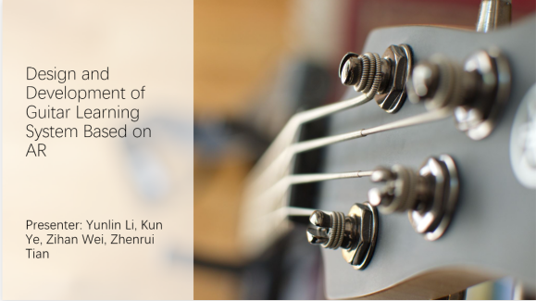

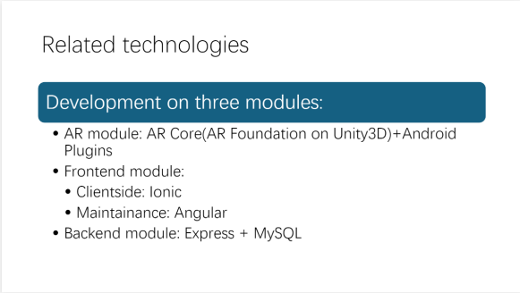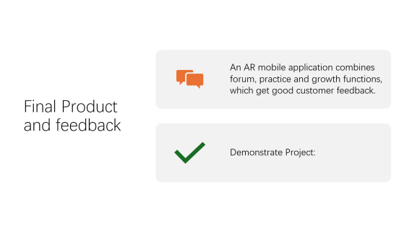

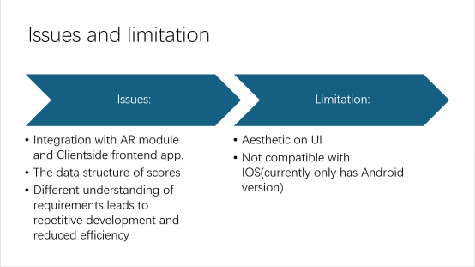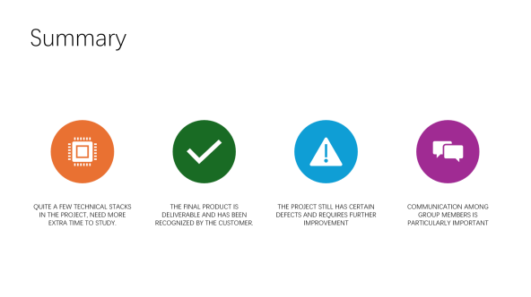

# Appendix: Documents on JIRA

|  |  |  |  |
| --- | --- | --- | --- |
| **Sprint** | ITP125GX Sprint 1 Planning | **Start Date** | March 27, 2025 |
| **Duration** | 20 days | **End Date** | April 3, 2025 |
| **Description** | Make some planning arrangements, including UI/UX design and subsequent development work arrangements. Conduct a survey for the general public, collect feedback to modify UI/UX | | |

|  |  |  |  |
| --- | --- | --- | --- |
| **Sprint** | ITP125GX Sprint 2 Preparation | **Start Date** | April 3, 2025 |
| **Duration** | 13 days | **End Date** | April 16, 2025 |
| **Description** | Environment configuration and installation ensure that all preparation work has been completed before the development sprint. | | |

|  |  |  |  |
| --- | --- | --- | --- |
| **Sprint** | ITP125GX Sprint 3 Development1 | **Start Date** | April 16, 2025 |
| **Duration** | 16 days | **End Date** | May 5, 2025 |
| **Description** | Finish All the development goals below:  1. AR core track function sample app and the front-end prototype.  2. Login system finish  3. AI function work | | |

|  |  |  |  |
| --- | --- | --- | --- |
| **Sprint** | ITP125GX Sprint 4 Development 2 | **Start Date** | May 2, 2025 |
| **Duration** | 18 days | **End Date** | May 20, 2025 |
| **Description** | Finish All the development goals below:  1. Maintenance subsystem with CURD for comment information  2. Comment Subsystem  3. Songs scores subsystem for user views  4. Home Functions (Experience growth record and information setting)  5. AR and Ionic combine  6. AR functions on chords guidance | | |

|  |  |  |  |
| --- | --- | --- | --- |
| **Sprint** | ITP125GX Sprint 5 Handover | **Start Date** | May 20, 2025 |
| **Duration** | 21 days | **End Date** | June 10, 2025 |
| **Description** | UI improvement and optimize performance | | |

|  |  |  |  |
| --- | --- | --- | --- |
| **[ITP125GX5-7] Client Application Development** | | | |
| **Sprint** | ITP125GX Sprint 1 Planning, ITP125GX Sprint 2 Preparation, ITP125GX Sprint 3 Development1, ITP125GX Sprint 4 Development2, ITP125GX Sprint 5 Handover | **Type** | Epic |
| **Priority** | Highest | **Assignee** | Yunlin Li |
| **Labels** |  | | |
| **Description** | Developing an AR application for guitar beginners and teaching staff. | | |
| **Parent** |  | | |
| **Child Work Items** | [ITP125GX5-166] Combine Unity as a Plugin Can Not Work Well in Ionic [ITP125GX5-188] Auto-Adjust AR Tracking Quality  [ITP125GX5-186] Efficient Background Tasks  [ITP125GX5-185] Incremental Comment Loading  [ITP125GX5-182] Fast Login Process  [ITP125GX5-179] Fast AR Tracking Initialization  [ITP125GX5-177] Minimal Battery Usage  [ITP125GX5-176] Smooth AR Guitar Tracking  [ITP125GX5-175] Fast Home Page Loading  [ITP125GX5-172] Smooth Screen Transitions  [ITP125GX5-171] Cleaner Shop Interface  [ITP125GX5-170] Responsive UI  [ITP125GX5-169] Simplified Comment Page  [ITP125GX5-168] Interactive Tooltips/Tutorials  [ITP125GX5-167] Intuitive Navigation Bar  [ITP125GX5-130] Combine AR and Frontend App  [ITP125GX5-129] Volume Button Chord Control  [ITP125GX5-128] Real-Time AR Chord Practice  [ITP125GX5-126] Experience on Home Page  [ITP125GX5-125] Change Personal Information  [ITP125GX5-124] View Liked Scores  [ITP125GX5-108] AI-Based Song/Chord Recognition  [ITP125GX5-97] Test All Functions  [ITP125GX5-96] Clean UI Design  [ITP125GX5-75] Mobile App Usage  [ITP125GX5-63] Registration Information  [ITP125GX5-62] Login Information  [ITP125GX5-61] Database for User Accounts  [ITP125GX5-60] Receive Register Request  [ITP125GX5-59] Receive Login Request  [ITP125GX5-58] Unity for Image Tracking  [ITP125GX5-56] Switch Login/Register Card  [ITP125GX5-55] Community Page Navigation  [ITP125GX5-54] Login Page Navigation  [ITP125GX5-53] Shop Page Navigation  [ITP125GX5-52] AI Page Navigation  [ITP125GX5-51] AR Guide Page Navigation  [ITP125GX5-38] Share Guitarist Experience  [ITP125GX5-35] Unity for Image Recognition  [ITP125GX5-165] Blackbox Test  [ITP125GX5-70] GitHub Repository Build  [ITP125GX5-17] Design Database Map  [ITP125GX5-16] Rough UI with WebStorm  [ITP125GX5-13] Front-Stack Environment  [ITP125GX5-11] UI/UX Design and Wireframe | | |

|  |  |  |  |
| --- | --- | --- | --- |
| **[ITP125GX5-8] Maintenance Backend Page** | | | |
| **Sprint** | ITP125GX Sprint 1 Planning, ITP125GX Sprint 2 Preparation, ITP125GX Sprint 3 Development1, ITP125GX Sprint 4 Development2, ITP125GX Sprint 5 Handover | **Type** | Epic |
| **Priority** | Medium | **Assignee** | Zhenrui Tian |
| **Labels** |  | | |
| **Description** | Maintenance side to manage all users' data and account. | | |
| **Parent** |  | | |
| **Child Work Items** | [ITP125GX5-189] Efficient Database Queries  [ITP125GX5-187] Optimize ARCore Integration  [ITP125GX5-184] Code Splitting in Angular  [ITP125GX5-183] Lazy Loading for Components  [ITP125GX5-180] Handle 1,000 Concurrent Requests  [ITP125GX5-174] Consistent Admin Interface Design  [ITP125GX5-173] Redesigned Admin Dashboard  [ITP125GX5-131] View and Edit Subsystem Data  [ITP125GX5-127] Subsystem for Data Management  [ITP125GX5-105] Development Environment Setup  [ITP125GX5-32] Collect User Feedback (Questionnaire)  [ITP125GX5-15] Database Environment  [ITP125GX5-14] Back-Stack Environment  [ITP125GX5-12] Obtain User Feedback  [ITP125GX5-10] Create Flowchart  [ITP125GX5-9] Project Schedule | | |

|  |  |  |  |
| --- | --- | --- | --- |
| **[ITP125GX5-166] Combine Unity as a Plugin Can Not Work Well in Ionic** | | | |
| **Sprint** | ITP125GX Sprint 4 Development2 | **Type** | Bug |
| **Priority** | Highest | **Assignee** | Kun Ye |
| **Labels** | AR, Integration | | |
| **Description** | Combining Unity as a plugin in Ionic results in a null pointer error in C++, a black view, a 10-second wait, and a jump to the Ionic login page. | | |
| **Parent** | [ITP125GX5-7] Client Application Development | | |
| **Child Work Items** |  | | |

|  |  |  |  |
| --- | --- | --- | --- |
| **[ITP125GX5-188] As a learner, I want the app to automatically adjust AR tracking quality based on my device’s capabilities for the best experience without manual configuration.** | | | |
| **Sprint** | ITP125GX Sprint 5 Handover | **Type** | Story |
| **Priority** | Highest | **Assignee** | Kun Ye |
| **Labels** | AR | | |
| **Description** | As a learner, I want the app to automatically adjust AR tracking quality based on my device’s capabilities for the best experience without manual configuration. | | |
| **Parent** | [ITP125GX5-7] Client Application Development | | |
| **Child Work Items** | [ITP125GX5-210] Use highest Android version | | |

|  |  |  |  |
| --- | --- | --- | --- |
| **[ITP125GX5-186] As a learner, I want the app to handle background tasks (e.g., syncing progress) efficiently to avoid slowdowns in AR mode.** | | | |
| **Sprint** | ITP125GX Sprint 5 Handover | **Type** | Story |
| **Priority** | Medium | **Assignee** | Zihan Wei |
| **Labels** | Performance | | |
| **Description** | As a learner, I want the app to handle background tasks (e.g., syncing progress) efficiently to avoid slowdowns in AR mode. | | |
| **Parent** | [ITP125GX5-7] Client Application Development | | |
| **Child Work Items** | [ITP125GX5-208] Async and await | | |

|  |  |  |  |
| --- | --- | --- | --- |
| **[ITP125GX5-185] As a learner, I want the comment page to load new comments incrementally to avoid delays in long discussion threads.** | | | |
| **Sprint** | ITP125GX Sprint 5 Handover | **Type** | Story |
| **Priority** | Highest | **Assignee** | Kun Ye |
| **Labels** | AR | | |
| **Description** | As a learner, I want the comment page to load new comments incrementally to avoid delays in long discussion threads. | | |
| **Parent** | [ITP125GX5-7] Client Application Development | | |
| **Child Work Items** | [ITP125GX5-207] Add logics to return a part of comments | | |

|  |  |  |  |
| --- | --- | --- | --- |
| **[ITP125GX5-182] As a learner, I want the login process to complete in under 3 seconds for quick and secure access.** | | | |
| **Sprint** | ITP125GX Sprint 5 Handover | **Type** | Story |
| **Priority** | Medium | **Assignee** | Zihan Wei |
| **Labels** | Login | | |
| **Description** | As a learner, I want the login process to complete in under 3 seconds for quick and secure access. | | |
| **Parent** | [ITP125GX5-7] Client Application Development | | |
| **Child Work Items** |  | | |

|  |  |  |  |
| --- | --- | --- | --- |
| **[ITP125GX5-179] As a learner, I want AR tracking to initialize in under 5 seconds for quick practice.** | | | |
| **Sprint** | ITP125GX Sprint 5 Handover | **Type** | Story |
| **Priority** | Highest | **Assignee** | Kun Ye |
| **Labels** | AR | | |
| **Description** | As a learner, I want AR tracking to initialize in under 5 seconds for quick practice. | | |
| **Parent** | [ITP125GX5-7] Client Application Development | | |
| **Child Work Items** | [ITP125GX5-214] Unity Minify check Release | | |

|  |  |  |  |
| --- | --- | --- | --- |
| **[ITP125GX5-177] As a learner, I want minimal battery usage during extended practice sessions.** | | | |
| **Sprint** | ITP125GX Sprint 5 Handover | **Type** | Story |
| **Priority** | Highest | **Assignee** | Kun Ye |
| **Labels** | AR, UI | | |
| **Description** | As a learner, I want minimal battery usage during extended practice sessions. | | |
| **Parent** | [ITP125GX5-7] Client Application Development | | |
| **Child Work Items** | [ITP125GX5-203] Reduce operations when running apps | | |

|  |  |  |  |
| --- | --- | --- | --- |
| **[ITP125GX5-176]** **As a learner, I want smooth AR guitar tracking without lag on mid-range devices.** | | | |
| **Sprint** | ITP125GX Sprint 5 Handover | **Type** | Story |
| **Priority** | Highest | **Assignee** | Kun Ye |
| **Labels** | AR, UI | | |
| **Description** | As a learner, I want smooth AR guitar tracking without lag on mid-range devices. | | |
| **Parent** | [ITP125GX5-7] Client Application Development | | |
| **Child Work Items** | [ITP125GX5-201] Use Dictionary for storing chords  [ITP125GX5-202] Delete useless invoke logics and simplify | | |

|  |  |  |  |
| --- | --- | --- | --- |
| **[ITP125GX5-175]** **As a learner, I want the home page to load in under 2 seconds.** | | | |
| **Sprint** | ITP125GX Sprint 5 Handover | **Type** | Story |
| **Priority** | High | **Assignee** | Yunlin Li |
| **Labels** | UI | | |
| **Description** | As a learner, I want the home page to load in under 2 seconds. | | |
| **Parent** | [ITP125GX5-7] Client Application Development | | |
| **Child Work Items** | [ITP125GX5-200] Optimization of performance on code level | | |

|  |  |  |  |
| --- | --- | --- | --- |
| **[ITP125GX5-172] As a learner, I want smooth transitions and animations between screens.** | | | |
| **Sprint** | ITP125GX Sprint 5 Handover | **Type** | Story |
| **Priority** | High | **Assignee** | Yunlin Li |
| **Labels** | UI | | |
| **Description** | As a learner, I want smooth transitions and animations between screens. | | |
| **Parent** | [ITP125GX5-7] Client Application Development | | |
| **Child Work Items** | [ITP125GX5-197] Add automatic jump scheme | | |

|  |  |  |  |
| --- | --- | --- | --- |
| **[ITP125GX5-171] As a learner, I want a cleaner shop interface to quickly find songs matching my preferences and skill level.** | | | |
| **Sprint** | ITP125GX Sprint 5 Handover | **Type** | Story |
| **Priority** | High | **Assignee** | Yunlin Li |
| **Labels** | UI | | |
| **Description** | As a learner, I want a cleaner shop interface to quickly find songs matching my preferences and skill level. | | |
| **Parent** | [ITP125GX5-7] Client Application Development | | |
| **Child Work Items** | [ITP125GX5-196] Redesign shop tab UI | | |

|  |  |  |  |
| --- | --- | --- | --- |
| **[ITP125GX5-170] As a learner, I want a responsive UI that adapts to different screen sizes.** | | | |
| **Sprint** | ITP125GX Sprint 5 Handover | **Type** | Story |
| **Priority** | High | **Assignee** | Yunlin Li |
| **Labels** | UI | | |
| **Description** | As a learner, I want a responsive UI that adapts to different screen sizes. | | |
| **Parent** | [ITP125GX5-7] Client Application Development | | |
| **Child Work Items** | [ITP125GX5-194] Design logics of adaptation UI  [ITP125GX5-195] Edit SCSS | | |

|  |  |  |  |
| --- | --- | --- | --- |
| **[ITP125GX5-169] As a learner, I want a simplified comment page layout with threaded replies.** | | | |
| **Sprint** | ITP125GX Sprint 5 Handover | **Type** | Story |
| **Priority** | High | **Assignee** | Yunlin Li |
| **Labels** | UI | | |
| **Description** | As a learner, I want a simplified comment page layout with threaded replies. | | |
| **Parent** | [ITP125GX5-7] Client Application Development | | |
| **Child Work Items** | [ITP125GX5-193] Comment tab UI improve | | |

|  |  |  |  |
| --- | --- | --- | --- |
| **[ITP125GX5-168] As a learner, I want interactive tooltips or onboarding tutorials for the AR feature.** | | | |
| **Sprint** | ITP125GX Sprint 5 Handover | **Type** | Story |
| **Priority** | High | **Assignee** | Yunlin Li |
| **Labels** | UI | | |
| **Description** | As a learner, I want interactive tooltips or onboarding tutorials for the AR feature. | | |
| **Parent** | [ITP125GX5-7] Client Application Development | | |
| **Child Work Items** | [ITP125GX5-192] Record guidance demo | | |

|  |  |  |  |
| --- | --- | --- | --- |
| **[ITP125GX5-167] As a learner, I want an intuitive navigation bar with clear icons and labels.** | | | |
| **Sprint** | ITP125GX Sprint 5 Handover | **Type** | Story |
| **Priority** | High | **Assignee** | Yunlin Li |
| **Labels** | UI | | |
| **Description** | As a learner, I want an intuitive navigation bar with clear icons and labels. | | |
| **Parent** | [ITP125GX5-7] Client Application Development | | |
| **Child Work Items** | [ITP125GX5-190] Edit tab bar  [ITP125GX5-191] Edit tab bar | | |

|  |  |  |  |
| --- | --- | --- | --- |
| **[ITP125GX5-130] As an app user, I want to combine AR module and frontend app for fluent use without manual switching.** | | | |
| **Sprint** | ITP125GX Sprint 4 Development2 | **Type** | Story |
| **Priority** | Highest | **Assignee** | Kun Ye |
| **Labels** | AR, Frontend | | |
| **Description** | As an app user, I want to combine AR module and frontend app for fluent use without manual switching. | | |
| **Parent** | [ITP125GX5-7] Client Application Development | | |
| **Child Work Items** | [ITP125GX5-158] Make plans for the function  [ITP125GX5-159] Try the capacitor plugin insert plan  [ITP125GX5-160] Directly jump to Unity if not working | | |

|  |  |  |  |
| --- | --- | --- | --- |
| **[ITP125GX5-129] As an app user, I want to use the volume physical button to control chord switching.** | | | |
| **Sprint** | ITP125GX Sprint 4 Development2 | **Type** | Story |
| **Priority** | High | **Assignee** | Kun Ye |
| **Labels** | AR, Android | | |
| **Description** | As an app user, I want to use the volume physical button to control chord switching. | | |
| **Parent** | [ITP125GX5-7] Client Application Development | | |
| **Child Work Items** | [ITP125GX5-155] Android develop environment build  [ITP125GX5-156] Android plugin creates and packaged  [ITP125GX5-157] Import to Unity and do some setting | | |

|  |  |  |  |
| --- | --- | --- | --- |
| **[ITP125GX5-128] As an app user, I want to practice chords with real-time guidance in the AR app.** | | | |
| **Sprint** | ITP125GX Sprint 4 Development2 | **Type** | Story |
| **Priority** | Highest | **Assignee** | Kun Ye |
| **Labels** | AR, Function | | |
| **Description** | As an app user, I want to practice chords with real-time guidance in the AR app. | | |
| **Parent** | [ITP125GX5-7] Client Application Development | | |
| **Child Work Items** | [ITP125GX5-152] Chords Prefabs creation (14)  [ITP125GX5-153] Add offsets for prefab on script  [ITP125GX5-154] On script create the locate logics | | |

|  |  |  |  |
| --- | --- | --- | --- |
| **[ITP125GX5-126] As an app user, I want to see my experience on the home page to track software usage growth.** | | | |
| **Sprint** | ITP125GX Sprint 4 Development2 | **Type** | Story |
| **Priority** | Lowest | **Assignee** | Yunlin Li |
| **Labels** | User, Function | | |
| **Description** | As an app user, I want to see my experience on the home page to track software usage growth. | | |
| **Parent** | [ITP125GX5-7] Client Application Development | | |
| **Child Work Items** | [ITP125GX5-148] API build  [ITP125GX5-149] Frontend page edits for add function view | | |

|  |  |  |  |
| --- | --- | --- | --- |
| **[ITP125GX5-125] As an app user, I want to change personal information settings from the home page.** | | | |
| **Sprint** | ITP125GX Sprint 4 Development2 | **Type** | Story |
| **Priority** | Medium | **Assignee** | Yunlin Li |
| **Labels** | User, Setting | | |
| **Description** | As an app user, I want to change personal information settings from the home page. | | |
| **Parent** | [ITP125GX5-7] Client Application Development | | |
| **Child Work Items** | [ITP125GX5-145] API Build  [ITP125GX5-147] Request Build  [ITP125GX5-146] Home page UI design | | |

|  |  |  |  |
| --- | --- | --- | --- |
| **[ITP125GX5-124] As an app user, I want to view liked scores from the scores list for practice.** | | | |
| **Sprint** | ITP125GX Sprint 4 Development2 | **Type** | Story |
| **Priority** | High | **Assignee** | Kun Ye |
| **Labels** | Frontend, Backend | | |
| **Description** | As an app user, I want to view liked scores from the scores list for practice. | | |
| **Parent** | [ITP125GX5-7] Client Application Development | | |
| **Child Work Items** | [ITP125GX5-142] API Build  [ITP125GX5-143] Request Build  [ITP125GX5-144] Create frontend view page | | |

|  |  |  |  |
| --- | --- | --- | --- |
| **[ITP125GX5-108] As an app user, I want an AI-based function to recognize songs or chords.** | | | |
| **Sprint** | ITP125GX Sprint 3 Development1 | **Type** | Story |
| **Priority** | Highest | **Assignee** | Zihan Wei |
| **Labels** | Backend, Development | | |
| **Description** | As an app user, I want an AI-based function to recognize songs or chords. | | |
| **Parent** | [ITP125GX5-7] Client Application Development | | |
| **Child Work Items** | [ITP125GX5-109] AI model chooses  [ITP125GX5-110] AI model build | | |

|  |  |  |  |
| --- | --- | --- | --- |
| **[ITP125GX5-97] As a developer, I want to test all functions to debug and ensure no issues for the next sprint.** | | | |
| **Sprint** | ITP125GX Sprint 3 Development1 | **Type** | Story |
| **Priority** | Highest | **Assignee** | Zhenrui Tian |
| **Labels** | Test | | |
| **Description** | As a developer, I want to test all functions to debug and ensure no issues for the next sprint. | | |
| **Parent** | [ITP125GX5-7] Client Application Development | | |
| **Child Work Items** | [ITP125GX5-100] AR Tracking Test  [ITP125GX5-101] Frontend UI elements Test  [ITP125GX5-103] AI function Test  [ITP125GX5-102] Login system Test | | |

|  |  |  |  |
| --- | --- | --- | --- |
| **[ITP125GX5-96] As an app user, I want a clean and proper UI design for a nice user experience.** | | | |
| **Sprint** | ITP125GX Sprint 3 Development1 | **Type** | Story |
| **Priority** | Medium | **Assignee** | Zhenrui Tian |
| **Labels** | Design, UI | | |
| **Description** | As an app user, I want a clean and proper UI design for a nice user experience. | | |
| **Parent** | [ITP125GX5-7] Client Application Development | | |
| **Child Work Items** | [ITP125GX5-98] Write Storyboards and design first UI  [ITP125GX5-99] Adaption and discussion with teammates | | |

|  |  |  |  |
| --- | --- | --- | --- |
| **[ITP125GX5-75] As an app user, I want to use a mobile app on my phone.** | | | |
| **Sprint** | ITP125GX Sprint 3 Development1 | **Type** | Story |
| **Priority** | Highest | **Assignee** | Yunlin Li |
| **Labels** | Development, Frontend | | |
| **Description** | As an app user, I want to use a mobile app on my phone. | | |
| **Parent** | [ITP125GX5-7] Client Application Development | | |
| **Child Work Items** | [ITP125GX5-76] Ionic App build | | |

|  |  |  |  |
| --- | --- | --- | --- |
| **[ITP125GX5-63] As an app user, I want to write registration information to register.** | | | |
| **Sprint** | ITP125GX Sprint 3 Development1 | **Type** | Story |
| **Priority** | Medium | **Assignee** | Yunlin Li |
| **Labels** | Development, Frontend | | |
| **Description** | As an app user, I want to write registration information to register. | | |
| **Parent** | [ITP125GX5-7] Client Application Development | | |
| **Child Work Items** | [ITP125GX5-94] Create a register card  [ITP125GX5-113] Login service (send register request) | | |

|  |  |  |  |
| --- | --- | --- | --- |
| **[ITP125GX5-62] As an app user, I want to write account information to login.** | | | |
| **Sprint** | ITP125GX Sprint 3 Development1 | **Type** | Story |
| **Priority** | Medium | **Assignee** | Yunlin Li |
| **Labels** | Development, Frontend | | |
| **Description** | As an app user, I want to write account information to login. | | |
| **Parent** | [ITP125GX5-7] Client Application Development | | |
| **Child Work Items** | [ITP125GX5-93] Create a login card  [ITP125GX5-112] Login service (send login request) | | |

|  |  |  |  |
| --- | --- | --- | --- |
| **[ITP125GX5-61] As a backend developer, I want a database to store user account data.** | | | |
| **Sprint** | ITP125GX Sprint 3 Development1 | **Type** | Story |
| **Priority** | Medium | **Assignee** | Zihan Wei |
| **Labels** | Backend, Development | | |
| **Description** | As a backend developer, I want a database to store user account data. | | |
| **Parent** | [ITP125GX5-7] Client Application Development | | |
| **Child Work Items** | [ITP125GX5-92] Create a table to store user information | | |

|  |  |  |  |
| --- | --- | --- | --- |
| **[ITP125GX5-60] As a frontend developer, I want to receive register requests at the backend.** | | | |
| **Sprint** | ITP125GX Sprint 3 Development1 | **Type** | Story |
| **Priority** | Medium | **Assignee** | Zihan Wei |
| **Labels** | Backend, Development | | |
| **Description** | As a front-end developer, I want to receive register requests at the backend. | | |
| **Parent** | [ITP125GX5-7] Client Application Development | | |
| **Child Work Items** | [ITP125GX5-91] Create API for register service | | |

|  |  |  |  |
| --- | --- | --- | --- |
| **[ITP125GX5-59] As a frontend developer, I want to receive login requests at the backend.** | | | |
| **Sprint** | ITP125GX Sprint 3 Development1 | **Type** | Story |
| **Priority** | Medium | **Assignee** | Zihan Wei |
| **Labels** | Backend, Development | | |
| **Description** | As a frontend developer, I want to receive login requests at the backend. | | |
| **Parent** | [ITP125GX5-7] Client Application Development | | |
| **Child Work Items** | [ITP125GX5-90] Create API for login service | | |

|  |  |  |  |
| --- | --- | --- | --- |
| **[ITP125GX5-58] As a developer, I want to use Unity to track featured image movement for guitar fretboard dot adaptation.** | | | |
| **Sprint** | ITP125GX Sprint 3 Development1 | **Type** | Story |
| **Priority** | Highest | **Assignee** | Kun Ye |
| **Labels** | Development, Unity AR | | |
| **Description** | As a developer, I want to use Unity to track featured image movement for guitar fretboard dot adaptation. | | |
| **Parent** | [ITP125GX5-7] Client Application Development | | |
| **Child Work Items** | [ITP125GX5-67] Component integrate  [ITP125GX5-68] Prefab add into component and build project  [ITP125GX5-69] Implement on phone and test | | |

|  |  |  |  |
| --- | --- | --- | --- |
| **[ITP125GX5-56] As an app user, I want to switch between login and register cards.** | | | |
| **Sprint** | ITP125GX Sprint 3 Development1 | **Type** | Story |
| **Priority** | High | **Assignee** | Yunlin Li |
| **Labels** | Development, Frontend | | |
| **Description** | As an app user, I want to switch between login and register cards. | | |
| **Parent** | [ITP125GX5-7] Client Application Development | | |
| **Child Work Items** | [ITP125GX5-87] Edit Login Tab and Add Elements  [ITP125GX5-95] Add jump logic on switch button | | |

|  |  |  |  |
| --- | --- | --- | --- |
| **[ITP125GX5-55] As an app user, I want to click a tab to jump to the community page.** | | | |
| **Sprint** | ITP125GX Sprint 3 Development1 | **Type** | Story |
| **Priority** | High | **Assignee** | Yunlin Li |
| **Labels** | Development, Frontend | | |
| **Description** | As an app user, I want to click a tab to jump to the community page. | | |
| **Parent** | [ITP125GX5-7] Client Application Development | | |
| **Child Work Items** | [ITP125GX5-85] Create Community Tab  [ITP125GX5-86] Edit Router for jumping | | |

|  |  |  |  |
| --- | --- | --- | --- |
| **[ITP125GX5-54] As an app user, I want to click a tab to jump to the login page.** | | | |
| **Sprint** | ITP125GX Sprint 3 Development1 | **Type** | Story |
| **Priority** | High | **Assignee** | Yunlin Li |
| **Labels** | Development, Frontend | | |
| **Description** | As an app user, I want to click a tab to jump to the login page. | | |
| **Parent** | [ITP125GX5-7] Client Application Development | | |
| **Child Work Items** | [ITP125GX5-83] Create Login tab [ITP125GX5-84] Edit Router | | |

|  |  |  |  |
| --- | --- | --- | --- |
| **[ITP125GX5-53] As an app user, I want to click a tab to jump to the shop page.** | | | |
| **Sprint** | ITP125GX Sprint 3 Development1 | **Type** | Story |
| **Priority** | High | **Assignee** | Yunlin Li |
| **Labels** | Development, Frontend | | |
| **Description** | As an app user, I want to click a tab to jump to the shop page. | | |
| **Parent** | [ITP125GX5-7] Client Application Development | | |
| **Child Work Items** | [ITP125GX5-81] Create Shop Tab  [ITP125GX5-82] Edit Router | | |

|  |  |  |  |
| --- | --- | --- | --- |
| **[ITP125GX5-52] As an app user, I want to click a tab to jump to the AI page.** | | | |
| **Sprint** | ITP125GX Sprint 3 Development1 | **Type** | Story |
| **Priority** | High | **Assignee** | Yunlin Li |
| **Labels** | Development, Frontend | | |
| **Description** | As an app user, I want to click a tab to jump to the AI page. | | |
| **Parent** | [ITP125GX5-7] Client Application Development | | |
| **Child Work Items** | [ITP125GX5-79] Create AI tab  [ITP125GX5-80] Edit Router  [ITP125GX5-104] AI function Development (Frontend Invoke) | | |

|  |  |  |  |
| --- | --- | --- | --- |
| **[ITP125GX5-51] As an app user, I want to click a tab to jump to the AR guide page.** | | | |
| **Sprint** | ITP125GX Sprint 3 Development1 | **Type** | Story |
| **Priority** | High | **Assignee** | Yunlin Li |
| **Labels** | Development, Frontend | | |
| **Description** | As an app user, I want to click a tab to jump to the AR guide page. | | |
| **Parent** | [ITP125GX5-7] Client Application Development | | |
| **Child Work Items** | [ITP125GX5-77] Create AR guide Tab  [ITP125GX5-78] Edit Router | | |

|  |  |  |  |
| --- | --- | --- | --- |
| **[ITP125GX5-38] As a guitarist with achievements, I want to share my experience and guidance to help beginners.** | | | |
| **Sprint** | ITP125GX Sprint 4 Development2 | **Type** | Story |
| **Priority** | Highest | **Assignee** | Yunlin Li |
| **Labels** | Post, Frontend | | |
| **Description** | As a guitarist with achievements, I want to share my experience and guidance to help beginners. | | |
| **Parent** | [ITP125GX5-7] Client Application Development | | |
| **Child Work Items** | [ITP125GX5-132] Comment Subsystem Frontend Page development  [ITP125GX5-133] Frontend page send get requests for all comments  [ITP125GX5-134] Comment API develop  [ITP125GX5-135] Comment receive and display  [ITP125GX5-136] Comment Post Request  [ITP125GX5-163] Like API creation  [ITP125GX5-164] Collect API creation | | |

|  |  |  |  |
| --- | --- | --- | --- |
| **[ITP125GX5-35] As a developer, I want to use Unity to recognize featured images for guitar tracking.** | | | |
| **Sprint** | ITP125GX Sprint 3 Development1 | **Type** | Story |
| **Priority** | Highest | **Assignee** | Kun Ye |
| **Labels** | Development, Unity AR | | |
| **Description** | As a developer, I want to use Unity to recognize featured images for guitar tracking. | | |
| **Parent** | [ITP125GX5-7] Client Application Development | | |
| **Child Work Items** | [ITP125GX5-64] Unity Track Image components build  [ITP125GX5-65] Prefab build  [ITP125GX5-66] Image find and evaluation | | |

|  |  |  |  |
| --- | --- | --- | --- |
| **[ITP125GX5-189] As an administrator, I want efficient database queries for fast user data retrieval and updates.** | | | |
| **Sprint** | ITP125GX Sprint 5 Handover | **Type** | Story |
| **Priority** | Medium | **Assignee** | Zihan Wei |
| **Labels** | Database, Performance | | |
| **Description** | As an administrator, I want efficient database queries for fast user data retrieval and updates. | | |
| **Parent** | [ITP125GX5-8] Maintenance Backend Page | | |
| **Child Work Items** |  | | |

|  |  |  |  |
| --- | --- | --- | --- |
| **[ITP125GX5-187] As a developer, I want to optimize ARCore integration to reduce memory usage.** | | | |
| **Sprint** | ITP125GX Sprint 5 Handover | **Type** | Story |
| **Priority** | Highest | **Assignee** | Kun Ye |
| **Labels** | AR | | |
| **Description** | As a developer, I want to optimize ARCore integration to reduce memory usage. | | |
| **Parent** | [ITP125GX5-8] Maintenance Backend Page | | |
| **Child Work Items** | [ITP125GX5-209] AR Foundation simplify (delete no-need) | | |

|  |  |  |  |
| --- | --- | --- | --- |
| **[ITP125GX5-184] As a developer, I want to implement code splitting in the Angular frontend for reduced initial load time.** | | | |
| **Sprint** | ITP125GX Sprint 5 Handover | **Type** | Story |
| **Priority** | Medium | **Assignee** | Zhenrui Tian |
| **Labels** | Angular, Performance | | |
| **Description** | As a developer, I want to implement code splitting in the Angular frontend for reduced initial load time. | | |
| **Parent** | [ITP125GX5-8] Maintenance Backend Page | | |
| **Child Work Items** |  | | |

|  |  |  |  |
| --- | --- | --- | --- |
| **[ITP125GX5-183] As a developer, I want the frontend codebase optimized with lazy loading for performance.** | | | |
| **Sprint** | ITP125GX Sprint 5 Handover | **Type** | Story |
| **Priority** | Medium | **Assignee** | Zihan Wei |
| **Labels** | AR | | |
| **Description** | As a developer, I want the frontend codebase optimized with lazy loading for performance. | | |
| **Parent** | [ITP125GX5-8] Maintenance Backend Page | | |
| **Child Work Items** | [ITP125GX5-206] Use Angular lazy load | | |

|  |  |  |  |
| --- | --- | --- | --- |
| **[ITP125GX5-180] As an administrator, I want the backend API to handle 1,000 concurrent user requests without crashing.** | | | |
| **Sprint** | ITP125GX Sprint 5 Handover | **Type** | Story |
| **Priority** | Highest | **Assignee** | Zhenrui Tian |
| **Labels** | Backend, Performance | | |
| **Description** | As an administrator, I want the backend API to handle 1,000 concurrent user requests without crashing. | | |
| **Parent** | [ITP125GX5-8] Maintenance Backend Page | | |
| **Child Work Items** | [ITP125GX5-204] Optimize backend logics | | |

|  |  |  |  |
| --- | --- | --- | --- |
| **[ITP125GX5-174] As an administrator, I want a consistent color scheme and typography in the admin interface.** | | | |
| **Sprint** | ITP125GX Sprint 5 Handover | **Type** | Story |
| **Priority** | Low | **Assignee** | Zhenrui Tian |
| **Labels** | Maintenance, UI | | |
| **Description** | As an administrator, I want a consistent color scheme and typography in the admin interface. | | |
| **Parent** | [ITP125GX5-8] Maintenance Backend Page | | |
| **Child Work Items** | [ITP125GX5-199] Edit theme color | | |

|  |  |  |  |
| --- | --- | --- | --- |
| **[ITP125GX5-173] As an administrator, I want a redesigned admin dashboard with collapsible menus and a modern layout.** | | | |
| **Sprint** | ITP125GX Sprint 5 Handover | **Type** | Story |
| **Priority** | Lowest | **Assignee** | Zhenrui Tian |
| **Labels** | UI | | |
| **Description** | As an administrator, I want a redesigned admin dashboard with collapsible menus and a modern layout. | | |
| **Parent** | [ITP125GX5-8] Maintenance Backend Page | | |
| **Child Work Items** | [ITP125GX5-198] Redesign Maintenance UI | | |

|  |  |  |  |
| --- | --- | --- | --- |
| **[ITP125GX5-131] As a maintainer, I want to see and change all data from the subsystem.** | | | |
| **Sprint** | ITP125GX Sprint 4 Development2 | **Type** | Story |
| **Priority** | Low | **Assignee** | Zhenrui Tian |
| **Labels** | Maintenance | | |
| **Description** | As a maintainer, I want to see and change all data from the subsystem. | | |
| **Parent** | [ITP125GX5-8] Maintenance Backend Page | | |
| **Child Work Items** | [ITP125GX5-161] Get request build  [ITP125GX5-162] Other CURD request build for edit | | |

|  |  |  |  |
| --- | --- | --- | --- |
| **[ITP125GX5-127]** **As a maintainer, I want a subsystem for management to CRUD all application data.** | | | |
| **Sprint** | ITP125GX Sprint 4 Development2 | **Type** | Story |
| **Priority** | High | **Assignee** | Zhenrui Tian |
| **Labels** | User, Function, Maintenance | | |
| **Description** | As a maintainer, I want a subsystem for management to CRUD all application data. | | |
| **Parent** | [ITP125GX5-8] Maintenance Backend Page | | |
| **Child Work Items** | [ITP125GX5-150] Special API for Management System  [ITP125GX5-151] UI creation (Simple) | | |

|  |  |  |  |
| --- | --- | --- | --- |
| **[ITP125GX5-105] As a developer, I want to determine the development environment for frontend and backend.** | | | |
| **Sprint** | ITP125GX Sprint 3 Development1 | **Type** | Story |
| **Priority** | Lowest | **Assignee** | Zhenrui Tian |
| **Labels** | Preparation | | |
| **Description** | As a developer, I want to determine the development environment for frontend and backend. | | |
| **Parent** | [ITP125GX5-8] Maintenance Backend Page | | |
| **Child Work Items** | [ITP125GX5-106] Choose the environment for front-stack [ITP125GX5-107] Choose the environment for back-stack | | |

|  |  |  |  |
| --- | --- | --- | --- |
| **[ITP125GX5-165] Blackbox Test** | | | |
| **Sprint** | ITP125GX Sprint 4 Development2 | **Type** | Task |
| **Priority** | Medium | **Assignee** | Kun Ye |
| **Labels** | Test | | |
| **Description** | Perform Blackbox testing to ensure application functionality. | | |
| **Parent** | [ITP125GX5-7] Client Application Development | | |
| **Child Work Items** |  | | |

|  |  |  |  |
| --- | --- | --- | --- |
| **[ITP125GX5-70] GitHub Repository Build** | | | |
| **Sprint** | ITP125GX Sprint 3 Development1 | **Type** | Task |
| **Priority** | Highest | **Assignee** |  |
| **Labels** | Management | | |
| **Description** | Set up GitHub repositories for project management. | | |
| **Parent** | [ITP125GX5-7] Client Application Development | | |
| **Child Work Items** | [ITP125GX5-71] Frontend Repository  [ITP125GX5-72] Backend Repository  [ITP125GX5-73] AR Module Repository | | |

|  |  |  |  |
| --- | --- | --- | --- |
| **[ITP125GX5-17] Design Database Map** | | | |
| **Sprint** | ITP125GX Sprint 3 Development1 | **Type** | Task |
| **Priority** | High | **Assignee** | Zihan Wei |
| **Labels** | Design, Graphic | | |
| **Description** | Create a database schema for the application. | | |
| **Parent** | [ITP125GX5-7] Client Application Development | | |
| **Child Work Items** |  | | |

|  |  |  |  |
| --- | --- | --- | --- |
| **[ITP125GX5-16] Rough UI with WebStorm** | | | |
| **Sprint** | ITP125GX Sprint 2 Preparation | **Type** | Task |
| **Priority** | Medium | **Assignee** | Yunlin Li |
| **Labels** | UI | | |
| **Description** | Develop a preliminary UI using WebStorm. | | |
| **Parent** | [ITP125GX5-7] Client Application Development | | |
| **Child Work Items** |  | | |

|  |  |  |  |
| --- | --- | --- | --- |
| **[ITP125GX5-13] Choose the environment for front-stack of our application.** | | | |
| **Sprint** | ITP125GX Sprint 2 Preparation | **Type** | Task |
| **Priority** | Medium | **Assignee** | Yunlin Li |
| **Labels** | Preparation, Environment | | |
| **Description** | Choose the environment for front-stack of our application. | | |
| **Parent** | [ITP125GX5-7] Client Application Development | | |
| **Child Work Items** |  | | |

|  |  |  |  |
| --- | --- | --- | --- |
| **[ITP125GX5-11] Questionnaire and Design user interface (UI) and plan user experience (UX), complete wireframe.** | | | |
| **Sprint** | ITP125GX Sprint 1 Planning, ITP125GX Sprint 2 Preparation | **Type** | Task |
| **Priority** | Medium | **Assignee** | Kun Ye |
| **Labels** | UI, Design | | |
| **Description** | Questionnaire and Design user interface (UI) and plan user experience (UX), complete wireframe. | | |
| **Parent** | [ITP125GX5-7] Client Application Development | | |
| **Child Work Items** |  | | |

|  |  |  |  |
| --- | --- | --- | --- |
| **[ITP125GX5-32] Collect User Feedback (Questionnaire)** | | | |
| **Sprint** | ITP125GX Sprint 5 Handover | **Type** | Task |
| **Priority** | Medium | **Assignee** | Kun Ye |
| **Labels** | Survey | | |
| **Description** | Collect user feedback through questionnaires to improve the system. | | |
| **Parent** | [ITP125GX5-8] Maintenance Backend Page | | |
| **Child Work Items** |  | | |

|  |  |  |  |
| --- | --- | --- | --- |
| **[ITP125GX5-15] Choose the environment for database of our application.** | | | |
| **Sprint** | ITP125GX Sprint 2 Preparation | **Type** | Task |
| **Priority** | Medium | **Assignee** | Zihan Wei |
| **Labels** | Environment, Preparation | | |
| **Description** | Choose the environment for database of our application. | | |
| **Parent** | [ITP125GX5-7] Client Application Development | | |
| **Child Work Items** |  | | |

|  |  |  |  |
| --- | --- | --- | --- |
| **[ITP125GX5-14] Choose the environment for back-stack of our application.** | | | |
| **Sprint** | ITP125GX Sprint 2 Preparation | **Type** | Task |
| **Priority** | Medium | **Assignee** | Zihan Wei |
| **Labels** | Environment, Preparation | | |
| **Description** | Choose the environment for back-stack of our application. | | |
| **Parent** | [ITP125GX5-7] Client Application Development | | |
| **Child Work Items** |  | | |

|  |  |  |  |
| --- | --- | --- | --- |
| **[ITP125GX5-12] Obtain user feedback and determine the final UI/UX elements based on the feedback.** | | | |
| **Sprint** | ITP125GX Sprint 1 Planning, ITP125GX Sprint 2 Preparation | **Type** | Task |
| **Priority** | Medium | **Assignee** | Zhenrui Tian |
| **Labels** | Survey | | |
| **Description** | Obtain user feedback and determine the final UI/UX elements based on the feedback. | | |
| **Parent** | [ITP125GX5-7] Client Application Development | | |
| **Child Work Items** |  | | |

|  |  |  |  |
| --- | --- | --- | --- |
| **[ITP125GX5-10] Create a flowchart for our application.** | | | |
| **Sprint** | ITP125GX Sprint 1 Planning | **Type** | Task |
| **Priority** | Medium | **Assignee** | Zihan Wei |
| **Labels** | Planning | | |
| **Description** | Create a flowchart for our application. | | |
| **Parent** | [ITP125GX5-7] Client Application Development | | |
| **Child Work Items** |  | | |

|  |  |  |  |
| --- | --- | --- | --- |
| **[ITP125GX5-9] Plan and create a schedule for the project.** | | | |
| **Sprint** | ITP125GX Sprint 1 Planning | **Type** | Task |
| **Priority** | Medium | **Assignee** | Zihan Wei |
| **Labels** | Planning | | |
| **Description** | Create a flowchart for our application. | | |
| **Parent** | [ITP125GX5-7] Client Application Development | | |
| **Child Work Items** |  | | |

|  |  |  |  |
| --- | --- | --- | --- |
| **[ITP125GX5-213] Usability Test** | | | |
| **Sprint** | ITP125GX Sprint 5 Handover | **Type** | Task |
| **Priority** | High | **Assignee** | Yunlin Li |
| **Labels** | Test, Handover | | |
| **Description** | Conduct usability testing to ensure user-friendly application. | | |
| **Parent** |  | | |
| **Child Work Items** |  | | |

|  |  |  |  |
| --- | --- | --- | --- |
| **[ITP125GX5-212] Compatibility Test** | | | |
| **Sprint** | ITP125GX Sprint 5 Handover | **Type** | Task |
| **Priority** | High | **Assignee** | Zhenrui Tian |
| **Labels** | Test, Handover | | |
| **Description** | Perform compatibility testing across devices and platforms. | | |
| **Parent** |  | | |
| **Child Work Items** |  | | |

|  |  |  |  |
| --- | --- | --- | --- |
| **[ITP125GX5-211] Acceptance Test** | | | |
| **Sprint** | ITP125GX Sprint 5 Handover | **Type** | Task |
| **Priority** | High | **Assignee** | Zihan Wei |
| **Labels** | Test, Handover | | |
| **Description** | Execute acceptance testing to validate project requirements | | |
| **Parent** |  | | |
| **Child Work Items** |  | | |